#### General Ledger User Guide

Page 1 of 148

#### Disclaimer

Avail ® Corporation, wholly owned subsidiary of Avail Technologies, Inc. makes no warranties about the contents of the manual and specifically disclaims any implied warranties of merchantability or fitness for any particular purpose. Avail ® Corporation, wholly owned subsidiary of Avail Technologies, Inc. further reserves the right to make changes to the specifications of the program and contents of the manual without obligation to notify any person or organization of such changes.

#### Copyright Notice

This software package and manual are copyrighted 2018. All rights reserved worldwide. No part of this publication may be reproduced, transmitted, transcribed, stored in any retrieval system or translated into any language by any means without the express written permission of Avail ® Corporation, wholly owned subsidiary of Avail Technologies, Inc., 9183 W. Flamingo Rd., Suite 110, Las Vegas, Nevada 89147.

#### License Agreement

The software described in this manual is furnished under a license agreement and may be used or copied only in accordance with the terms of the agreement. Failure to sign this agreement and still use the software is illegal.

#### Trademark Acknowledgment

Avail® is the Registered Trademark of Avail Corporation, wholly owned subsidiary of Avail Technologies, Inc. Microsoft®, Access®, Windows®, the Windows® Logo, and other Microsoft® Office Products are either registered trademarks or trademarks of Microsoft® Corporation in the United States and/or other countries. The names of actual companies and products mentioned herein may be the trademarks of their respective owners.

Table of Contents

Product Description General Ledger 5

General Ledger Implementation 6

About This Guide 7

General Ledger Checklists 8

Initial Setup Checklist 8

Standard Cycles Checklist 8

Month End Cycles Checklist 8

Fiscal Year End Closing Checklist 9

Financial Main Menu 10

General Ledger Setup 10

Control Record Setup 11

Fiscal Year Setup 12

GL Division Setup 13

Chart of Accounts Setup 15

Miscellaneous List Setup 22

Redistribution Reference Setup 27

Auto Post Setup 29

Update Consolidation Fields 34

Re-Compute Account Balances 40

Fiscal Year Delete 41

Budget Maintenance 42

Create New Budget Year 42

Annual Budget Setup 44

Modify Monthly Budget 46

Export/Import Budget 48

Budget Planning Setup 51

Budget Transaction Entry 62

Budget Transaction Audit 66

Journal Entries Menu 67

Journal Entry 67

One Sided Journal Entries 71

Re-occurring Journal Entry 73

Re-distribution Entry 77

Auto Post Closing 86

General Ledger Excel Journal Entry Import Tool 89

Journal Update 92

Checkbook Adjustment Form 99

Un-post Journal Entries 103

Financial Statements/Inquiries 104

Financial Statements 104

Reports 107

Encumbrance Inquiry 111

Financial Graphs 112

Financial Statement Builder 122

Account Balance Inquiry 128

GL Transaction Inquiry 130

Quick Balance Inquiry 132

Month End Closing 133

Fiscal Year End Closing 136

Uniform System of Accounts 138

### Product Description General Ledger

The General Ledger system allows for a user-defined Chart of Accounts with up to a three-digit division and ten-digit account coding structure.

In addition, existing accounts can be translated into any user specified cross-reference structure for external reporting purposes. Account numbers up to 26 digits can be specified. This facilitates reporting of financial data for external requirements.

Avail provides for interfaces between Accounts Payable, Accounts Receivable, Payroll, Inventory, Work Orders, Fixed Assets and Vehicle Maintenance into the General Ledger. This is done by placing journal entries to a journal holding file that contain all entries from source systems. System is a double entry system – debits and credits must balance before holding files can be transferred to the General Ledger. Journal entries may be posted to the G/L at user's discretion as long as postings are in balance.

THE SYSTEM ALLOWS FOR GENERAL JOURNAL POSTINGS AS WELL AS PRIOR PERIOD ADJUSTMENTS THAT AFFECT LIFE OR YEAR-TO-DATE TOTALS, WITHOUT AFFECTING CURRENT PERIOD FIGURES ON THE MONTHLY FINANCIAL STATEMENTS. OTHER ACCOUNTING TOOLS INCLUDE REOCCURRING JOURNAL ENTRIES, ACCRUAL/REVERSAL POSTINGS, PROJECT TRACKING WITH ENCUMBRANCES, AND AUTO POSTING SURPLUS OR LOSS.

Avail® features include a full set of Financial Reports, monthly budget capabilities, comparative analysis capabilities, and multiple general ledgers by departments, colored graphs for visual reporting, consolidated financial reporting and G/L on-line inquiries.

If you can't find the answer, please create a case in the Portal and a support tech will assist you.

### General Ledger Implementation

It is understood that the Systems Administration Guide had been followed completely and that all other modules are working prior to the General Ledger installation.

As with all Avail® modules, the module must first be installed as directed in the System Administration Guide. Briefly, this includes (1) copying the data files, program files, server database, and the client master database, (2) running the configuration program, (3) copying the client master for individual use.

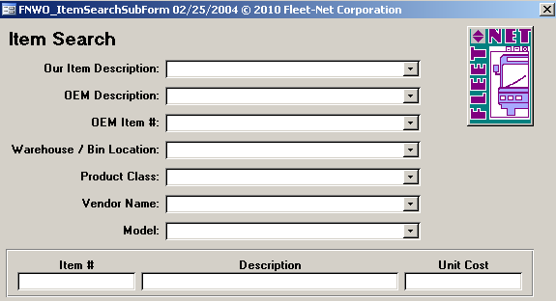

Throughout Fleet-Net® modules, there are Green Check marks that will appear next to specific fields. These Green Checkmarks when selected will open the Misc. List Codes form allowing the user to set up the necessary codes and their value for the associated field.

### About This Guide

This guide contains standard procedures for operation and a description of each feature released with the module. The module description provides the intended application or use of the module and any comments that relate to this specific module.

Below are features that are used throughout FNW applications.



To correctly exit a form or exit out of Fleet-Net® completely click on the Fleet-Net® Icon always located in the upper right of every form.



**When the binoculars search function is not available, nor a drop down list, select ‘Ctrl F’ as a search tool.

When using this button to search the following sample form will open up. Use any of the search item criteria to find your item select it and it will populate at the bottom of this form. To populate the previous form with the selected item simply hover over the item # and double click it. Close the search form.



The clock button allows for changing the time entry.



The question mark button opens the search option.



The Stop button aborts the current selection process.



The calendar button allows for quick selection of a specific date via a calendar. Calendar defaults to current date.



The calculator button allows for quick simple calculations on the fly. It opens up your systems calculator.

# General Ledger Checklists

### Initial Setup Checklist

This checklist follows the instructions outlined on the following pages.

Done Menu Program/Procedure

GL01 (a) GL Control Record Setup defined using **Control Record Setup.**

GL01 (b) GL Fiscal Year defined using **Fiscal Year Setup.**

GL01 (c) GL Divisions defined using **GL Division Setup.**

GL01 (d) GL Accounts defined using **Chart of Accounts Setup.**

GL01 (e) Miscellaneous Codes defined using **Miscellaneous Code Setup.**

GL01 (f) Redistribution References defined using **Redistribution Reference Setup.**

GL01 (g) Interface for closing entries defined using **Auto Post Setup.**

GL01 (h) Consolidation Fields defined using **Update Consolidation Fields**.

### Standard Cycles Checklist

Done Menu Program/Procedure

GL03 (a) Process & Update re-occurring journal entries (If applicable). **Re- occurring Journal Entry**.

GL03 (b) Process & Update re-distribution journal entries (If applicable). **Re- distribution Entry**.

GL03 (c) Enter & Batch manual journal entries (If applicable). **Journal Entry**.

GL03 (d) Update closing entries to the general ledger via journal update.

**Journal Update**.

### Month End Cycles Checklist

GL03 (a) Run Auto-Post Closing to create closing entries **Auto Post Closing**.

GL03 (b) Update closing entries to the general ledger via journal update.

**Journal Update**.

GL (c) Run month end closing **Month End Closing**.

GL04 (d) Review and/or Print preliminary financial reports. **Financial Statements**

### Fiscal Year End Closing Checklist

Done Menu Program/Procedure

GL01 (a) Create New Fiscal Year ** this should be done a few months prior to the end of the current fiscal year. **Fiscal Year Setup**.

GL02 (b) Create New Budget Year ** this should be done a few months prior to the end of the current fiscal year. **Annual Budget Setup**.

(c) Complete the G/L Standard Cycle as shown above.

GL04 (d) Run Fiscal Year End Closing. **Fiscal Year End Closing**.

# Financial Main Menu

Navigate to Finance > General Ledger.

# General Ledger Setup

Navigate to ***General Ledger Setup*** to enter all required setup information needed to utilize the General Ledger Module.

### Control Record Setup

Navigate to ***Control Record Setup*** to set the starting value for three record types.

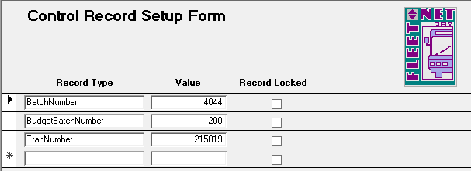

|  |  |
| --- | --- |
| **Record Type** | **Value** |
| BatchNumber | Enter the starting number for sequential numbering of general ledger batch transactions. |
| BudgetBatchNumber | Enter the starting number for sequential numbering of general ledger budget batch transactions. |
| TranNumber | Enter the starting number for sequential numbering of general ledger transactions. |

***Record Locked*** checkbox will be checked when a record type is in use for example updating a batch, during the update process the system will check this box to not allow for the same record value # to be used more than once.

### Fiscal Year Setup

Navigate to ***Fiscal Year Setup*** to define fiscal years.

All future fiscal years must be created **prior** to generating any entries, creating budgets, entering payroll data, or creating reports for that year.

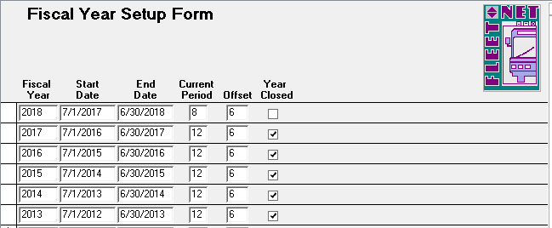

|  |  |  |
| --- | --- | --- |
| **Field Name** | **Field Type** | **Description** |
| Fiscal Year | Number | Enter fiscal year being created. |
| Start Date | Date/Time | Enter the first day of the fiscal year. |
| End Date | Date/Time | Enter the last day of the fiscal year. |

|  |  |  |
| --- | --- | --- |
| **Field Name** | **Field Type** | **Description** |
| Current Period | Number | Enter the current period of the fiscal year. If the year is closed, enter 12. If defining a future fiscal year, enter 1. |
| Offset | Number | Enter offset period between the fiscal year and the calendar year. i.e. Enter 0 if the fiscal year is January 1 to December 31; 6 if the fiscal year is July 1 to June 30; or 9 if the fiscal year is October 1 to September 30. |
| Year Closed | Yes/No | Check the box if the fiscal year being defined is closed; leave unchecked if it should be open. |

### GL Division Setup

Navigate to ***GL Divisions Setup*** to identify the individual Division(s) associated with the General Ledger Chart of Accounts.

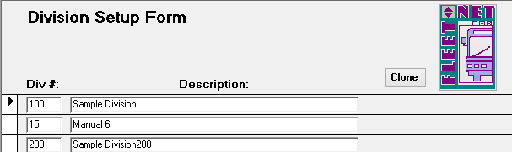

|  |  |  |  |
| --- | --- | --- | --- |
| **Field Name** | **Max Field Size** | **Field Type** | **Description** |
| Div # | 4 | Alpha/Numeric | Enter division(s) as delineated in the Chart of Accounts. When adding a new division, enter the number and description **prior** to creating Chart of Accounts or cloning an existing division’s Chart of Accounts. |
| Description | 50 | Alpha/Numeric | Enter description for the division, as it will appear on report headings. |

Click ***Clone*** to copy (clone) Chart of Accounts for an existing division to a new division. The following form displays.

(A new division must be created, prior to using the clone function).

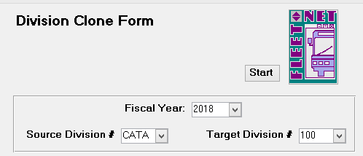

|  |  |  |  |
| --- | --- | --- | --- |
| **Field Name** | **Max Field Size** | **Field Type** | **Description** |
| Fiscal Year |  | Number | Enter or select fiscal year from drop down options. |
| Source Division # | 4 | Alpha/Numeric | Enter or select division from drop down options containing the accounts being copied (cloned). |
| Target Division # | 4 | Alpha/Numeric | Enter or select new division from drop down options, to create the Chart of Accounts. |

#### Start

Click ***Start*** the following prompt displays.

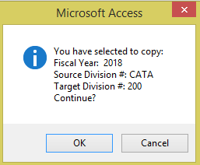

Click ***Ok*** to create Chart of Accounts for selected division or ***Cancel*** to return to Division Clone Form.

***Target Division*** with an existing Chart of Account will not allow Cloning. The following message will display.

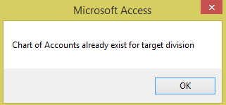

Click ***OK*** to return to the Division Clone Form.

Once the clone (copying) is completed the following message displays.

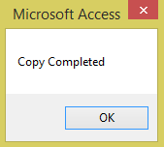

Click ***OK.***

### Chart of Accounts Setup

Navigate to ***Chart of Accounts Setup*** to create, add, delete, or maintain existing account(s) numbers in the Chart of Accounts. Each General Ledger Account Number can accommodate up to five Sort/Consolidation fields to allow more defined reports and/or graphs.

NOTE*: If interfaced general ledger account numbers are changed, interface(s) must be modified, or postings will be out of balance or incorrect. See* ***Auto Post Setup*** *for explanation of interfaced accounts.*

The following form displays.

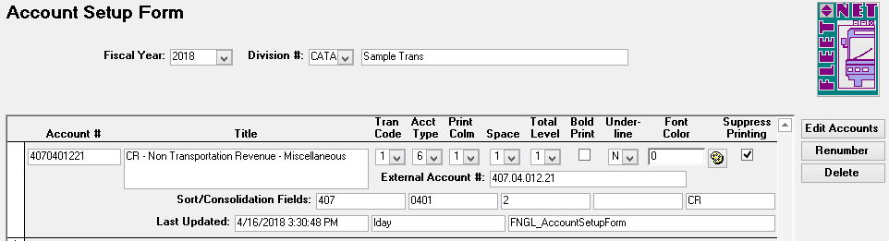

#### Edit Accounts

Click ***Edit Accounts*** to add or change an existing account. To add a new account, scroll to the last record



Or use at bottom of the form to open a new record form. The table below defines each field on the Edit Accounts form.

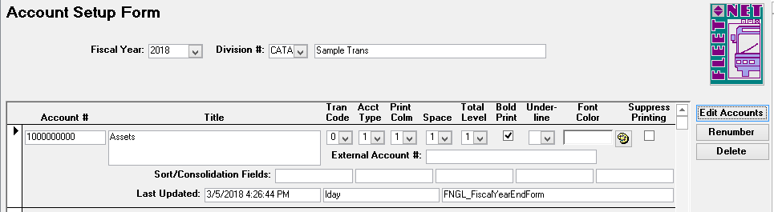

|  |  |  |  |
| --- | --- | --- | --- |
| **Field** | **Max Field Size** | **Field Type** | **Description** |
| Account # | 10 | Alpha/Numeric | Account number accommodates up to ten (10) digits. |
| Title | 50 | Alpha/Numeric | Description for the General Ledger Account #, as it will appear on financial reports. |
| Tran Code | 1 | Alpha/Numeric | Select the type of transaction applicable for the GL account # from the drop-down list. |
| 0 |  | | ***Heading*** define the heading for Balance Sheet and Income Statement Reports. |
| 1 | ***Valid Posting Account*** when selected does not allow for reports to be summarized (Grouped) when the Summary option is selected for creating reports. To summarize these accounts the Suppress Print box can be checked to allow for ***Summary*** option in Financial Statement report  options. |
| 2 | ***Inactive Account*** utilize this option to prohibit new activity to be posted to the account #. The account number will continue to show on financial reports. |
| 3 | ***Total*** Totals/subtotals for net on balance sheet. |
| 4 | ***Valid Posting Account /Suppress Printing*** allows for detail or summary reports to be generated in Financial Statement options: Balance Sheet or Income Statement. |
| 5 | ***Income Summary*** will be setup as the control account for tracking the Profit or Loss reported on the Income Statement and for Auto Post  Closing. |
| 6 | ***Subtotal*** utilized in conjunction with level(s) option. Generates a total for the selected group (level) of General Ledger Account Numbers. Subtotal line will populate on Income Statement Report. |
| Acct Type | 1 | Alpha/Numeric | Identifies type of account for posting and financial reporting. |
| 1 |  | | ***Asset*** |
| 2 | ***Liability*** |
| 3 | ***Capital/Equity*** |
| 4 | ***Revenue*** |
| 5 | ***Expense*** |
| 6 | ***Revenue percentage calculation,*** generates a percentage figure based on the individual revenue source against the total revenue dollar amount. |

|  |  |  |  |
| --- | --- | --- | --- |
| **Field** | **Max Field Size** | **Field Type** | **Description** |
| Print Column | 1 | Alpha/Numeric | Specify column (1, 2 or 3) for Balance Sheet & Income Statement printing (See Note below). |
| Space | 1 | Alpha/Numeric | Specify one of the following to determine vertical print line space between accounts for both Balance Sheets and  Income Statements (See Notes below). |
| 1 |  | | Skip 1 Line (print on next line). |
| 2 | Skip 2 Lines (double space). |
| 3 | Skip 3 Lines (triple space). |
| 4 | Skip 4 Lines (Skips 3 lines – prints on 4th). |
| 5 | Skip 5 Lines (Skips 4 lines – prints on 5th). |
| 6 | Skip 6 Lines (Skips 5 lines – prints on 6th). |
| 7 | Skip 7 Lines (Skips 6 lines – prints on 7th). |
| 8 | Skip 8 Lines (Skips 7 lines – prints on 8th). |
| 9 | Force new page (starts a new page) |
| Total Level | 1 | Alpha/Numeric | Total level code number (1-9) determines where subtotals and totals print on financial reports. The total level code used for heading accounts with Tran Code 0 will not impact the reports (See Note below). |
| Bold Print |  | Yes/No | Select checkbox to print the account number, title and amount in bold print on financial reports. |
| Underline | 1 | Alpha/Numeric | Select single or double to determine an underline option below the amount on financial reports. |
| Font Color |  | Number | Select the palette icon to choose a font color to print the account number, title and amount on financial reports. |
| Suppress Printing |  | Yes/No | Select checkbox to suppress the printing for  ***Valid Posting Accounts***. If option #4 was selected for Tran Code, no further action is require for utilizing Summary option in Financial Statements. |
| External Account # | 30 | Alpha/Numeric | Used for reporting GL # in a format structure utilized by outside agencies. (i.e. State; Federal; etc. account number). |
| Sort/Consolidation Fields | 10 | Alpha/Numeric | Allows for up to five sort/consolidation fields to be specified for each Consolidation account number. These fields can be manually edited or automatically updated by using the Update Consolidation Fields Form. These fields are used  for consolidating the financial reports and graphs or for sorting the reports. |
| Last Updated | 20 | Alpha/Numeric | Time and date stamp when the account was last updated. User name displays in second field; third field displays the form used when updated. |

***NOTE:*** *All numbers on financial statements (except contra accounts and/or a loss on income statement) appear as positive numbers. If this is not the case when you print financials, account type specified is incorrect.*

***Print Column*** *Although a number must be entered in this field for all accounts, it only affects printing of Balance Sheet accounts.*

***Spacing*** *Spacing of financial reports may be changed at any time; this only makes a cosmetic change in printing of financials. If any number except 1 is selected, the added lines will appear above the account.*

***Totaling Levels*** *Create a Subtotal or Total line, select the next level required to populate the totals for the lower level.*

***Examples:***

*A Total Level 2 account will display the total of all of the accounts listed above it with a Total Level 1.*

*A Total Level 3 account will display the total of all of the accounts listed above it with a Total Level 2, if there are none, it will display the total of all accounts with a Total Level 1.*

*A Total Level 4 account will display the total of all of the accounts listed above it with a Total Level 3, if there are none, it will display the total of all accounts with a Total Level 2 or 1 if there are no Total Level 2 accounts.*

#### Renumber

Enter or select Fiscal Year & Division # from drop down options.

Click ***Renumber*** to renumber a selected account number to a newly created account number.

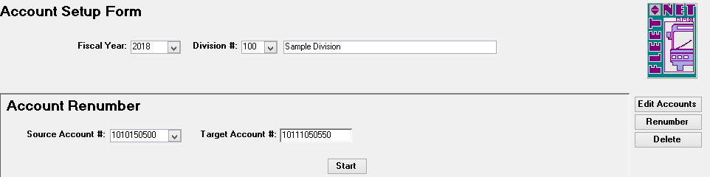

|  |  |  |  |
| --- | --- | --- | --- |
| **Field** | **Max Field Size** | **Field Type** | **Description** |
| Source Account # | 10 | Alpha/Numeric | Enter or select the account being renumbered from the drop down options. |
| Target Account # | 10 | Alpha/Numeric | Enter the new account number. |

#### Start

Click ***Start***. The following prompt displays.

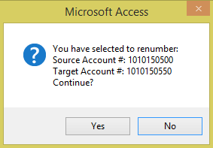

Click ***Yes*** to renumber the account # and transfer all historical data to the new number or ***No*** to return to the Account Renumber form.

The following confirmation message displays upon completion of the renumber.

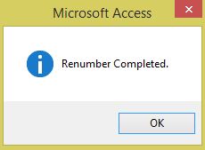

Click ***OK***.

#### Delete

Enter or select Fiscal Year & Division # from drop down options.

Click ***Delete*** to delete account numbers that have no transactions associated with the number. Account numbers can be deleted only when there has been no activity in the fiscal year selected. *Note: Utilize this option when an account has been set up in error.*

Enter or select the account # to be deleted.

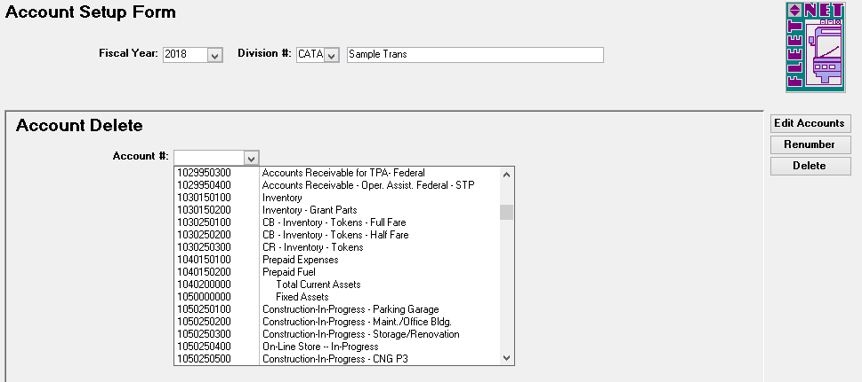

#### Start

Click ***Start***. The following confirmation message displays.

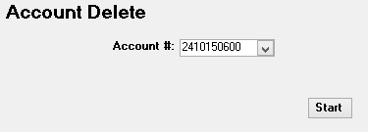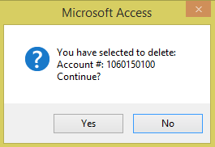

Click ***Yes*** to delete the General Ledger account number or ***No*** to return to the Account Delete form. If, Yes is selected the following confirmation message displays upon completion of the deletion.

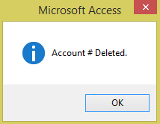

Click ***Ok***.

If Account # has activity the following message will be display.

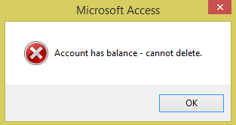

Click ***Ok***.

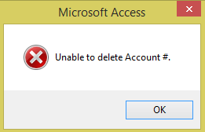

Click ***Ok***.

### Miscellaneous List Setup

Navigate to ***Misc Codes (GL)*** to enter all miscellaneous codes utilized in the General Ledger module.

Each application includes a list of miscellaneous codes that are used within the system. Some of these codes are preset by Avail (Specific) while others are user defined.

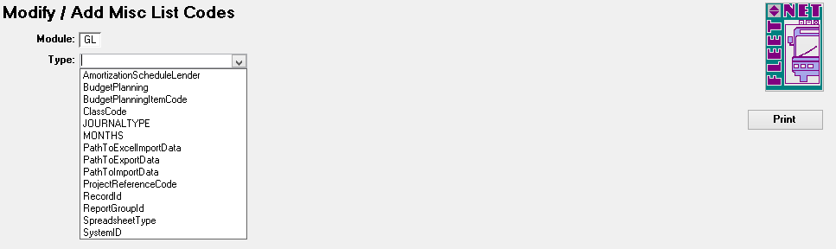

|  |  |  |  |
| --- | --- | --- | --- |
| **Field Name** | **Max Field Size** | **Field Type** | **Description** |
| Type | 50 | Alpha/Numeric | Select an existing code from the drop down list or enter a new code by typing in the definition provided by Avail. |
| Code | 50 | Alpha/Numeric | Enter a code, either user defined or specific. |
| Value | 255 | Alpha/Numeric | Enter a description to define the selected code. |

AmortizationScheduleLender **(User Defined)**

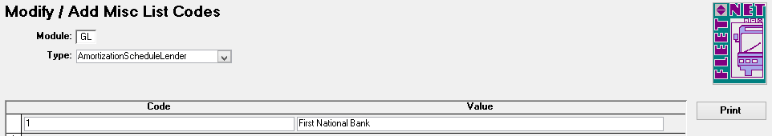

BudgetPlanning **(User Defined)**

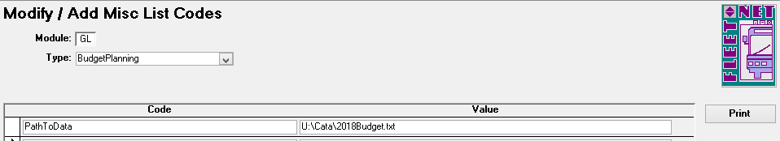

BudgetPlanningItemCode **(User Defined)**

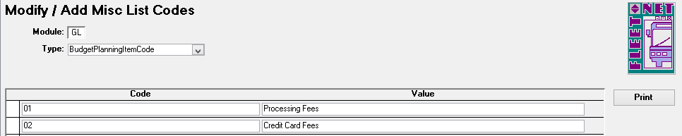

ClassCode **(User Defined)**

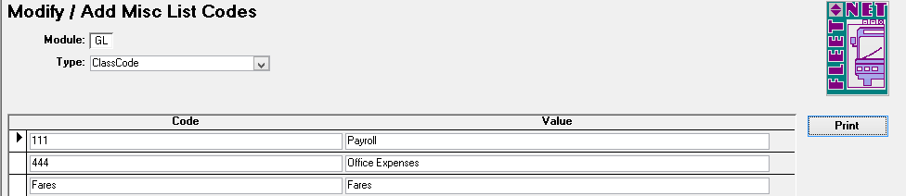

JOURNALTYPE: (User Defined – Except the Payroll Journal. It must be PRL)

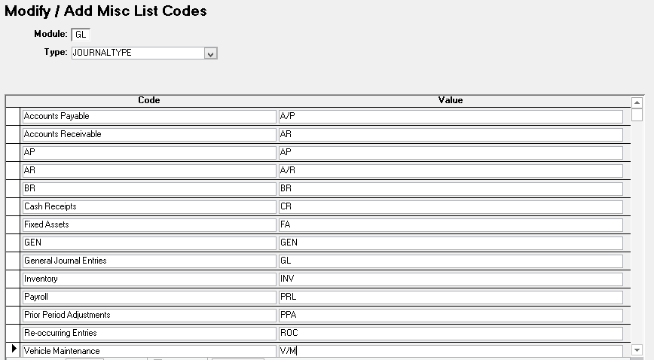

MONTHS **(Specific)** - Enter Codes and Values as shown in table below.

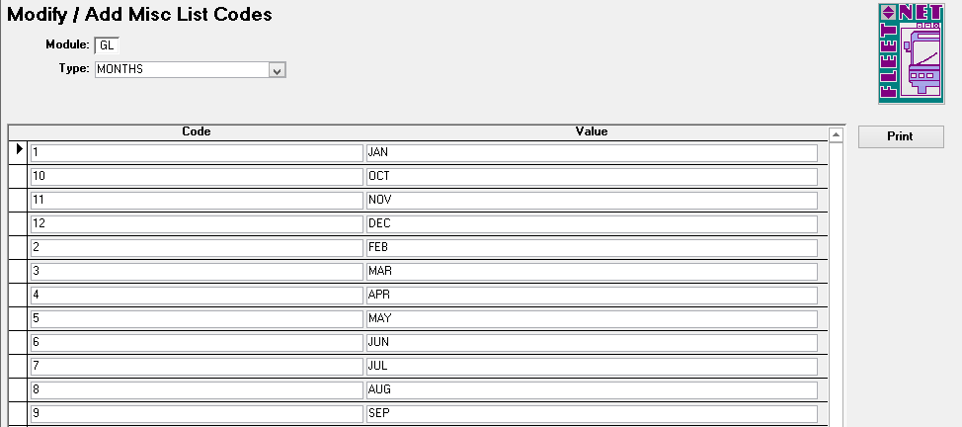

|  |  |
| --- | --- |
| **Code** | **Value** |
| 1 | JAN |
| 10 | OCT |
| 11 | NOV |
| 12 | DEC |
| 2 | FEB |
| 3 | MAR |
| 4 | APR |
| 5 | MAY |
| 6 | JUN |
| 7 | JUL |
| 8 | AUG |
| 9 | SEP |

PathToExcelImportData **(User Defined)**

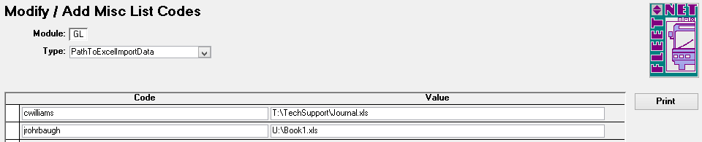

PathToExportData **(User Defined)**

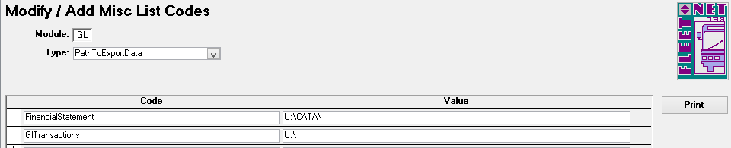

PathToImportData **(User Defined)**

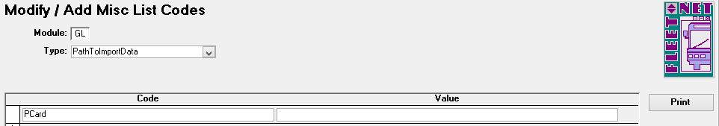

ProjectReferenceCode **(Specific)** - Enter Codes and Values as shown in table below.

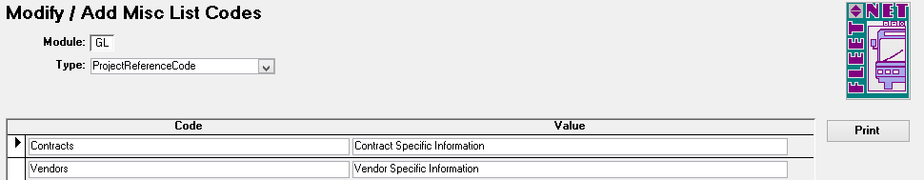

|  |  |
| --- | --- |
| **Code** | **Value** |
| Contracts | Contract Specific Information |
| Vendor | Vendor Specific Information |

RecordId: (**Specific)** - Enter Codes and Values as shown in table below.

**E*ntries for RecordId must be added for use with the post interface form. See below:***

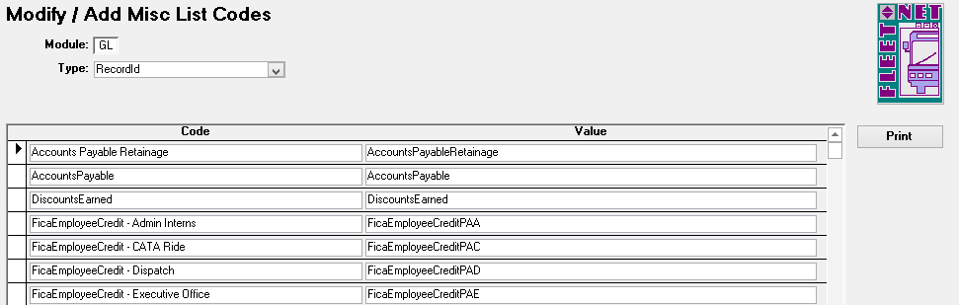

***Specific entries for RecordId must be added for use with the post interface form.***

|  |  |
| --- | --- |
| **Code** | **Value** |
| AccountsPayable | AccountsPayable |
| DiscountsEarned | DiscountsEarned |
| MEI | Month End Closing Income Summary |
| MER | Month End Closing Retained Earnings |

***The following RecordId entries must be added for use with the FNW Payroll program:***

*xx = Two Letter State Code; z = One Letter/Number Department Designation Code*

|  |  |  |
| --- | --- | --- |
| **Description** | **Code** | **Value** |
| Earned Income Credit (EIC) | EicEmployerDebitxx | EicEmployerDebitxx |
| FICA Payable (Employee) | FicaEmployeeCreditxxz | FicaEmployeeCreditxxz |
| FICA Payable (Employer) | FicaEmployerCreditxxz | FicaEmployerCreditxxz |
| FICA Expense (Employer) | FicaEmployerDebitxxz | FicaEmployerDebitxxz |
| Federal Withholding (FIT) | FitEmployeeCreditxx | FitEmployeeCreditxx |
| FUTA Payable (Employer) | FutaEmployerCreditxxz | FutaEmployerCreditxxz |
| FUTA Expense (Employer) | FutaEmployerDebitxxz | FutaEmployerDebitxxz |
| Medicare Payable (Employee) | MedicareEmployeeCreditxxz | MedicareEmployeeCreditxxz |
| Medicare Payable (Employer) | MedicareEmployerCreditxxz | MedicareEmployerCreditxxz |
| Medicare Expense (Employer) | MedicareEmployerDebitxxz | MedicareEmployerDebitxxz |
| Net Pay (Employee) | NetPayEmployeeCreditxx | NetPayEmployeeCreditxx |
| State Withholding (SIT) | SitEmployeeCreditxx | SitEmployeeCreditxx |
| SUTA Payable (Employer) | SutaEmployerCreditxxz | SutaEmployerCreditxxz |
| SUTA Expense (Employer) | SutaEmployerDebitxxz | SutaEmployerDebitxxz |

ReportGroupID **(User Defined)**

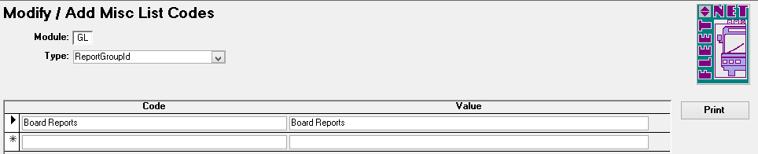

SpreadsheetType **(Specific)** – Avail will assist in this setup.

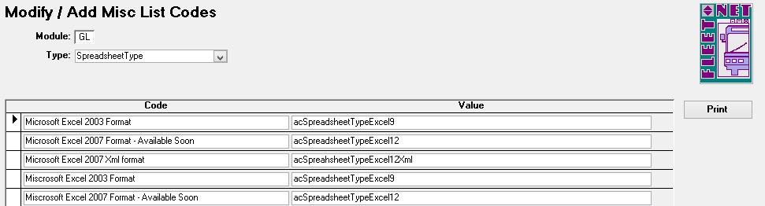

|  |  |
| --- | --- |
| **Code** | **Value** |
| Microsoft Excel XXXX Format | acSpreadsheetTypeExcel(X) |

SystemID **(Specific)** Enter Codes and Values as shown in table below.

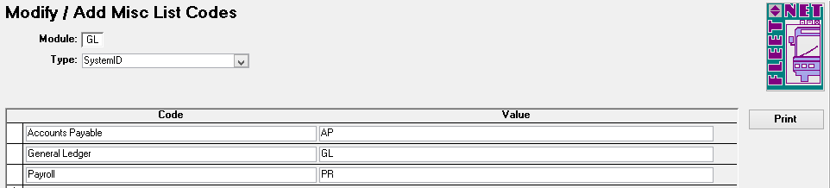

|  |  |
| --- | --- |
| **Code** | **Value** |
| Accounts Payable | AP |
| General Ledger | GL |
| Payroll | PR |

### Redistribution Reference Setup

Navigate ***Redistribution Reference*** to set up references where an amount is posted to an account and then redistributed to other account(s) based on a fixed percentage or percentage of the total amount.

(See Redistribution Entry Page 74).

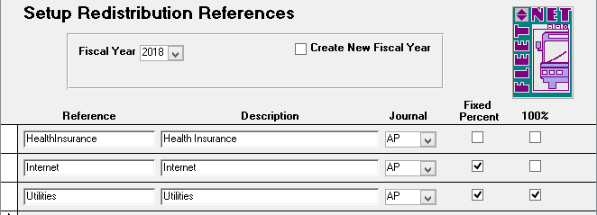

|  |  |  |  |
| --- | --- | --- | --- |
| **Field Name** | **Max Field Size** | **Field Type** | **Description** |
| Fiscal Year |  | Number | Select fiscal year from the drop down options. |
| Create New Fiscal Year |  | Yes/No | Check box to copy redistribution references from the current fiscal year to a new fiscal year. (See below for additional instructions). |
| Reference | 20 | Alpha/Numeric | Enter a reference code to identify the redistribution entry. The reference will be used for selection purposes when processing redistribution entries. |
| Description | 20 | Alpha/Numeric | Enter a description for the new reference. |
| Journal | 3 | Alpha/Numeric | Select subsidiary journal where entries will be posted for the selected reference. |
| Fixed Percent |  | Yes/No | Check box if the redistribution will be based upon a fixed percentage. Leave the box blank if the redistribution will be computed based on a  source account. |
| 100% |  | Yes/No | Check box if the **fixed percentage** distribution must equal 100%. Leave box blank if the redistribution will be computed based on a source account. |

When Create New Fiscal Year box is checked, the system populates the New Fiscal Year drop down option. The new fiscal year must be setup to populate in the drop down options. (See Fiscal Year Setup Page 11).

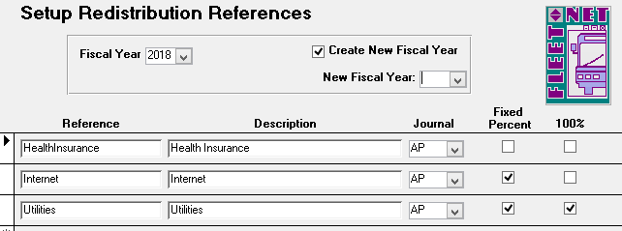

Select the new fiscal year from the drop down list. The following prompt displays.

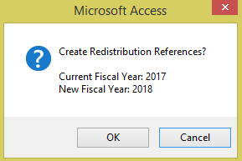

Click ***OK*** to create the redistribution entries to the new fiscal year or ***Cancel*** to return to the Setup Redistribution Reference form.

If ***OK*** is selected the following completion confirmation displays.

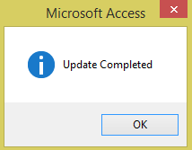

Click ***Ok***.

### Auto Post Setup

Navigate to ***Auto Post Setup*** to specify general ledger interfaces for auto-post closing entries. The following 3 System Id’s will be setup at this time, Accounts Payable, General Ledger & Payroll.

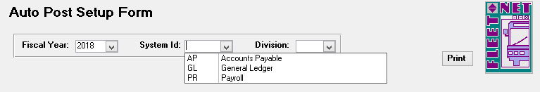

**Accounts Payable Entries:** *Setup AccountsPayable, DiscountsEarned & Retainage Payable.*

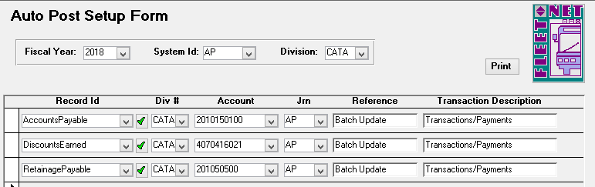

|  |  |  |  |
| --- | --- | --- | --- |
| **Field Name** | **Max Field Size** | **Field Type** | **Description** |
| Fiscal Year | 4 | Number | Select the fiscal year from the drop down options. |
| System ID | 4 | Alpha/Numeric | Select ***AP*** or ***A/P*** from the drop down options based on setup. |
| Division | 4 | Alpha/Numeric | Select the division containing the accounts payable GL account from the drop down options. |
| **Accounts Payable** |  |  |  |
| Record ID | 30 | Alpha/Numeric | Select AccountsPayable from the drop down options. |
| Div # | 4 | Alpha/Numeric | Select the division containing accounts payable GL account # from the drop down options. |
| Account | 10 | Alpha/Numeric | Select Accounts Payable GL account # from the drop down options. |
| Jrn | 3 | Alpha/Numeric | Select the Accounts Payable subsidiary journal from the drop down options. (AP or A/P based on setup). |
| Reference | 20 | Alpha/Numeric | Enter a reference to identify the posting in the General Ledger records. |
| Description | 30 | Alpha/Numeric | Enter a description, to appear when printing, financial detail reports. |
| **Discounts Earned** |  |  |  |
| Record ID | 30 | Alpha/Numeric | Select DiscountsEarned from the drop down options. |
| Div # | 4 | Alpha/Numeric | Select division containing Accounts Payable GL account # from the drop down options to be credited when vendor discounts are computed and taken based on the setup in  Accounts Payable Vendor Master. |
| Account | 10 | Alpha/Numeric | Select GL Account Number that will be credited when vendor discounts are computed and taken based on the setup in Accounts Payable Vendor Master. |
| Jrn | 3 | Alpha/Numeric | Select Accounts Payable subsidiary journal from the drop down options. |
| Reference | 20 | Alpha/Numeric | Enter reference description to identify the posting in General Ledger records. |
| Description | 30 | Alpha/Numeric | Enter a description. The description will print on financial detail reports. |

|  |  |  |  |
| --- | --- | --- | --- |
| **Field Name** | **Max Field Size** | **Field Type** | **Description** |
| **Retainage Payable** |  |  |  |
| Record ID | 30 | Alpha/Numeric | Select Retainage Payable from the drop down options. |
| Div # | 4 | Alpha/Numeric | Select the division containing the account that will be credited when retainage is held. |
| Account | 10 | Alpha/Numeric | Select the account that will be credited when vendor discounts are computed and taken based on the setup in Accounts Payable vendor master. |
| Jrn | 3 | Alpha/Numeric | Select the Accounts Payable subsidiary journal from the drop down options. |
| Reference | 20 | Alpha/Numeric | Enter a reference to identify the posting in the General Ledger records. |
| Description | 30 | Alpha/Numeric | Enter a description, to appear when printing, financial detail reports. |

**General Ledger Entries:** *Setup MEI (Month End Closing Income Summary) & MER* **(***Month End Closing Retained Earnings).* Entries shown in the following example must be set up for **every** division. At month- end all divisions must be in balance and all income and expense accounts are closed out to Retained Earnings General Ledger account number.

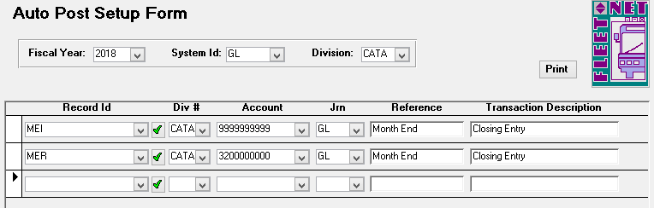

|  |  |  |  |
| --- | --- | --- | --- |
| **Field Name** | **Max Field Size** | **Field Type** | **Description** |
| Fiscal Year | 4 | Number | Select fiscal year from the drop down options. |
| System ID | 4 | Alpha/Numeric | Select ***GL*** from the drop down options. |
| Division | 4 | Alpha/Numeric | Select division being set up from the drop down options. |
| Record ID | 30 | Alpha/Numeric | Select **MEI (Month End Closing Income Summary)** from the drop down options. |
| Div # | 4 | Alpha/Numeric | Select division for Income Summary General Ledger Account from the drop down options. This will be the same division that was selected at  the top of the form. |
| Account | 10 | Alpha/Numeric | Select Income Summary General Ledger account from the drop down options |
| Jrn | 3 | Alpha/Numeric | Select the applicable subsidiary journal for the closing entries from the drop down options. This is typically the general ledger division (G/L, GEN, GL, etc.). |
| Reference | 20 | Alpha/Numeric | Enter reference description to identify the posting. This is typically Month End. |

|  |  |  |  |
| --- | --- | --- | --- |
| **Field Name** | **Max Field Size** | **Field Type** | **Description** |
| Description | 30 | Alpha/Numeric | Enter a description. The description will print on financial detail reports. This is typically Closing Entry. |
| Record ID | 30 | Alpha/Numeric | Select **MER (Month End Closing Retained Earnings)** from the drop down options. |
| Div # | 4 | Alpha/Numeric | Select division for Retained Earnings General Ledger account number from the drop down options. |
| Account | 10 | Alpha/Numeric | Select Retained Earnings General Ledger account number from the drop down options. |
| Jrn | 3 | Alpha/Numeric | Select the applicable subsidiary journal for the closing entries from the drop down options. This is typically the general ledger division (G/L, GEN, GL, etc.). |
| Reference | 20 | Alpha/Numeric | Enter reference description to identify the posting. This is typically Month End. |
| Description | 30 | Alpha/Numeric | Enter a description. The description will print on financial detail reports. This is typically Closing Entry. |

**Payroll Entries:** *Creates the payroll tax month end entries.*

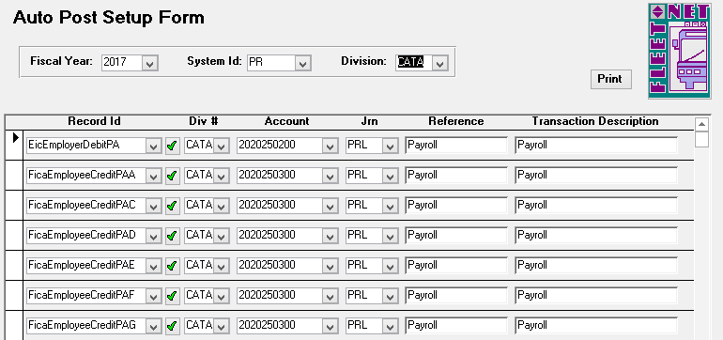

|  |  |  |  |
| --- | --- | --- | --- |
| **Field Name** | **Max Field Size** | **Field Type** | **Description** |
| Fiscal Year |  | Number | Select the fiscal year from the drop down options. |
| System ID | 4 | Alpha/Numeric | Select ***PR*** from the drop down options. |
| Division | 4 | Alpha/Numeric | Select division being set up from the drop down options. |
| Record ID | 30 | Alpha/Numeric | Select the applicable Record ID from the drop down options or add a new item. Click ***Green Check Mark*** (See below for detailed instructions). |
| Div # | 4 | Alpha/Numeric | Select applicable division for the expense or accrual from drop down options. |
| Account | 10 | Alpha/Numeric | Select the applicable General Ledger account number from the drop down options. |
| Jrn | 3 | Alpha/Numeric | Select the payroll subsidiary (PRL) journal from the drop down options. |
| Reference | 20 | Alpha/Numeric | Enter reference description to identify the posting. This is typically Payroll. |
| Description | 30 | Alpha/Numeric | Enter a description. The description will print on financial detail reports. This is typically Payroll. |

RecordID Codes:

*xx = Two Letter State Code*

*z = One Letter/Number Department Designation Code*

|  |  |
| --- | --- |
| **Description** | **Record ID Entry** |
| Earned Income Credit (EIC) | EicEmployerDebitxx |
| FICA Payable (Employee) | FicaEmployeeCreditxxz |
| FICA Payable (Employer) | FicaEmployerCreditxxz |
| FICA Expense (Employer) | FicaEmployerDebitxxz |
| Federal Withholding (FIT) | FitEmployeeCreditxx |
| FUTA Payable (Employer) | FutaEmployerCreditxxz |
| FUTA Expense (Employer) | FutaEmployerDebitxxz |
| Medicare Payable (Employee) | MedicareEmployeeCreditxxz |
| Medicare Payable (Employer) | MedicareEmployerCreditxxz |
| Medicare Expense (Employer) | MedicareEmployerDebitxxz |
| Net Pay (Employee) | NetPayEmployeeCreditxx |
| State Withholding (SIT) | SitEmployeeCreditxx |
| SUTA Payable (Employer) | SutaEmployerCreditxxz |
| SUTA Expense (Employer) | SutaEmployerDebitxxz |

#### Print

Click ***Print*** to generate a report including all divisions and codes. Leave the System Id and Division blank to review all setups. The following report generates.

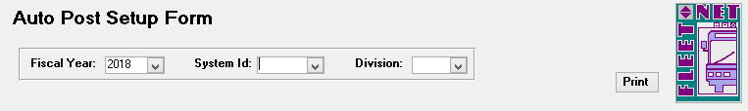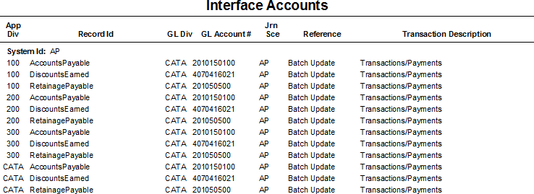

### Update Consolidation Fields

Navigate to  ***Consolidation Fields*** to automatically update Chart of Accounts General Ledger numbers, utilizing sort/consolidation fields based upon user-defined criteria.

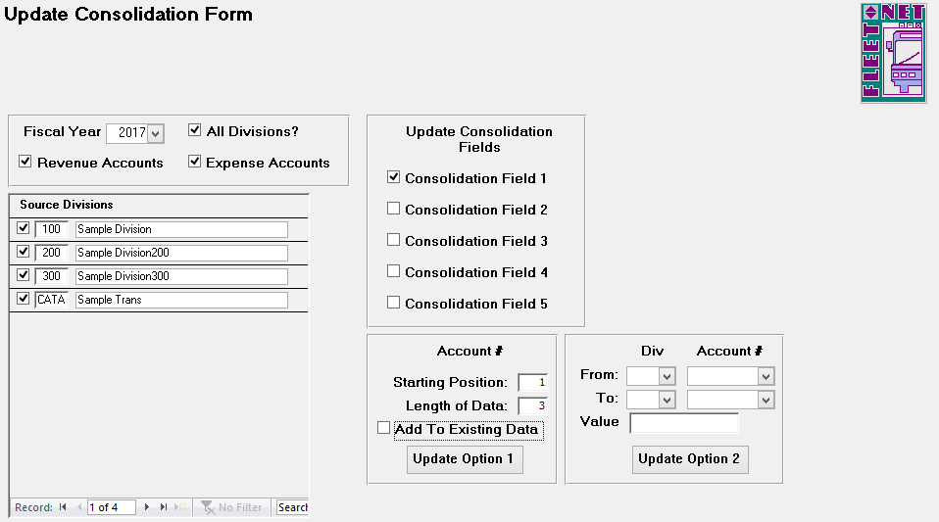

|  |  |  |  |
| --- | --- | --- | --- |
| **Field Name** | **Max Field Size** | **Field Type** | **Description** |
| Fiscal Year |  | Number | Select the fiscal year from drop down options. |
| All Divisions? |  | Yes/No | Check box if update applies to all divisions for selected fiscal year. If only specific divisions are to be included, select them by checking the box to the left of their Division  ID(s). |
| Revenue Accounts |  | Yes/No | Check box to update revenue accounts for the selected divisions. |
| Expense Accounts |  | Yes/No | Check box to update expense accounts for the selected divisions. |

***Update Option 1***

Using selections as shown below, Consolidation Field #1 will be updated to contain the first 3 numbers of General Ledger Revenue & Expense account numbers.



|  |  |  |  |
| --- | --- | --- | --- |
| **Field Name** | **Max Field Size** | **Field Type** | **Description** |
| Update Consolidation Fields |  | Yes/No | Select one of five available consolidation fields. (Example states Field #1) |
| Starting Position | 2 | Alpha/Numeric | Enter starting position of the account number. This will be the beginning value for the consolidation field. (Example shows the first number of the GL Account number). |
| Length of Data | 2 | Alpha/Numeric | Specify the number of digits from the starting position to be included in the value for consolidation fields. (Example shows that the first 3 numbers of the General Ledger number will be  consolidated). |
| Add to Existing Data |  | Yes/No | Check box if selected options above should be applied to existing data. |

Click ***Update Option 1***, the following confirmation message displays.

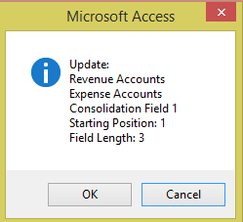

Click ***OK*** to update the General Ledger Account # using the selected criteria or ***Cancel*** to return to the Update Consolidation form. If ***OK*** was selected the following confirmation message displays.

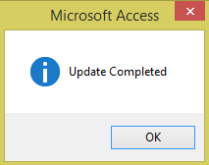

Click ***OK***.

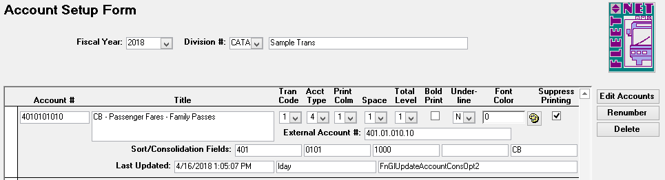

Using the selections as shown in the example below, Consolidation Field #2 will be updated to contain the 4th thru 8th numbers of General Ledger account number.

Update Option 1 Consolidation Field 2

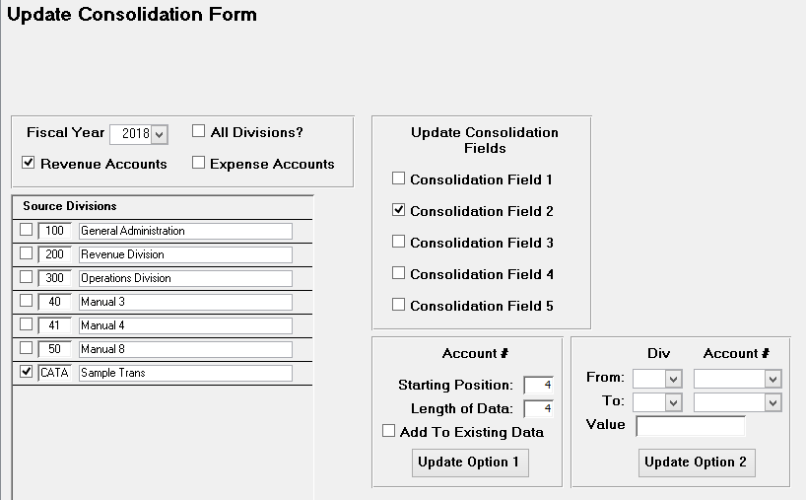

|  |  |  |  |
| --- | --- | --- | --- |
| **Field Name** | **Max Field Size** | **Field Type** | **Description** |
| Update Consolidation Field |  |  | Select one of five available consolidation fields. (Example states Field #2) |
| Starting Position | 4 | Alpha/Numeric | Enter starting position for the second consolidation (Example states starting position for this consolidation will begin with 4th position. |
| Length of Data | 10 | Alpha/Numeric | Enter the number of characters to be include in this layer of consolidation. (Example states 4 positions) |
| Add to Existing Data | 4 | Alpha/Numeric | Check box if selected options above should be applied to existing data. |

Click ***Update Option 1*** to update the selected options for Consolidation Field 2. The following confirmation message displays.

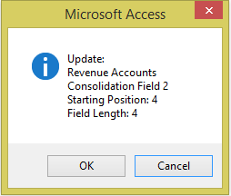

Click ***OK*** to update the General Ledger Account # using the selected criteria or ***Cancel*** to return to the Update Consolidation form. If ***OK*** is selected the following message displays.



Click ***OK.***

After update is run, the Account Setup Form now lists the 4th thru 8th digits of the account number in consolidation field #2.

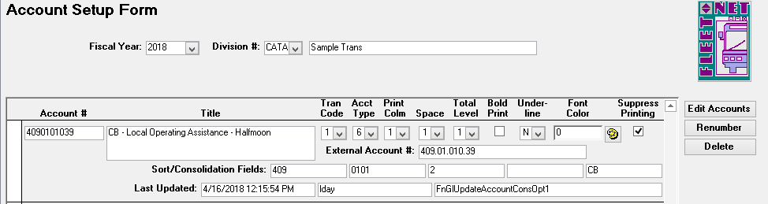

***Update Option 2***

Using the selections as shown in the example below, Consolidation Field #3 will be updated to 1000 for all CB Revenue Accounts.

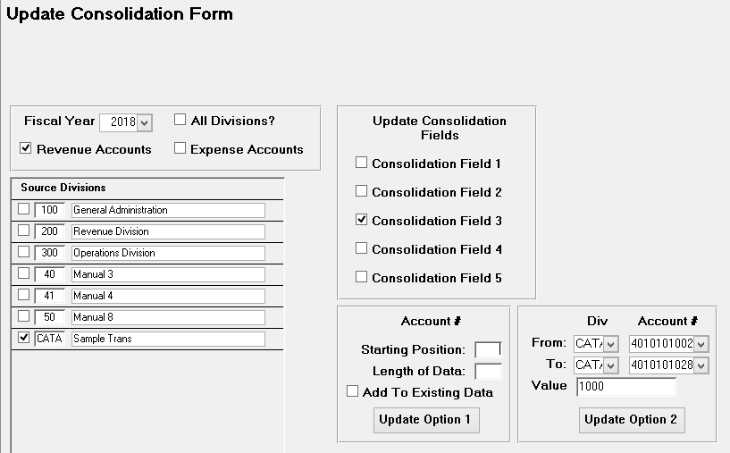

Click ***Update Option 2*** to update the selected options for Consolidation Field 3. The following confirmation message displays.

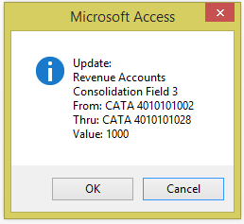

Click ***OK*** to execute the selected consolidation option or ***Cancel*** to return to Update Consolidation Form. If ***OK*** is selected the following confirmation message displays.



Click ***OK.***

After the update is executed, the Account Setup Form now lists the1000 in consolidation field #3.

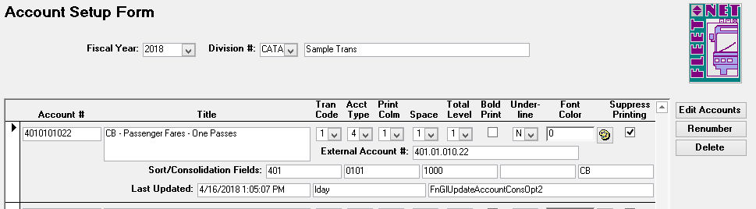

### Re-Compute Account Balances

This process should only be used with assistance from an Avail Technician. Contact Avail Corporation at 800-258-2762.

Navigate to 

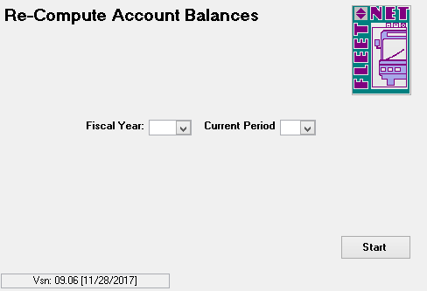

### Fiscal Year Delete

This process should only be used with assistance from an Avail Technician. Contact Avail Corporation at 800-258-2762.

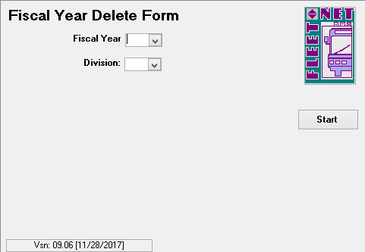

# Budget Maintenance

Navigate to Finance > Budgeting to create and/or manage budget information.

### Create New Budget Year

Navigate to ***Create New Budget*** to create (clone) a new chart of accounts from an existing fiscal year.

*NOTE: The new fiscal year must be set up in order for it to be available for selection.*

The following form displays.

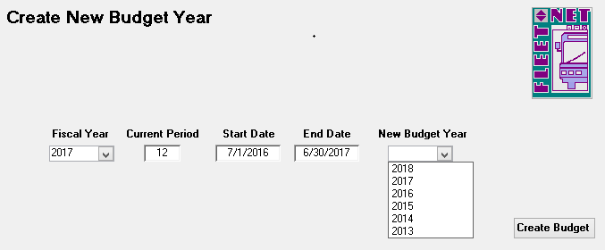

|  |  |
| --- | --- |
| **Field Name** | **Description** |
| Fiscal Year | Enter or select the fiscal year from the drop down options. (Source) |
| Current Period | Automatically populates based on the fiscal year selected. |
| Start Date | Automatically populates based on the fiscal year selected. |
| End Date | Automatically populates based on the fiscal year selected. |
| New Budget Year | Select new budget year from the drop down options. (Target) |

#### Create Budget

Click ***Create Budget***. The following confirmation message displays.

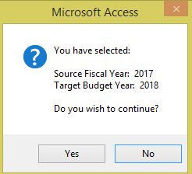

Click ***Yes*** to create the new budget year cloning the Chart of Accounts from the source fiscal year selected or ***No*** to return to the Create New Budget Year form.

***NOTE:*** *This is a good time to review the chart of accounts. Deleting any accounts from the new fiscal year should be done prior to selecting Yes. Accounts cannot be deleted once entries are posted to them.*

*Deleting an account in the new fiscal year will not affect the previous years.*

Once ***Yes*** is selected the following confirmation message displays when the new budget has been built.

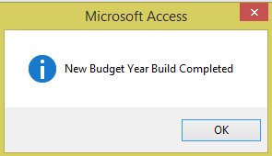

Click ***Ok***.

### Annual Budget Setup

Navigate to ***Annual Budget*** to enter or modify the annual budget amounts for selected fiscal year.

|  |  |  |
| --- | --- | --- |
| **Field Name** | **Field Type** | **Description** |
| Fiscal Year | Number | Enter or select the fiscal year from the drop down options. |
| Fiscal Start |  | Automatically populates based on the fiscal year selected. |
| Fiscal End |  | Automatically populates based on the fiscal year selected. |
| Division | Alpha/Numeric | Enter or select Division from the drop down options. |
| Update Monthly Budget | Yes/No | Check box to implement the allocation 1/12 of the annual budget amount per month. If annual budget amount is being edited and original annual budget amount was previously allocated at 1/12 per month, checking the box to execute the new amounts being  allocated monthly. (See Modify Monthly Budget on next page for further details). |

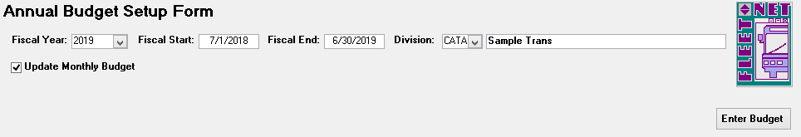

#### Enter Budget

Click ***Enter Budget*** to add or modify annual budget amounts. If Update Monthly Budget is not checked, the following alert message displays.

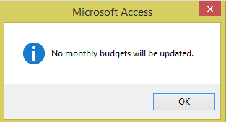

Click ***OK*** to continue, the following form displays.

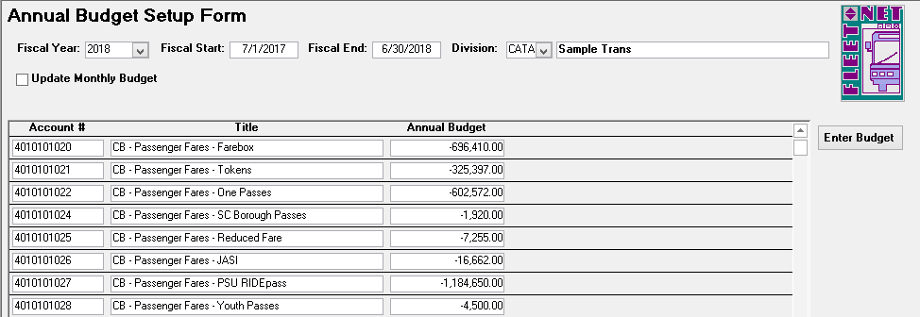

Enter the annual budget amounts for each account; if there is no budget amount for an account enter **ZERO**. *Do not leave any amount fields blank* (If fields are left blank the export/import options will not execute properly). ***Revenue accounts must be entered as credits, expense accounts as debits.***

### Modify Monthly Budget

Navigate to ***Modify Monthly Budget*** to change amounts, percentage, total annual budget amounts. Compute the applicable allocation for annual amounts.

The following form displays.

|  |  |  |  |
| --- | --- | --- | --- |
| **Field Name** | **Max Field Size** | **Field Type** | **Description** |
| Fiscal Year |  | Number | Enter or select Fiscal Year from the drop down options. |
| Division | 4 | Alpha/Numeric | Enter or select Division from the drop down options. |
| Account | 10 | Alpha/Numeric | Enter or select General Ledger Account number from the drop down options. |
| Current Period |  |  | Automatically populates based on the fiscal year selected. |
| Fiscal Start |  |  | Automatically populates based on the fiscal year selected. |
| Fiscal End |  |  | Automatically populates based on the fiscal year selected. |
| Change Amounts |  | Yes/No | Check box to make amount field accessible for editing. |
| Change Percents |  | Yes/No | Check box to make percentage field accessible for editing. |
| Change Annual Budget |  | Yes/No | Check box to make annual budget field accessible for editing. |

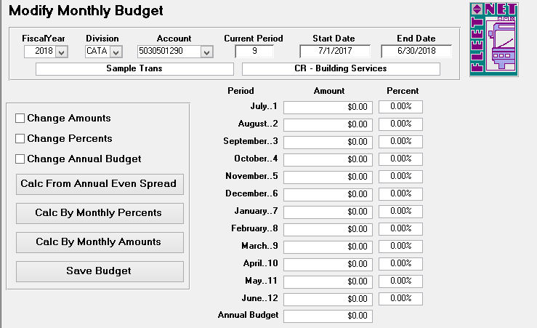

Once changes are made to amount, percentage or annual amount, select one of the following calculation options:

If ***Change Annual Budget*** was utilized than ***Calc From Annual Even Spread*** will distributes annual amount by 1/12 for each month.

If ***Change Percents*** was utilized than ***Calc By Monthly Percents*** will distributes the monthly amounts based on monthly percentages entered.

If ***Change Amount*** was utilized than ***Calc By Monthly Amounts*** will adjust the monthly percentages by monthly dollar amounts entered.

Click ***Save Budget*** after **EACH** account is edited. The following confirmation message displays.

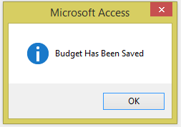

Click ***OK***.

### Export/Import Budget

Click ***Export/Import Budget*** to export the budget to Excel or a Text file. The export will fail if there are any blank records. If no amount is to be budgeted for an account or accounts, enter zeros.

##### Export Budget

Click ***Export Budget*** to export a Working Budget to Excel.

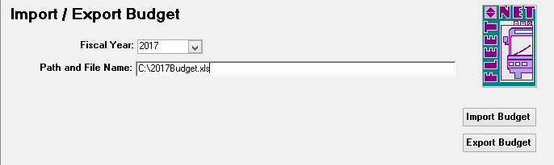

|  |  |  |  |
| --- | --- | --- | --- |
| **Field Name** | **Max Field Size** | **Field Type** | **Description** |
| Fiscal Year |  | Number | Enter or select the fiscal year from the drop down options. |
| Path and File Name | 4 | Alpha/Numeric | Specify a path and file name location where budget data will be exported. If an extension on the file name is .xls The budget will be exported to Excel. If the extension is left blank, the budget will be exported to a text file. |

The following message displays

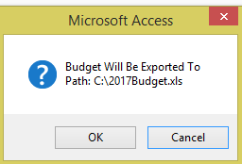

Click ***OK*** to export the budget or ***Cancel*** to return to the Import/Export Budget form. When export is completed, the following message displays.

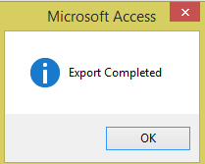

Click ***OK.***

Once export is completed, proceed to the specified location to open the Excel Spreadsheet. Budget figures can be entered, then utilizing the Import Budget option import the modified budget back into the program.

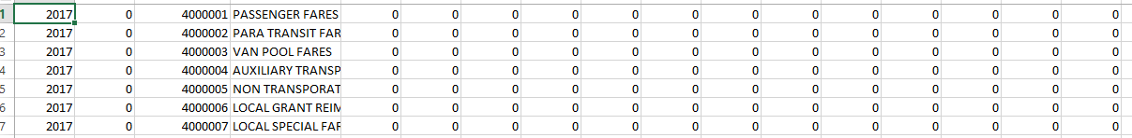

##### Import Budget

Click ***Import Budget*** to import the budget from a text file. If the budget is exported to Excel so that formulas can be used to update the amounts, prior to importing the data, the formulas must be removed. To remove formulas from the Excel spreadsheet, with the spreadsheet open, select all fields in the spreadsheet [Ctrl-A]; use the Windows *Edit/Copy* function.

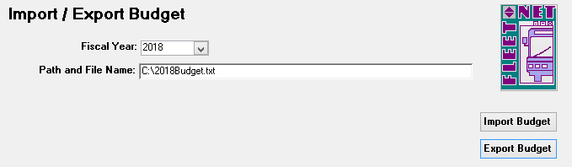

To paste the contents without the formulas, use the Windows *Edit/Paste Special* function and select *Values*

from the menu; click OK. The data is now pasted without formulas.

To save the copy of the budget with no formulas, use the Windows *File/Save As* function, and assign a new name to the file.

***The import file format must be Text (Tab delimited) (*.txt)***

|  |  |  |  |
| --- | --- | --- | --- |
| **Field Name** | **Max Field Size** | **Field Type** | **Description** |
| Fiscal Year |  | Number | Enter or select the fiscal year from the drop down options. |
| Path and File Name | 4 | Alpha/Numeric | Enter path and name of the budget file to be imported. If the budget is being imported into a new fiscal year, the fiscal year must be set up, the budget must be built for that year prior to running the import (See *Create Budget Year* section in this manual). |

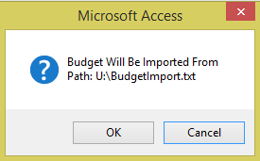

Click ***OK*** to continue or ***Cancel*** to cancel.

If the budget is out of balance, the following message displays for each line item that is out of balance. Use these messages to determine what correction need to be made.

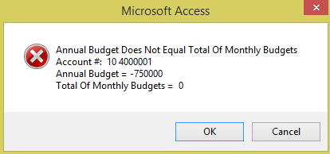

When Importing the Budget, if the monthly amounts are not included in the spreadsheet the following message displays. Avail recommends calculating the monthly amounts in Excel prior to importing.

Once the import reviews all records for errors.

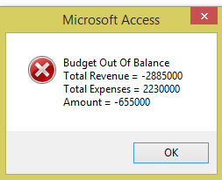

Click ***OK***.

If budget is out of balance, the data **will** import. The amounts can be edited to bring the budget into balance or left as is. In the case of the out of balance amount, it could be reflected in Net Profit amount.

### Budget Planning Setup

Navigate to ***Budget Planning Setup*** to create and modification budget figures. View up to 5 years of actual and budget history at one time.

Categorize budget accounts by assigning class codes to each account. Automatically, adjust proposed budget by account number range, percentage increase or decrease amount.

Once budget meets final approval the update option transfers, completed budget to live budget tables within the GL module.

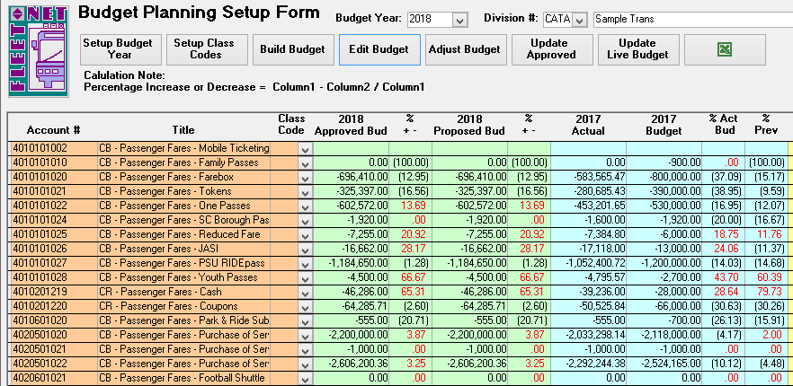

|  |  |
| --- | --- |
| **Field** | **Description** |
| Budget Year | Enter or select Budget Year from the drop down options. |
| Division | Enter or select Division # from the drop-down options. |

#### Setup Budget Year

Click ***Setup Budget Year,*** allows for setup of various years. Before beginning work on a budget for a particular year, it must be setup in the *Budget Year* field. Once the budget year is created, the previous fiscal years fields will auto-populate.

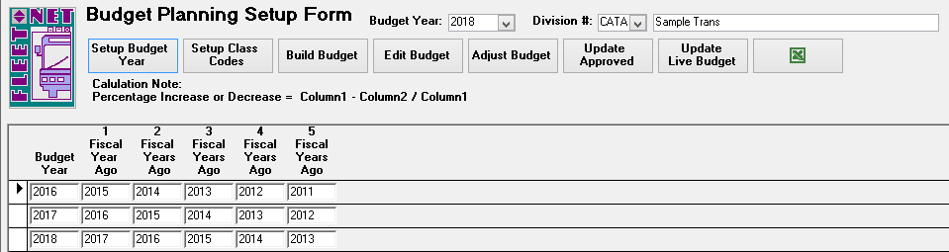

|  |  |
| --- | --- |
| **Field** | **Description** |
| Budget Year | Enter new budget year. |
| 1 Fiscal Year Ago | Auto-populates based on the year entered in Budget Year field. |
| 2 Fiscal Year Ago | Auto-populates based on the year entered in Budget Year field. |
| 3 Fiscal Year Ago | Auto-populates based on the year entered in Budget Year field. |
| 4 Fiscal Year Ago | Auto-populates based on the year entered in Budget Year field. |
| 5 Fiscal Year Ago | Auto-populates based on the year entered in Budget Year field. |

#### Setup Class Codes

Click ***Setup Class Code***. This feature is optional. Setting up Class Codes allowing for grouping or categorization of the various accounts for generating reports. These codes can be used to adjust budget amounts via the Adjust Budget option. ***Example:*** If all income referencing, Fares are given the “Fares” class code, and a determination is made to increase all fares by 5%. The Adjust Budget utilizing class codes can accomplish this task automatically.

Once the Build Budget button is selected the form will then assign the class code. This button serves as a template for the class codes. Once the Build Budget option hdas been executed the class codes can be revised via the Edit Budget option, however it will not write back to the Setup Class Codes option here.

Class Code can be alpha/numeric, and up to a maximum of 5 characters.

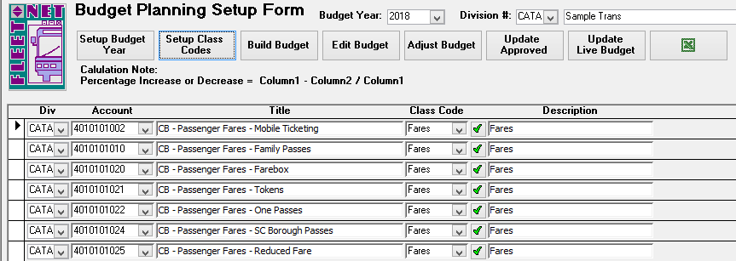

|  |  |
| --- | --- |
| **Field** | **Description** |
| Div | Enter or select Div (divisions) from the drop-down option. |
| Account | Enter or select Account (GL Account #) from the drop-down options. |
| Title | Auto populates description for the GL Account number # selected. |
| Class Code | Enter or select Class Code from the drop-down option. Click ***Green Check mark*** to enter a new Class Code. |
| Description | Auto populates the description for the selected Class Code. |

To create new class codes, Click ***Green Check Mark***. The following form displays.

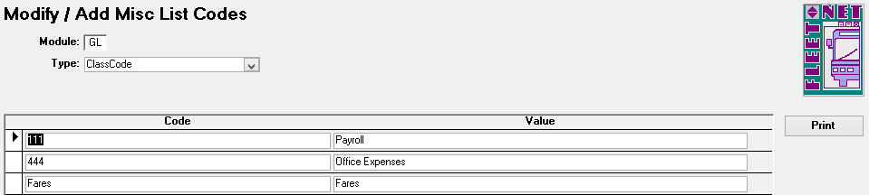

|  |  |  |  |
| --- | --- | --- | --- |
| **Field Name** | **Max Field Size** | **Field Type** | **Description** |
| Code | 5 | Alpha/Numeric | Enter a user defined class code. |
| Value | 30 | Alpha/Numeric | Enter a user defined class code definition. |

#### Build Budget

Click ***Build Budget*** to build the budget for the selected fiscal year and division.

If the Build Budget process has already been executed for the selected year and division .The following message displays.

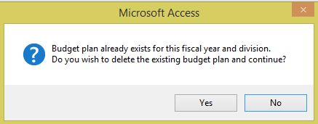

Click ***No*** will clear the message and not execute the routine.

**Cautionary Note**: Click ***Yes*** will delete the records for the selected year and division specified. If budget amounts have been entered via this form this data will be **DELETED** and it will need to be re-entered. This option may be necessary to execute in the initial stages when no budget information has been entered and it has been determined that new account numbers have been created. The build in this case will need to be executed again in order to bring in the new accounts.

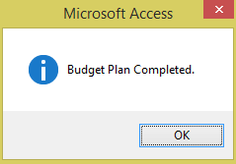

Click ***Ok.***

Once built, the budget can then be accessed and modified via the Edit Budget Button.

#### Edit Budget

Click ***Edit Budget*;** the following form displays. The Account #, Title and Class Codes displays to the left followed by each fiscal year that was specified via the Setup Budget Year button. In this example fiscal year 2018 has been selected and the five previous years display. By utilizing the horizontal scroll bar at the bottom of the form to view previous year documentation. The years will display in alternating colors.

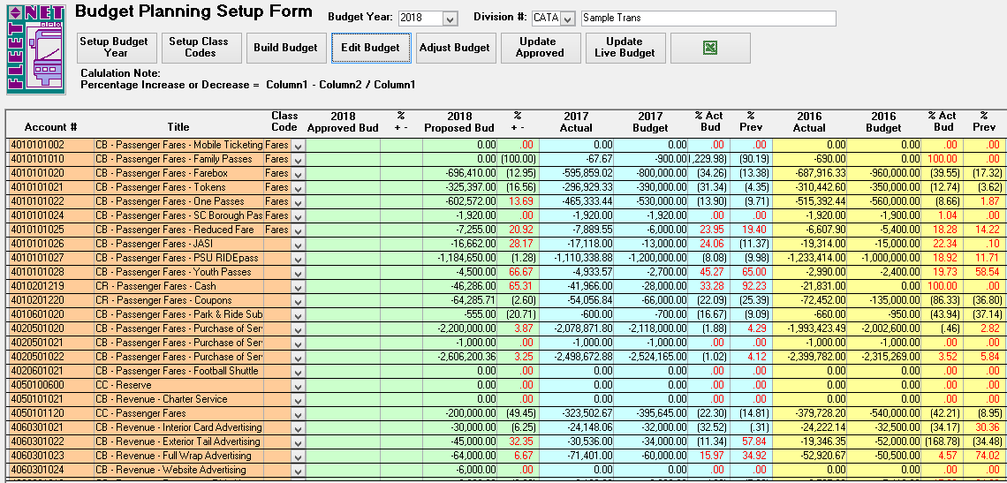

Modification to any of the past years fields (Actual, Budget, % Act/Bud, % Prev) is not allowed. Modification and data entry can only be made to the active Budget Year. Once amounts are entered into the Actual and Budget fields the system automatically calculates the % Act/Bud and % Prev field amounts.

|  |  |
| --- | --- |
| **Field** | **Description** |
| YYYY Actual | Displays account balance for the respective year. |
| YYYY Budget | Displays account’s yearly budget amount entered in Modify Monthly Budget form. Fields will appear blank for those years with no budget established. |
| % Act / Bud | Automatically displays the percentage difference between the YYYY Actual versus YYYY Budget fields. |
| % Prev | Automatically displays the percentage difference between the YYYY Actual versus the YYYY Actual from the previous year. |
| Totals | Click ***Totals*** to have the system display the column totals for each respective column.  Click ***Totals*** again to refresh totals when amounts have been revised to reflect the change. |

Double Click ***Proposed Bud*** line item a drill-down feature is available for each field which can be used as a worksheet to calculate detailed expenses for the specific account. Once the sub form is closed the system will total the detail records and enter the grand total into the YYYY Proposed Bud field.

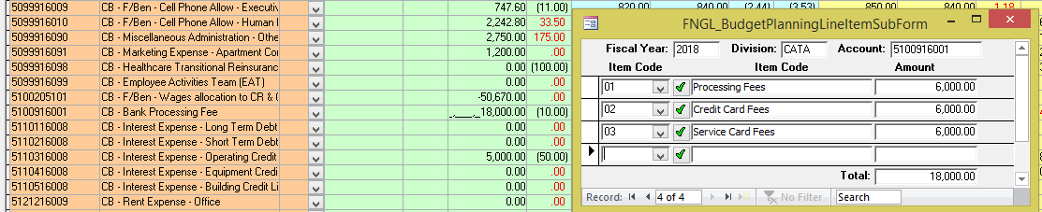

|  |  |  |  |
| --- | --- | --- | --- |
| **Field Name** | **Max Field Size** | **Field Type** | **Description** |
| Item Code |  |  | Select the applicable from the drop-down list |
| Item Description |  |  | Auto populates based on the Item code selected |
| Amount |  | Currency | Enter the amount for the selected code |

Closing the sub form by clicking the ‘X” in corner causes the total to update on the main budget form.

To create new Item Codes. Click ***Green Check Mark***. The following form displays.

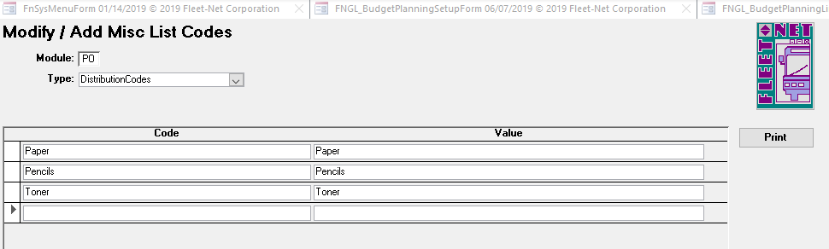

Double Click ***Actual*** line item a drill-down feature is available for each field which can be used to review the transaction for that selected year’s populating individual transaction that reflects the total amount.

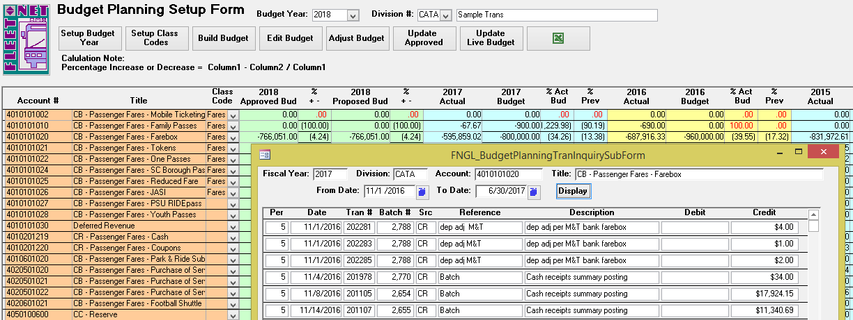

#### Adjust Budget

Click ***Adjust Budget*** to globally revise account numbers by range or within a range by class code assigned. The amounts can be increased or decreased by whatever percentage amount is specified.

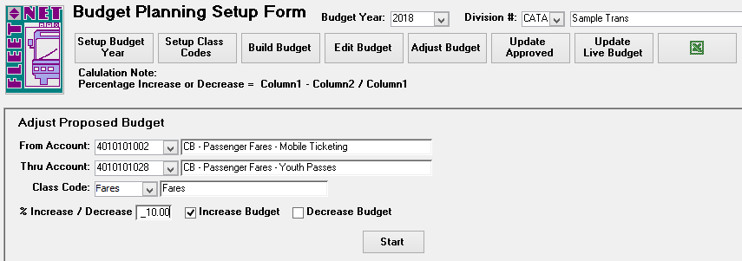

Note: An account range must always be entered the class code cannot be used alone.

|  |  |
| --- | --- |
| **Field** | **Description** |
| From Account | Enter or select GL Account # from the drop-down options, to determine a range of accounts to be globally revised. |
| Thru Account | Enter or select GL Account # from the drop-down options, to determine a range of accounts to be globally revised. |
| Class Code | Enter a class code to update only those accounts within the range that have been assigned that specific class code. This field can be left blank. |
| % Increase / Decrease | Enter the percentage amount that the accounts are to be increased or decreased by. Entering 10.00 reflects 10 percent. |
| Increase Budget | Check the box in order to increase the Proposed Bud amounts by the percentage specified. |
| Decrease Budget | Check the box in order to decrease the Proposed Bud amounts by the percentage specified. |

Click ***Start*** button to begin to global update procedure. The following confirmation message displays.

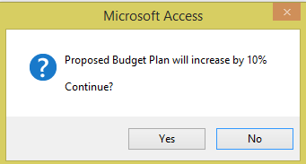

Click ***Yes*** to execute the global update procedure or ***No*** to return to the Budget Planning Setup Form.

If ***Yes*** was selected the following completion message displays.

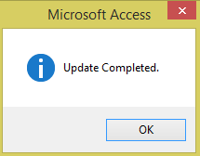

Click ***OK***.

#### Update Approved

Click ***Update Approved*** to transfer the amounts entered in the Proposed Bud to Approved Bud column.

The recommendation is to make this transfer once the board or final deciding parties have finalized the budget.

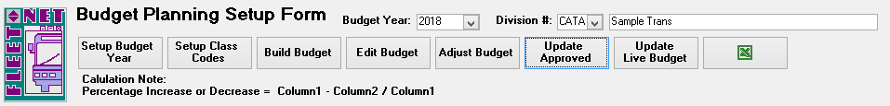

The following form displays.

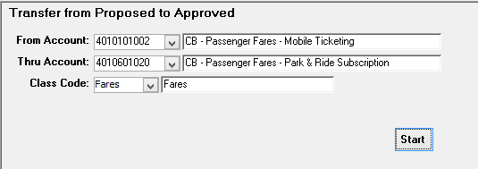

|  |  |
| --- | --- |
| **Field** | **Description** |
| From Account | Enter or select GL Account # from the drop down options, to determine a range of accounts to be globally copied from Proposed Bud to Approved Bud. |
| Thru Account | Enter or select GL Account # from the drop down options, to determine a range of accounts to be globally copied from Proposed Bud to Approved Bud. |
| Class Code | Enter class code to copy only those accounts within the range that have been assigned the specific class code entered. This field can be left blank. |

#### Start

Click ***Start*** to begin to global update procedure. The following confirmation message displays.

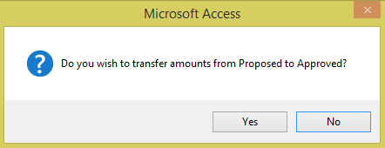

Click ***Yes*** to execute the global update procedure or ***No*** to return to Budget Planning Setup Form. If ***Yes*** was selected the following completion message displays.

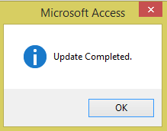

Click ***OK***.

Once completed budget figures will be transferred to the Approved Bud Column.

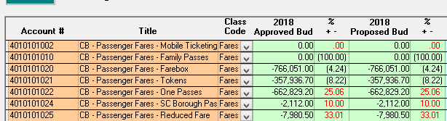

#### Update Live Budget

Click ***Update Live Budget*** to transfer the Approved Budget to Live Budget once Live Budget option is selected the system populates the budget information into General Ledger. This is the final process from Budget Planning Setup Form.

The following confirmation message displays.

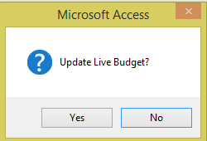

Click ***Yes*** to execute the Live Budget update or ***No*** to return to the Budget Planning Setup Form.

**Cautionary Note**: Any budget amounts that exist within the live budget as seen via the Modify Monthly Budget options will be overwritten with the amounts found within the Budget Planning Setup form. This includes any accounts within the Budget Planning Setup form that have a zero they will overwrite the current Live Budget amounts as seen via the Modify Monthly Budget form.

If Yes is selected and update is completed the following confirmation message displays.

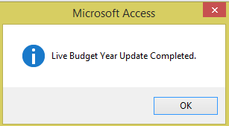

Click ***OK.***

Import/Export

Click ***Excel Icon*** to export budget to Excel. Once selected the following prompt displays indicating that the entire year can be selected which will include all divisions, enter the fiscal year only or specify the year and one division.

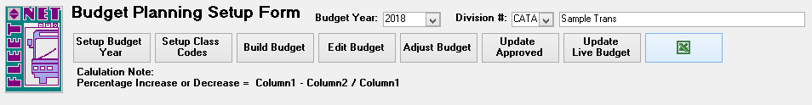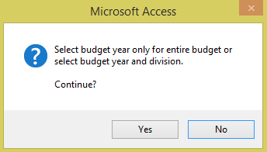

Click ***Yes*** to execute the export based on the selection made for Year and Division or ***No*** to return to the Budget Planning Setup Form.

The following form displays:

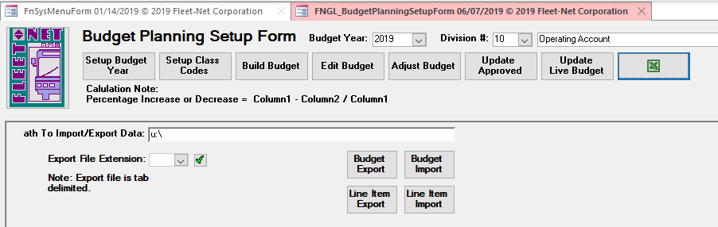

Enter the path to the Windows O Drive where the exported Excel file will be saved.

Add the file types available for export by clicking on the green checkmark. The following form displays: (txt and xls are the only available codes)

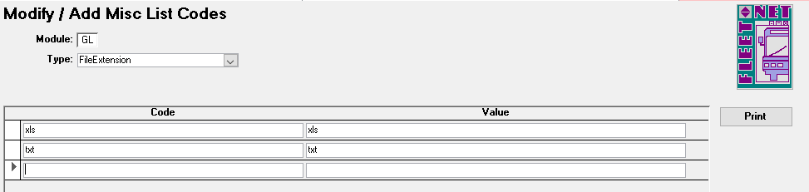

#### Exports

Click ***Budget Export*** to export the data to Excel or click ***Line Item Export*** to export the Item Codes (Distribution Codes) assigned to the budget Line Items.

To proceed with export, Click ***Yes*** to continue or ***No*** to return to the Budget Planning Setup Form.

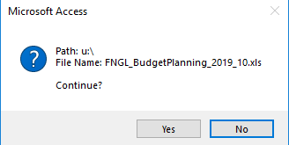

#### Imports

Click ***Excel Icon*** to import budget from Excel. Once selected the following prompt displays indicating that the entire year can be selected which will include all divisions enter the fiscal year only or specify the year

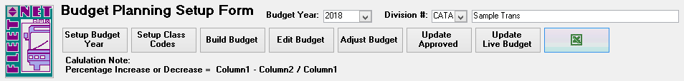

and one division.

The following form displays.

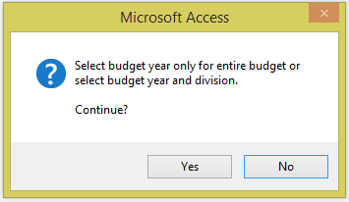

Click ***Budget Import*** to import the data from a Text File or click ***Line Item Import*** to import the Item Codes (Distribution Codes) assigned to the budget Line Items.

Click ***Import*** to import selected budget that was modified/calculated in Excel to the Proposed Budget in Avail. It is mandatory that the export option be executed first with a blank budget in order to obtain the correct column descriptions, formatting and naming convention required to import back into the selected budget. Remove any formulas entered in the exported spreadsheet and save as a .txt file prior to importing the data into Budget Planning.

**Cautionary Note**: Do not import a specific division or the entire budget into Avail if the Proposed Budget has already been completed in Budget Projection. Importing will overwrite the data in those fields with the data contained in the Excel file even if Excel account amounts are zero. **Note:** *Only the amounts within the Proposed Budget Amt are actually imported.*

Once budget is imported if not in balance and equal to zero the system will advise that the

Budget is out of balance. A budget that reflects a profit/loss will generate an out of balance message.

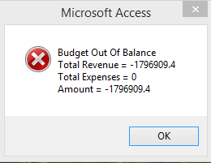

Click ***OK.***

### Budget Transaction Entry

Navigate to ***Budget Transaction Entry*** to enter or edit budget amounts. Utilizing this option will enable users to determine when and why a budget amount was changed.

#### Enter

Click ***Enter*** to add or modify existing budget line items, dollar amounts and reason for the adjustment.

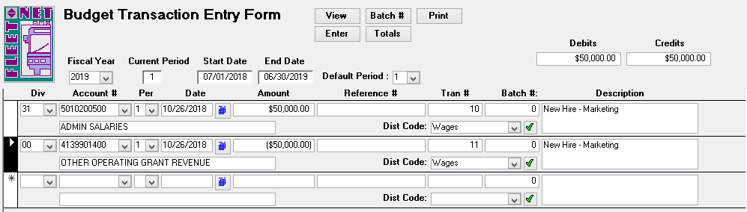

|  |  |  |  |
| --- | --- | --- | --- |
| **Field Name** | **Max Field Size** | **Field Type** | **Description** |
| Fiscal Year | 4 | Number | Enter or select the fiscal year from the drop down list. |
| Current Period |  | Number | Defaults to the current period for the fiscal year selected. |
| Start Date |  | Date/Time | Defaults to the starting date of the fiscal year selected. |
| End Date |  | Date/Time | Defaults to the ending date of the fiscal year selected. |
| Default Period |  | Number | Defaults to the current period for the fiscal year selected. ***The edits will be added to or subtracted from the period selected in this field.*** |
| Division | 4 | Number | Enter or select division from the drop down options. |
| Account # | 10 | Number | Enter or select the applicable account for the budget account being edited. |
| Per | 2 | Number | Defaults to the current period. The period selected in this field must match the period selected at the top of the form in the Default Period field. |
| Date |  | Date/Time | Enter the edit date. This date will not affect which period the adjustment is being posted to; it is for tracking the day the change was made. |
| Amount |  | Currency | If the budget amount is an expense and it is being increased, enter the amount of the increase as a debit. If it is being decreased, enter the amount of the decrease as a credit. If the budget amount is revenue and it is being increased, enter the amount of the increase  as a credit. If it is being decreased, enter the amount of the decrease as a debit. |
| Reference # | 20 | Alpha/Numeric | Enter a user defined reference. This is an optional field. |
| Tran # |  |  | The system auto-generates the Tran number. |
| Description | 255 | Alpha/Numeric | Enter a user defined description. |
| Batch # |  |  | The system auto-generates the Batch number (see Batch # below). |
| Dist Code | 20 | Alpha/Numeric | Select a predefined distribution code from the drop down list. This is an optional field. |

#### Totals

Click ***Totals*** to populate the totals for all Debits & Credits entered in Transaction Entry.



#### Batch #

Click ***Batch #*** to assign batch numbers to transactions entered. The following prompt displays if batch is out of balance.

Click OK.

Return to ***Enter*** screen. Make correction and Click ***Batch #*** again.

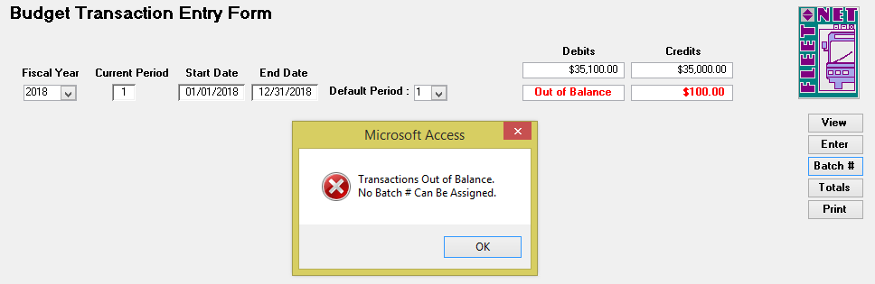

The following confirmation message displays.

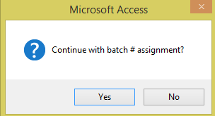

Click ***Yes*** to assign batch #’s or ***No*** to return to the Budget Transaction Entry Form. Items must be batched prior to being updated.

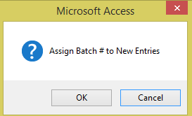

Click ***OK*** to continue or ***Cancel*** to return to Budget Transaction Entry Form. Once batch #’s are assigned the following message displays.

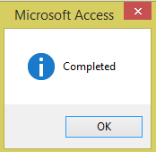

Click ***OK.***

#### View

Click ***View*** to populate all entries for the selected options. Both batched and unbatched entries will be available to view. Entries cannot be changed on this form.

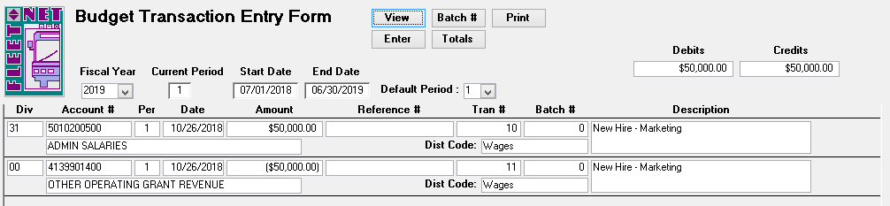

#### Print

Click ***Print*** to view/print audit reports and to update entries. Only batched entries will be included on the report. Two reports will be generated. The first report Budget Update Batch Listing. Click ***Close Print Preview*** to generate the second report.

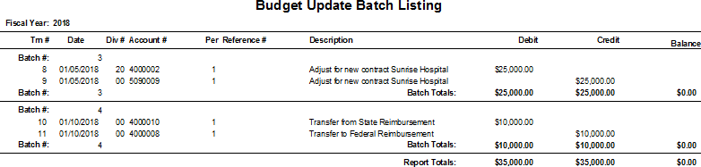

The following message displays when print preview is printed and closed.

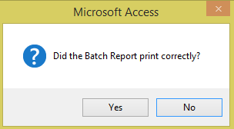

Click ***Yes*** to generate the second report or ***No*** to return to Budget Transaction Entry Form. If ***Yes*** is selected the Budget Update Report will populate to view/print.

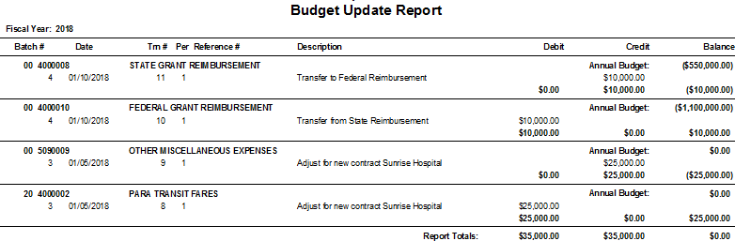

Click ***Close Print Preview*** the following message displays.

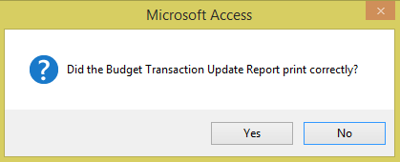

Click ***Yes*** to proceed to the update confirmation message or ***No*** to return to Budget Transaction Entry Form.

If ***Yes*** is selected the following confirmation message displays.

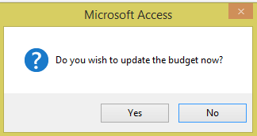

Click ***Yes*** to update the budget or ***No*** to return to Budget Transaction Entry Form.

### Budget Transaction Audit

Navigate to ***Budget Transaction Audit*** to view/print all edits made to a selected account.

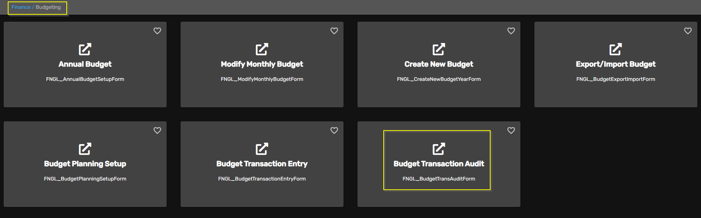

Enter Fiscal Year, General Division and General Ledger Account being reviewed. Click ***Display.***

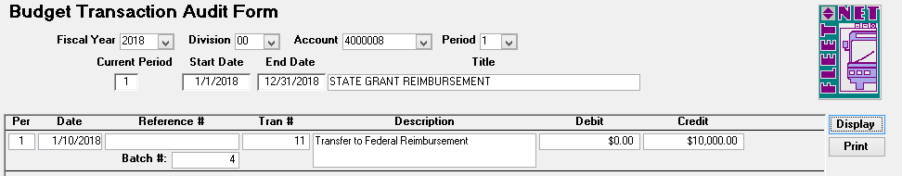

#### Print

Click ***Print*** to generate a report for the selected account.

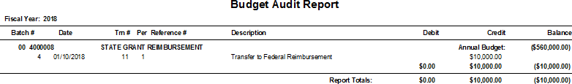

# Journal Entries Menu

### Journal Entry

Navigate to ***Journal Entry*** to enter, modify manual journal entries, or view entries created from other Avail modules. The entries will remain in the subsidiary journals until the Journal Update is completed.

*Note: Journal entries made to Bank Account’s General Ledger #’s will not impact Banking Maintenance, Bank Reconciliation and would create a General Ledger out of balance error. (See Checkbook Adjustments for details when making journal entries that will impact the bank accounts).*

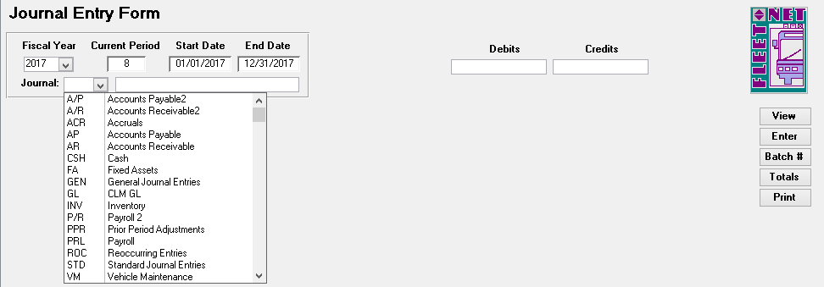

|  |  |  |
| --- | --- | --- |
| **Field Name** | **Field Type** | **Description** |
| Fiscal Year | Number | Enter or select fiscal year from the drop down options. |
| Current Period | Number | Automatically populates based on the fiscal year selected. |
| Start Date | Date/Time | Automatically populates based on the fiscal year selected. |
| End Date | Date/Time | Automatically populates based on the fiscal year selected. |
| Journal | Alpha/Numeric | Enter or select applicable subsidiary journal from the drop down options. |

***Posting to Period 13 is available. The date used for the entries must be within the fiscal year being posted to. See the Journal Update section of this manual for further instructions.***

#### Enter

Click ***Enter*** to enter a new journal entry to the selected subsidiary journal.

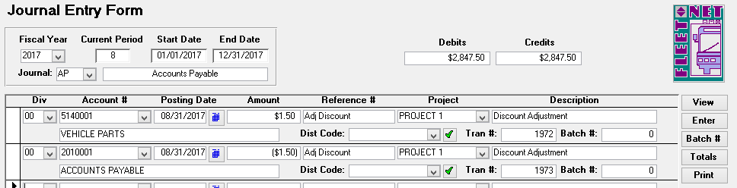

|  |  |  |  |
| --- | --- | --- | --- |
| **Field Name** | **Max Field Size** | **Field Type** | **Description** |
| Division | 4 | Alpha/Numeric | Enter or select division from the drop down options. |
| Account # | 10 | Alpha/Numeric | Enter or select account number from the drop down options. |
| Posting Date |  | Date/Time | Enter posting date or select date using calendar. |
| Amount |  | Currency | Enter dollar amount applicable to transaction being posted; both the debit and credit entries must be entered. Credits entered as a negative amount. Debits entered as a positive amount. |
| Reference # | 20 | Alpha/Numeric | Enter a reference # description (check #, deposit date, invoice number, etc.) for this entry. |
| Project | 20 | Alpha/Numeric | Enter or select a project associated with the entry from drop down options, if applicable. |
| Description | 50 | Alpha/Numeric | Enter a description for this entry. The description will print on financial reports. |
| Tran # |  | Number | Automatically populates with a sequential transaction number. |
| Batch # |  | Number | The batch number will be assigned when manual entries are batched. (See Batch # below) |

#### Batch #

Click ***Batch #*** once all debits and credits are entered for the selected subsidiary journal.

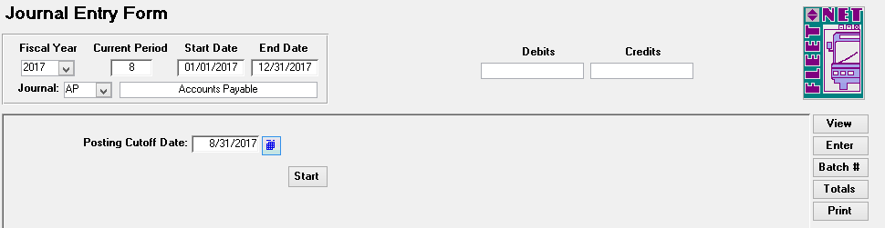

*Posting Cutoff Date:* Enter the last date for batch assignment. For example, if there are entries posted for October and November and only the October entries are to be batched and updated, enter 10/31/xxxx.

Batch numbers will be assigned to all entries with a date less than or equal to 10/31/xxxx. Any entries with dates greater than the date entered will not be assigned batch numbers.

#### Start

Enter Posting Cutoff Date. *Note: Once batch numbers are assigned, no changes are allowed.*

Click ***Start.*** The following confirmation message displays.

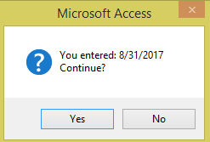

Click ***Yes*** to assign Batch #’s or ***No*** to return to Journal Entry Form. If ***Yes*** is selected the following confirmation message displays.

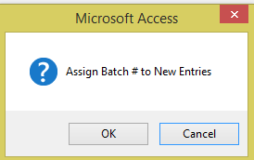

Click ***OK*** to assign batch #’s or ***Cancel*** to return to Journal Entry Form.

If ***OK*** is selected and the batch # are assigned the following confirmation message displays.

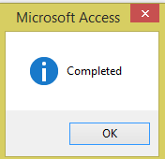

Click ***OK***.

If the entries are out of balance the following message displays after entering the cutoff date & clicking

***Start.***

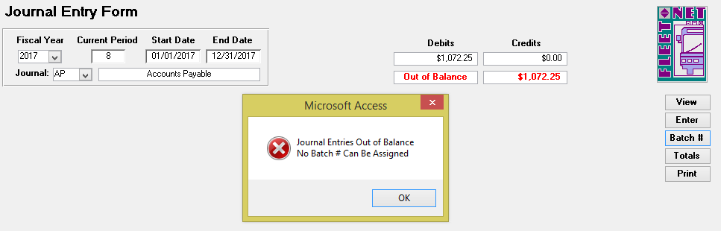

Click ***OK*** to close the message. Process back to Enter and make corrections, then proceed to assign batch numbers again. (Following instruction on previous pages.)

#### View

Click ***View*** to view the batched entries. The following forms displays.

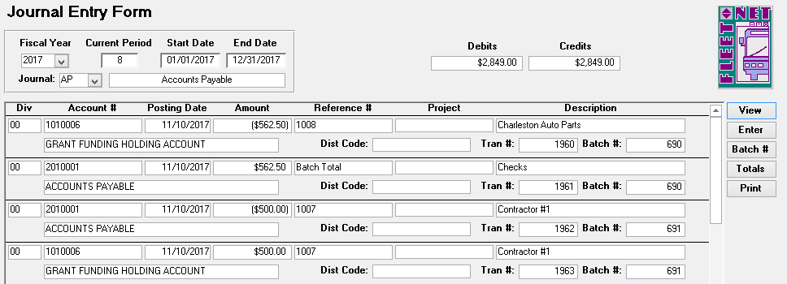

***Note: Once batch number is assigned, no changes are permitted on the batched entries. If corrections are necessary, the entry will need to be reversed and re-entered.***

#### Print

Click ***Print*** to print a report for audit purposes; the following form displays.

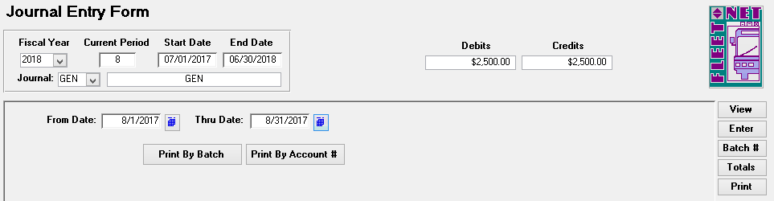

Enter the starting and ending date for the report and Click ***Print by Batch* or *Print by Account #.***

The following confirmation message displays.

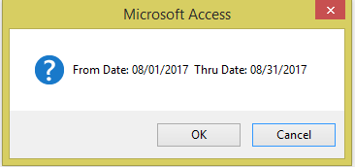

Click ***OK*** to generate the selected report or ***Cancel*** to return to the Journal Entry Form.

Use the File/Print option to print the report. The entries for the selected subsidiary journal will print grouped either by Batch number or Account number based on the Print option selected.

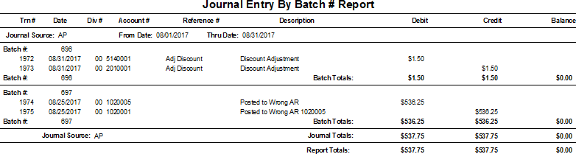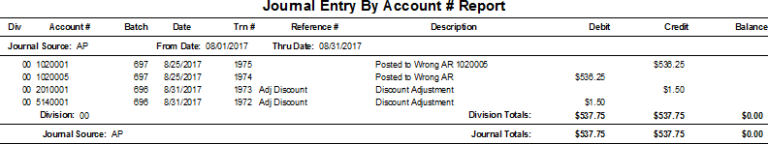

### One Sided Journal Entries

If previously batched entries are out of balance a one-sided journal entry can be made to correct the out of balance. To correct the Out of Balance, click ***Enter***; the Out of Balance message displays, Click ***OK***. The following form displays.

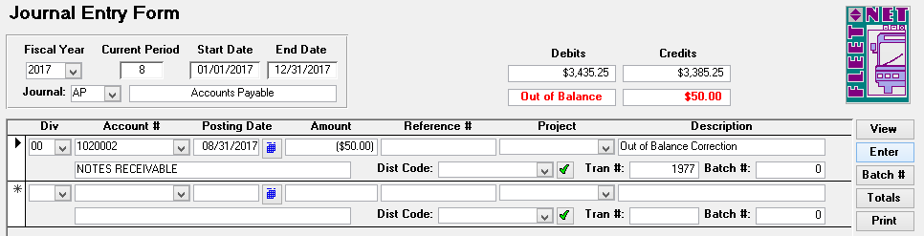

|  |  |  |  |
| --- | --- | --- | --- |
| **Field Name** | **Max Field Size** | **Field Type** | **Description** |
| Division | 4 | Alpha/Numeric | Enter or select division from the drop down options. |
| Account # | 10 | Alpha/Numeric | Enter or select account number from the drop down options. |
| Posting Date |  | Date/Time | Enter the posting date or select the date using the calendar. **The posting date must be in the same Period as the original entry.** |
| Amount |  | Currency | Enter dollar amount applicable to the transaction being posted. Credits are entered as a negative figure. Debits as a positive figure. |
| Reference # | 20 | Alpha/Numeric | Enter an applicable reference description (check #, deposit date, invoice number, etc.) for this entry. |
| Project | 20 | Alpha/Numeric | Select a project associated with this entry from the drop down list if applicable. |
| Description | 50 | Alpha/Numeric | Enter a description for this entry. The description will print on financial reports. |
| Tran # |  | Number | Automatically populates with a sequential transaction number. |
| Batch # |  | Number | The batch number **MUST** be the same number as the batch that is out of balance. |

Once correction have been completed. Repeat the process for Batch # button. Click ***Batch #***

Enter Posting Cutoff Date:

Click ***Start***

#### Totals

Click ***Totals*** to display debits and credits for all subsidiary journals not yet updated to the General Ledger.

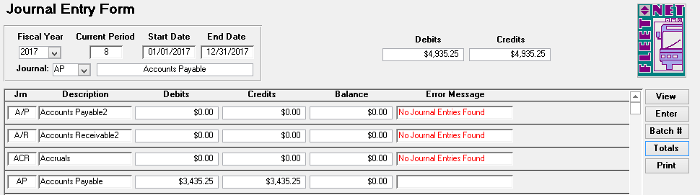

### Re-occurring Journal Entry

Navigate to ***Re-occurring Journal Entry*** to post monthly accrual, reversal entries, and reoccurring journal entries. This form is useful for monthly payroll accruals, depreciation and amortization entries.

The following form displays.

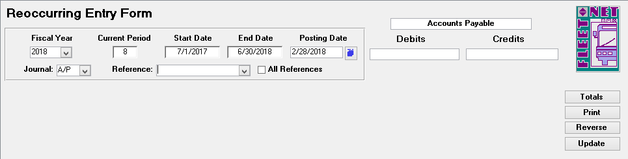

|  |  |  |  |
| --- | --- | --- | --- |
| **Field Name** | **Max Field Size** | **Field Type** | **Description** |
| Fiscal Year |  | Number | Enter or select fiscal year from the drop down options. |
| Current Period |  | Number | Automatically populates based on the fiscal year selected. |
| Start Date |  | Date/Time | Automatically populates based on the fiscal year selected. |
| End Date |  | Date/Time | Automatically populates based on the fiscal year selected. |
| Posting Date |  | Date/Tim | Enter general ledger posting date or select date from the calendar. |

|  |  |  |  |
| --- | --- | --- | --- |
| **Field Name** | **Max Field Size** | **Field Type** | **Description** |
| Debits |  | Currency | Automatically populates based on reference or references selected. |
| Credits |  | Currency | Automatically populates based on reference or references selected. |
| Journal |  | Alpha/Numeric | Select subsidiary journal where entries from selected reference or references will be posted. |
| Reference | 20 | Alpha/Numeric | Select existing reference from the drop down options to view the entries that were previously entered for the reference or create a  new reference by entering the new reference number. (See below for further details for a new reference.) |
| All References |  | Yes/No | Check box to update all references with the posting date entered to the subsidiary journal selected. |

To make changes to an existing reference, select the reference from the drop down list. Edit entries as applicable.

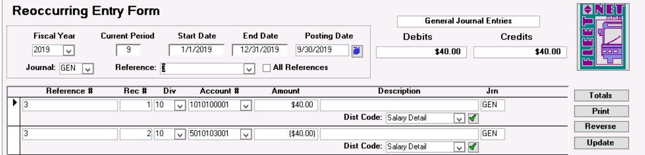

To enter a new reference the following form displays.

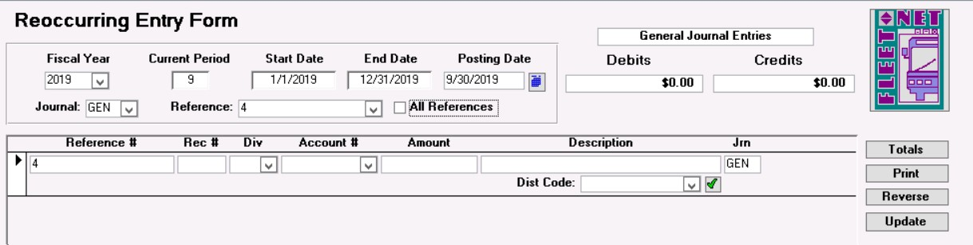

|  |  |  |  |
| --- | --- | --- | --- |
| **Field Name** | **Max Field Size** | **Field Type** | **Description** |
| Reference # | 20 | Alpha/Numeric | Automatically populates based on the reference selected. |
| Rec # |  | Number | Enter a record number. Each record must have a unique number. |
| Division | 3 | Alpha/Numeric | Enter or select division from the drop down list. |
| Account # | 10 | Alpha/Numeric | Enter or select account number from the drop down list. |
| Amount |  | Currency | Enter dollar amount applicable to the transaction being posted. Both the debit and credit entries must be entered. Credits are entered as a negative amount. Debits entered as a positive amount. |
| Description | 20 | Alpha/Numeric | Check box to update all references with the posting date entered to the subsidiary journal selected. |
| Jrn | 3 | Alpha/Numeric | Automatically populates based on the subsidiary journal selected at the top of the form. |
| Dist Code | 20 | Alpha/Numeric | Enter or select distribution code from drop down list. This is optional |

Totals

Click ***Totals***. The debit and credit fields will calculate and populate. The following form will display.

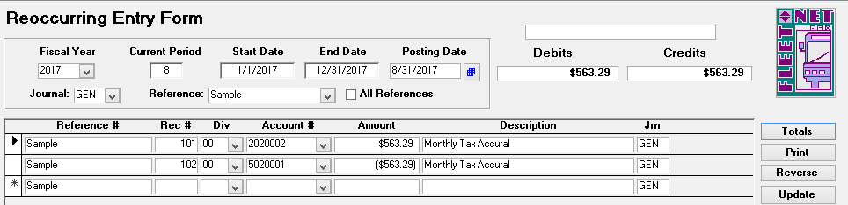

#### Print

Click ***Print*** to generate the following reoccurring entry report.

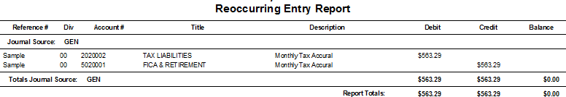

#### Update

Click ***Update*** to update the selected references to the applicable subsidiary journals. The following confirmation message displays.

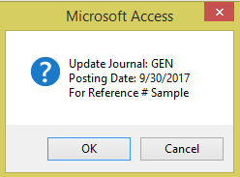

Click ***OK*** to update Re-occurring entries to the General Ledger or ***Cancel*** to return to the Reoccurring Entry Form. If ***OK*** is selected, an update confirmation message displays.

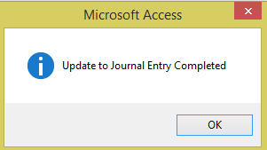

#### Reverse

Click ***Reverse*** to reverse reoccurring entries for the selected references. Debit entries will reverse to credits and credit entries will reverse to debits. This function simplifies reversing accrual entries posted in a previous month. **It’s important to verify the Posting Date selected.** The following prompt displays.

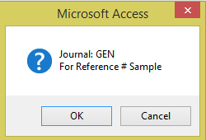

Click ***OK*** to reverse the Re-occurring entries or ***Cancel*** to return to the Reoccurring Entry Form. If ***Yes*** is selected the following message displays once all selected entries have been reversed.

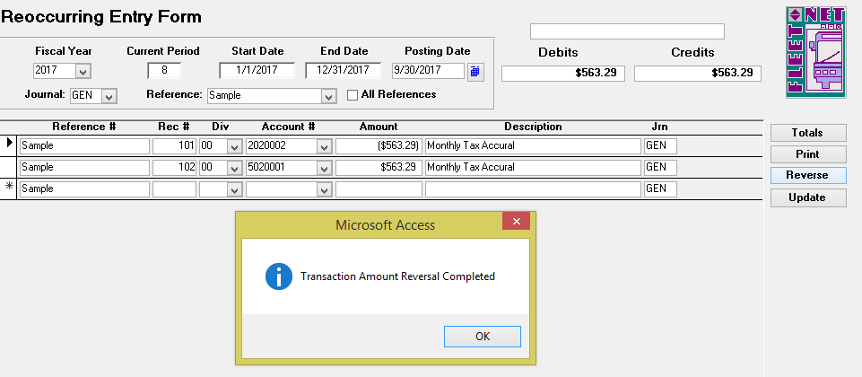

Click ***OK***.

#### Update

Click ***Update*** to update the reversing entries to the applicable subsidiary journals. The following message displays.

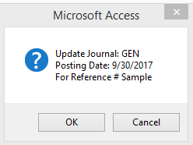

Click ***OK*** to update the reversing entries or ***Cancel*** to return to Reoccurring Entry Form. If ***OK*** is selected, an update confirmation message displays.

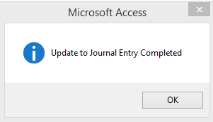

Click ***OK***.

### Re-distribution Entry

Prior to doing redistribution the General Ledger update for the Journals impacted by the process will need to be performed.

Navigate to ***DIstribution Entry*** to redistribute balance(s) from one or more accounts (source accounts) into alternate accounts (destination accounts) based on a percentage computed according to the sum of other specified accounts (percentage base accounts).

***Note:*** Redistribution Reference Setup must be completed prior to generating entries & all journals impacted by the re-distribution must be updated to the General Ledger. See the General Ledger setup section of this manual for details.

#### Percentage Based on Actual Expenses

***Example #1*** *The monthly health insurance expense of $208,600.00 (source account) is incurred. The expense is charged to overhead for Finance, Human Resources and Marketing departments (destination accounts) based on the percentage of actual wage expense (percentage base) each department incurs*.

*NOTE: This program updates only current period figures; it is meant to be used on a monthly basis.*

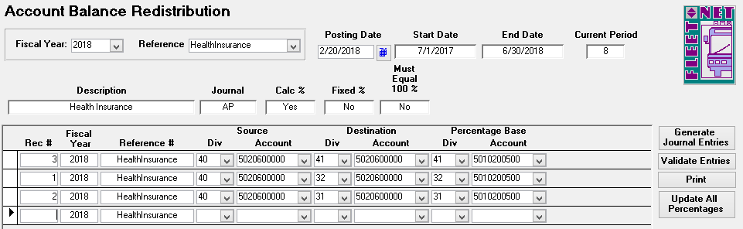

|  |  |  |  |
| --- | --- | --- | --- |
| **Field Name** | **Max Field Size** | **Field Type** | **Description** |
| Fiscal Year |  | Number | Enter or select the fiscal year from the drop down options. |
| Reference # | 20 | Alpha/Numeric | Enter or select reference previously setup in Re-distribution Setup. |
| Posting Date |  | Date/Time | Enter general ledger posting date or select it from calendar. |
| Start Date |  | Date/Time | Automatically populates based on fiscal year selected. |
| End Date |  | Date/Time | Automatically populates based on fiscal year selected. |
| Current Period |  | Number | Automatically populates based on fiscal year selected. |
| Description | 50 | Alpha/Numeric | Automatically populates based on reference selected. |
| Journal | 3 | Alpha/Numeric | Automatically populates based on reference selected. |
| Calc % |  | Yes/No | Automatically populates based on reference selected. |
| Fixed % |  | Yes/No | Automatically populates based on reference selected. |
| Must Equal 100% |  | Yes/No | Automatically populates based on reference selected. |
| Fiscal Year |  | Number | Automatically populates based on fiscal year selected at the top of the form. |
| Div [Source] | 3 | Alpha/Numeric | Enter or select source division from drop down options. |
| Account # [Source] | 10 | Alpha/Numeric | Enter or select source GL account number from drop down options. |
| Div [Destination] | 3 | Alpha/Numeric | Enter or select destination division from drop down options. |
| Account # [Destination] | 10 | Alpha/Numeric | Enter or select destination GL account # from drop down options. |
| Div [Percentage Base] | 3 | Alpha/Numeric | Enter or select base division for the percentage basis calculation from the drop down options. |
| Account # [Percentage Base] | 10 | Alpha/Numeric | Enter or select GL account for the percentage basis calculation from the drop down options. |

#### Validate Entries

Click ***Validate Entries*** to validate entries for selected reference. The following message displays.

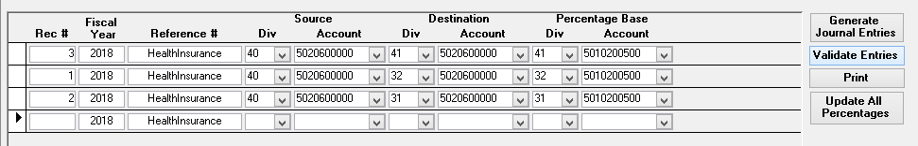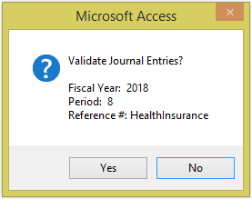

Click ***Yes*** to validate posting entries or ***No*** to return to the Account Balance Redistribution form.

If ‘Must Equal 100%’ was selected in redistribution setup and entries do not total 100%. The following message displays.

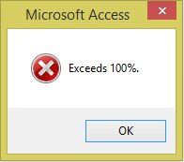

Click ***OK***; make appropriate correction and Validate Entries again. If no errors are detected the following message displays.

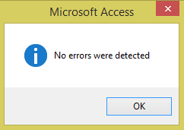

Click ***OK***, proceed to Generate Journal Entries.

#### Generate Journal Entries

Click ***Generate Journal Entries*** to create the re-distribution entries that will be updated to the General Ledger.

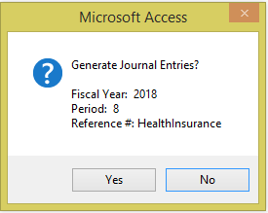

Click ***Yes*** to generate journal entries or ***No*** to return to the Account Balance Redistribution form. If re-distribution journal entries have not been validated the following message displays.

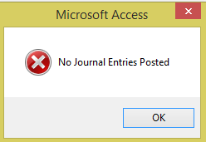

Click ***OK***. Validate the entries and re-execute ***Generate Journal Entries.***

Once Journal Entries are updated without issues the following message displays.

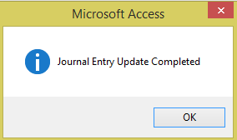

Click OK. The updated entries are now in the applicable subsidiary journals.

Once the system has updated the Journal Entries the General Ledger Update process will need to be performed for the redistribution process to be completed. Proceed to the Print option for updating journal entries.

#### Print

Click ***Print*** view or print the Redistribution Reference Report & update Journal Entries. The following message displays.

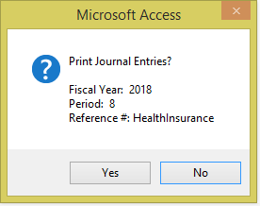

Click ***Yes*** to print reports and update Journal Entries or ***No*** to return to Account Balance Redistribution.

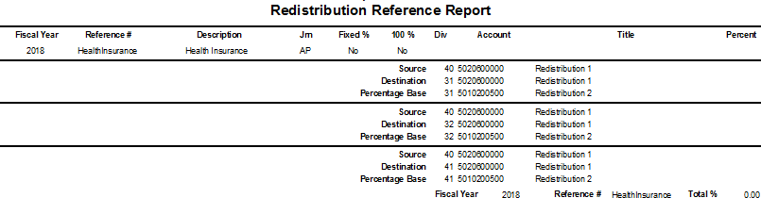

Example of redistribution calculation based on a calculated percentage:

|  |  |  |  |  |  |  |  |
| --- | --- | --- | --- | --- | --- | --- | --- |
| **Redistribution Setup** | | | | | | | |
| **Source** | |  | **Destination** | |  | **Percentage Base** | |
| *Division* | *Account* |  | *Division* | *Account* |  | *Division* | *Account* |
| 40 | 5020600000 |  | 41 | 5020600000 |  | 41 | 5010200500 |
| 40 | 5020600000 |  | 32 | 5020600000 |  | 32 | 5010200500 |
| 40 | 5020600000 |  | 31 | 5020600000 |  | 31 | 5010200500 |
|  |  |  |  |  |  |  |  |

|  |  |  |  |  |  |
| --- | --- | --- | --- | --- | --- |
| **Postings for Period X** | | | | | |
| **Source** | |  | **Percentage Base** | |  |
| *Division* | *Account* |  | *Division* | *Account* |  |
| 40 | 5020600000 | $5,000.00 | 41 | 5010200500 | $35,750.00 |
|  |  |  | 32 | 5010200500 | $47,850.00 |
|  |  |  | 31 | 5010200500 | $125,000.00 |
|  |  |  |  |  |  |
|  |  |  |  |  | $208,600.00 |

|  |  |  |  |  |  |  |  |  |  |
| --- | --- | --- | --- | --- | --- | --- | --- | --- | --- |
| **Redistribution Calculation** | | | | | | | | | |
| **Source** | |  | **Destination** | |  | **Percentage Base** | |  |  |
| *Division* | *Account* |  | *Division* | *Account* |  | *Division* | *Account* |  |  |
| 40 | 5020600000 | $5,000.00 | 41 | 5020600000 | $856.90 | 41 | 5010200500 | $35,750.00 | 17.14% |
|  |  |  | 32 | 5020600000 | $1,146.93 | 32 | 5010200500 | $47,850.00 | 22.94% |
|  |  |  | 31 | 5020600000 | $2,996.16 | 31 | 5010200500 | $125,000.00 | 59.92% |
|  |  |  |  |  |  |  |  |  |  |
|  |  |  |  |  | $5,000.00 |  |  | $208,600.00 | 100.00% |

*Example: The redistribution process will total all amounts in the specified Percentage Base accounts ($208,600.00) and calculate the percentage of each of the accounts ($35,750.00 / $208,600.00 = 17.14%;*

*$47,850.00 / $208,600.00 = 22.94%; $125,000.00 / $208,600.00 = 59.92%).*

*It then multiplies the calculated percentage by the amount in the Source account ($5,000.00 x 17.14% =*

*$856.90; $5,000.00 x 22.94% = $1,146.93; $5,000.00 x 59.92% = $2,996.16).*

Journal entries are created as follows:

Division 41 – Account 5020600000 - $856.90 debit Division 40 – Account 5020600000 -$856.90 credit

Division 32 – Account 5020600000 -$1,146.93 debit Division 40 – Account 5020600000 -$1,146.93 credit

Division 31 – Account 5020360000 - $2,996.16 debit Division 40 – Account 5020600000 - $2,996.16 credit

#### Fixed Percentage

If the distribution is based on a fixed percentage, the redistribution setup would be entered as shown below: Redistribution Setup for this option would be checkmarks in Fixed Percent and 100%.

To change percentage for a specific reference, Click percentage amount field and modify percentage amount save the record.

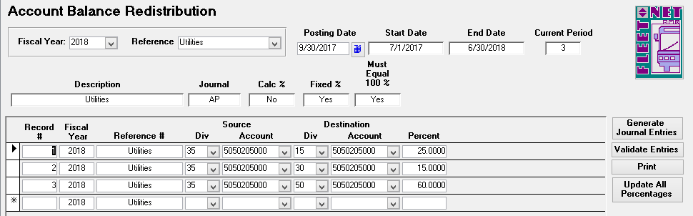

|  |  |  |  |
| --- | --- | --- | --- |
| **Field Name** | **Max Field Size** | **Field Type** | **Description** |
| Fiscal Year |  | Number | Enter or select fiscal year from drop down options |
| Reference # | 20 | Alpha/Numeric | Enter or select reference from drop down options. |
| Posting Date |  | Date/Time | Enter general ledger posting date or select it from calendar. |
| Start Date |  | Date/Time | Automatically populates based on fiscal year selected. |
| End Date |  | Date/Time | Automatically populates based on fiscal year selected. |
| Current Period |  | Number | Automatically populates based on fiscal year selected. |
| Description | 50 | Alpha/Numeric | Automatically populates based on reference selected. |
| Journal | 3 | Alpha/Numeric | Automatically populates based on reference selected. |
| Calc % |  | Yes/No | Automatically populates based on reference selected. |
| Fixed % |  | Yes/No | Automatically populates based on reference selected. |
| Must Equal 100% |  | Yes/No | Automatically populates based on reference selected. |
| Rec # |  | Number | Enter a record number. Each record must have a unique number. |
| Fiscal Year |  | Number | Automatically populates based on fiscal year selected at the top of the form. |
| Div [Source] | 3 | Alpha/Numeric | Enter or select source division from drop down options. |
| Account # [Source] | 10 | Alpha/Numeric | Enter or select source GL Account # from drop down options. |
| Div [Destination] | 3 | Alpha/Numeric | Enter or select destination division from the drop down options |
| Account # [Destination] | 10 | Alpha/Numeric | Enter or select destination GL Account # from the drop down options. |
| Percent |  | Number | Enter percentage for each destination GL Account #. |

Example of redistribution calculation based on fixed percentages:

|  |  |  |  |  |  |
| --- | --- | --- | --- | --- | --- |
| **Redistribution Setup** | | | | | |
| **Source** | |  | **Destination** | |  |
| *Division* | *Account* |  | *Division* | *Account* | *Percentage* |
| 35 | 5050205000 |  | 15 | 5050205000 | 25.00% |
| 35 | 5050205000 |  | 30 | 5050205000 | 15.00% |
| 35 | 5050205000 |  | 50 | 5050205000 | 60.00% |
|  |  |  |  |  | 100.00% |

|  |  |  |
| --- | --- | --- |
| **Postings for Period 9** | | |
| **Source** | |  |
| *Division* | *Account* |  |
| 35 | 5050205000 | $17,000.00 |
|  |  |  |

|  |  |  |  |  |  |
| --- | --- | --- | --- | --- | --- |
| **Redistribution Calculation** | | | | | |
| **Source** | |  | **Destination** | |  |
| *Division* | *Account* |  | *Division* | *Account* |  |
| 35 | 5050205000 | $17,000.00 | 15 | 5050205000 | $4,250.00 |
|  |  |  | 30 | 5050205000 | $2,550.00 |
|  |  |  | 50 | 5050205000 | $10,200.00 |
|  |  |  |  |  |  |
|  |  |  |  |  | $17,000.00 |

In the example shown above, the redistribution process will multiply the Source Amount ($17,000.00) by the percentages listed: ($17,000.00 x 25% = $4,250.00; $17,000.00 x 15% = $2,550.00; $17,000.00 x 60% =

$10,200.00).

Journal entries are created as follows:

Division 15 – Account 5050205000 - $4,250.00 debit Division 35 – Account 5050205000 - $4,250.00 credit

Division 30 – Account 5050205000 - $2,550.00 debit Division 35 – Account 5050205000 - $2,550.00 credit

Division 25 – Account 5050205000 - $10,200.00 debit Division 35 – Account 5050205000 - $10,200.00 credit

#### Update All Percentages

Click ***Update All Percentages***. The following form displays.

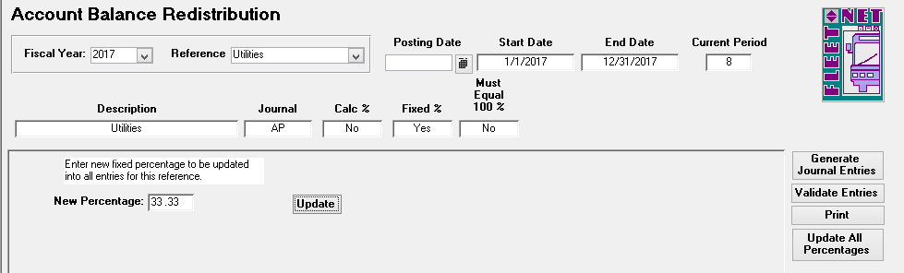

#### Update

Enter the new percentage. Click ***Update***. In the sample above ALL items for reference Utilities will be updated to 33.333%.

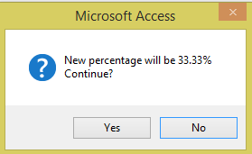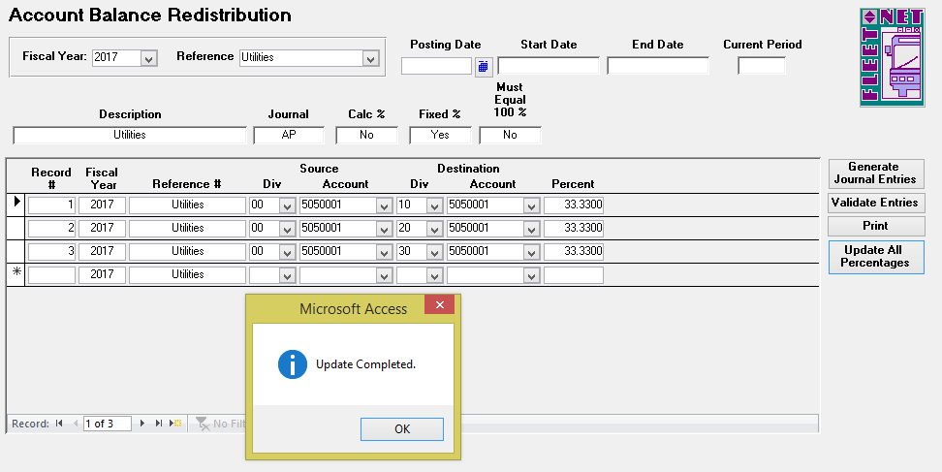

### Auto Post Closing

Auto Post Closing generates closing entries to Retained Earnings and Income Summary for the current period.

It is recommended that Auto Post Close be run only once. However, if Auto Post Closing has been run, updated, and additional entries are necessary, running Auto Post Close again will only generate closing entries for the additional postings. It will not duplicate the previous generated closing entries.

Navigate to ***Auto Post Closing*** to generate month end closing entries based on the posting date selected.

Enter Fiscal Year.Program will begin immediately compiling the month end closing data.

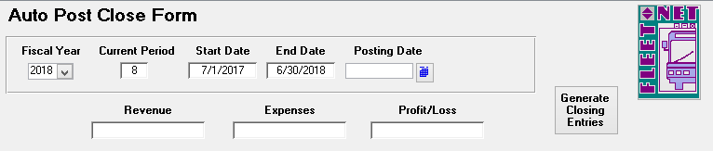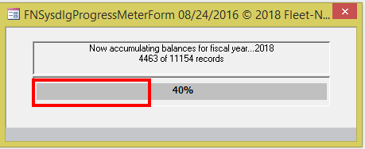

If Auto Post Closing has been run and not updated, the following message displays.

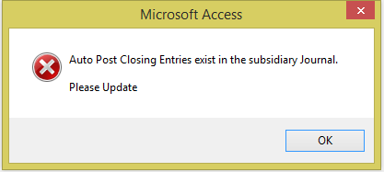

If errors (Out of Balance Issues) are detected the program will display the following message.

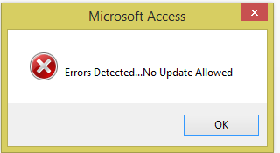

Click ***Ok*** make any applicable correction or ***X*** out to return to the Auto Post Close Form.

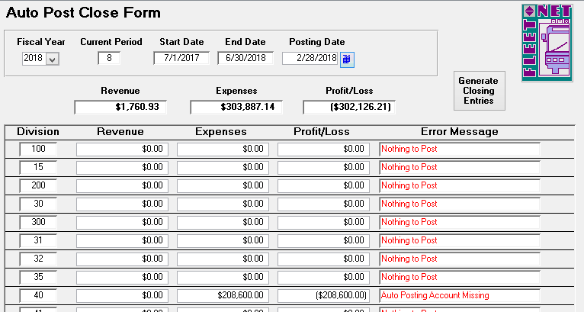

Once the system has accumulated data for closing entries the following form displays, if no errors are detected program will now allow Closing Entries to be generated. Proceed to Generate Closing Entries.

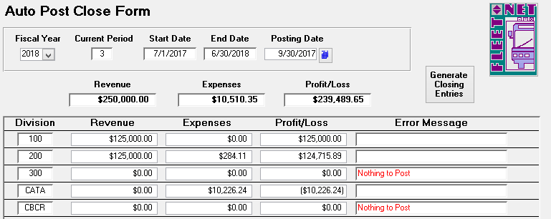

|  |  |  |
| --- | --- | --- |
| **Field Name** | **Field Type** | **Description** |
| Fiscal Year | Number | Enter or select fiscal year from drop down options. |
| Current Period | Number | Automatically populates based on fiscal year selected. |
| Start Date | Date/Time | Automatically populates based on fiscal year selected. |
| End Date | Date/Time | Automatically populates based on fiscal year selected. |
| Posting Date | Date/Time | Enter general ledger posting date or select from calendar. |

#### Generate Closing Entries

Click ***Generate Closing Entries***; the following message displays.

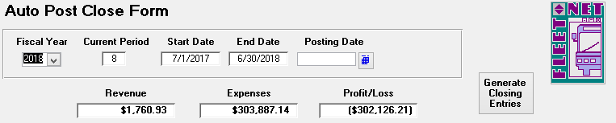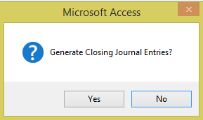

Click ***Yes*** to create the month end closing General Ledger entries or ***No*** to return to Auto Post Close Form. The following confirmation message displays.

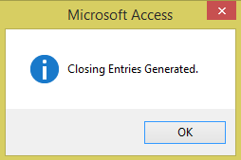

Click ***OK***.

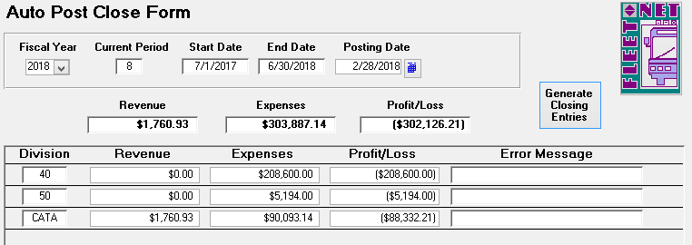

***NOTE: After the Auto Post Closing entries are generated Journal Update must be run.***

### General Ledger Excel Journal Entry Import Tool

Navigate ***Journal Entry Excel Import***. To import data from Excel in the General Ledger module.

Prior to using the import, the following: Miscellaneous Codes must be setup. From the General Leger Setup menu (GL01), select menu item #5 – Miscellaneous List Set up

PathToExcelImportData

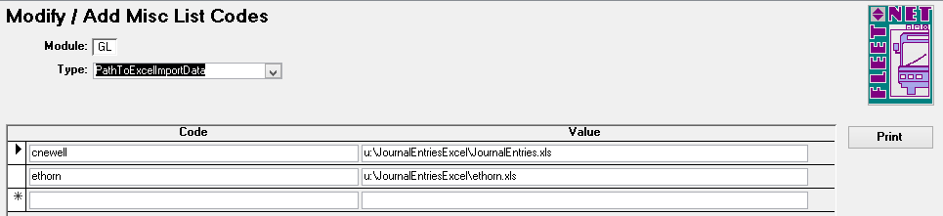

**SpreadsheetType**

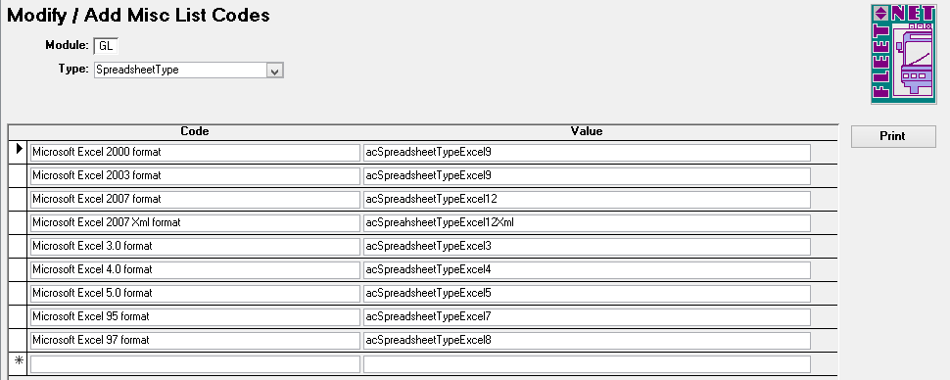

|  |  |  |
| --- | --- | --- |
| **Field Name** | **Field Type** | **Description** |
| Type | Alpha | Enter PathToExcelImportData. |
| Code | Alpha/Numeric | Enter Avail username of the person running the import. |
| Value | Alpha/Numeric | Add location and file name of the spreadsheet containing the journal entries being imported. |
| Type | Alpha | Enter SpreadsheetType |
| Code | Alpha/Numeric | Enter Excel |
| Value | Alpha/Numeric | Enter acSpreadsheetTypeExcel |

The spreadsheet must contain a header row with all nine fields exactly as shown below:

|  |  |  |  |  |  |  |  |  |
| --- | --- | --- | --- | --- | --- | --- | --- | --- |
| Division | Account | PostingDate | Reference | Project | Description | DebitAmount | CreditAmount | DistributionCode |
|  |  |  |  |  |  |  |  |  |
|  |  |  |  |  |  |  |  |  |
|  |  |  |  |  |  |  |  |  |

The Division and Account numbers must be listed correctly in the spreadsheet. The import will fail if the Division and Account numbers cannot be validated.

The posting date (format is mm/dd/yyyy) must be within the selected fiscal year. The import will fail if the date cannot be validated.

The maximum number of characters for the Reference field is 20. If more characters are added they will be truncated when imported into Avail. (This field can be left blank)

The Project number must be a valid Avail Project number. The import will fail if the Project number cannot be validated. (This field can be left blank)

The maximum number of characters for the Description field is 225. If more characters are added they will be truncated when imported into Avail. (This field can be left blank)

The debit and credit amounts are currency format with 2 decimal positions. The import will fail if the debits and credits do not balance.

The DistributionCode must be a valid Avail Distribution code. The import will fail if the Distribution Code cannot be validated. (This field can be left blank)

The completed spreadsheet must be saved prior to running the import. The spreadsheet must be saved in 97-2003 Workbook format regardless of the version of Excel running on the workstation.

Click ***Journal Entry Import From Excel*** to import journal entries from an Excel spreadsheet, the following form displays.

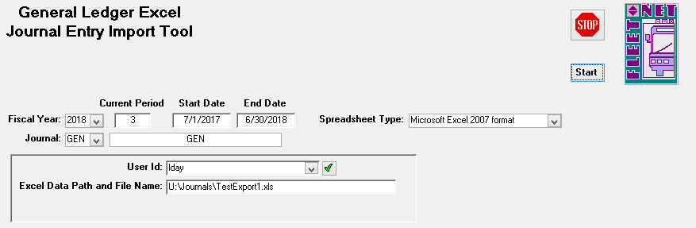

|  |  |
| --- | --- |
| **Field Name** | **Description** |
| Fiscal Year | Enter or select fiscal year from the drop down options. |
| Current Period | Auto-populates based on fiscal year selected. |
| Start Date | Auto-populates based on fiscal year selected. |
| End Date | Auto-populates based on fiscal year selected. |
| Journal | Enter or select subsidiary journal from drop down options. |
| Description | Auto-populates based on subsidiary journal selected. |
| Spreadsheet Type | Select spreadsheet type from drop down options. |
| User ID | Select the user Id for the employee running the import. |
| Excel Data Path and File Name | Auto-populates based on the User Id selected. |

#### Start

Click ***Start***, the following confirmation message displays.

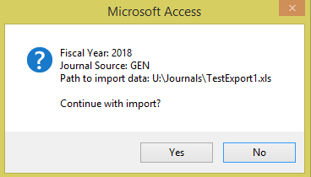

Click ***Yes*** to begin import or ***No*** to return to General Ledger Excel Journal Entry Import Tool form.

### Journal Update

Navigate to ***Journal Update*** to update subsidiary journal.

The following form displays:

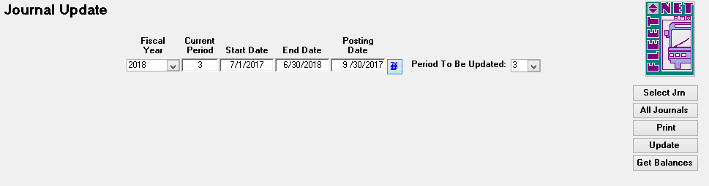

|  |  |  |
| --- | --- | --- |
| **Field Name** | **Field Type** | **Description** |
| Fiscal Year | Number | Enter or select fiscal year from drop down options. |
| Current Period | Number | Automatically populates based on fiscal year selected. |
| Start Date | Date/Time | Automatically populates based on fiscal year selected. |
| End Date | Date/Time | Automatically populates based on fiscal year selected. |
| Posting Date | Date/Time | Enter GL posting date or select from the calendar. It is very important that the correct posting date is entered. Entries in the subsidiary journals with the date entered or earlier will  be updated to the period shown in the Period To Be Updated field. |
| Period To Be Updated | Alpha/Numeric | The system defaults to the current period however any period in the current fiscal year can be selected. **Review the Posting to a Period Other than the Current Period section of this manual for instructions.** |

#### Select Jrn

Click ***Select Jrn***; the following form displays.

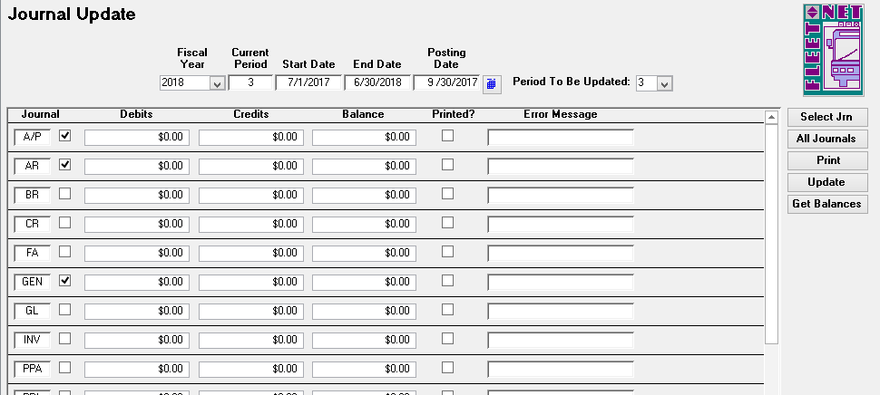

#### All Journals

Click ***All Journals*** to select all journal options to select specific subsidiary journals by clicking box to the right of the subsidiary journal name. The following form displays with all boxes checked based on the selection.

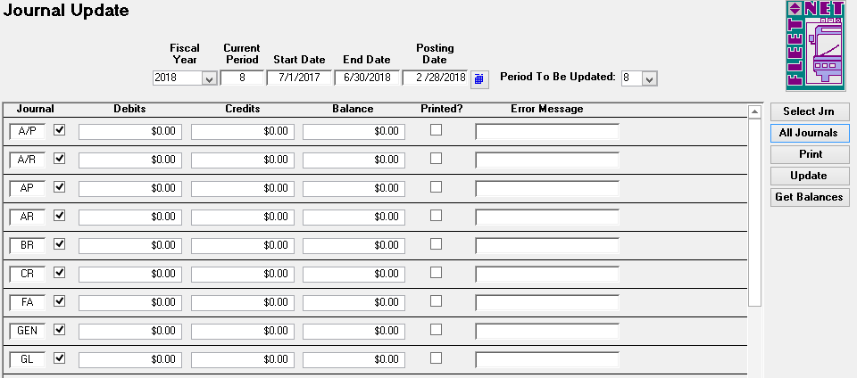

#### Get Balances

Click ***Get Balances*** the following form displays listing balances or No Journal Entries Found for all checked subsidiary journals. Once balances have populated and before the system will allow for updates the Print option must be selected.

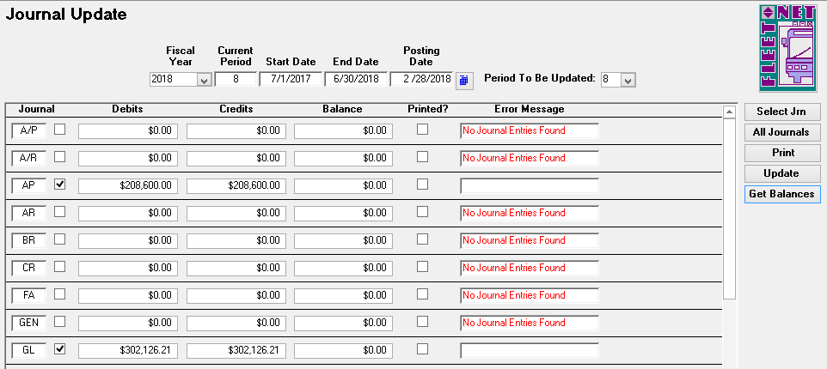

#### Print

Click ***Print*** to print a journal proof listing (this option must be selected in order to update the entries). If Print has not be executed the system will display an error detected message. Error Message for individual Journal line will state. ***Journal Not Printed.***

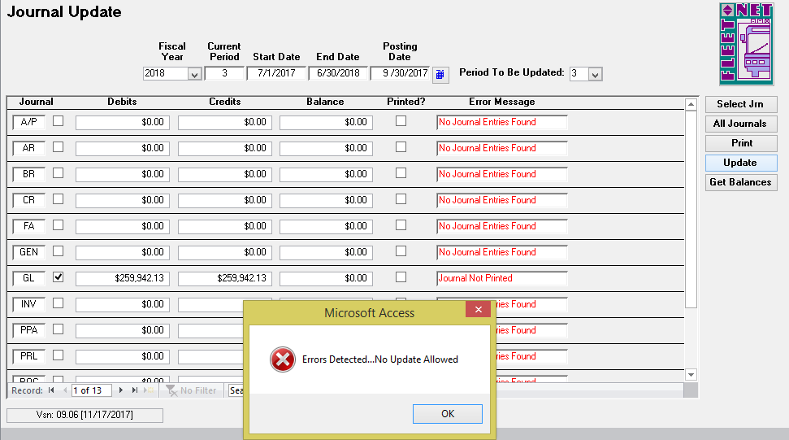

One no errors are detected the program will generate 2 reports. The first report being: Journal Proof Batch Listing. View/Print/Save the documentation. Once completed. Click ***Close Print Preview*** to generate the next report, Journal Proof Listing Report.

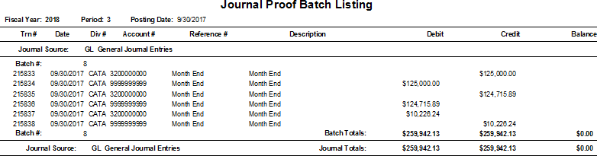

Close the report after printing; the following message displays.

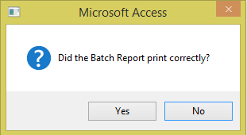

Click ***Yes*** to view and print the journal proof by Journal, Division and Account Number or ***No*** to be returned to the Journal Update screen.

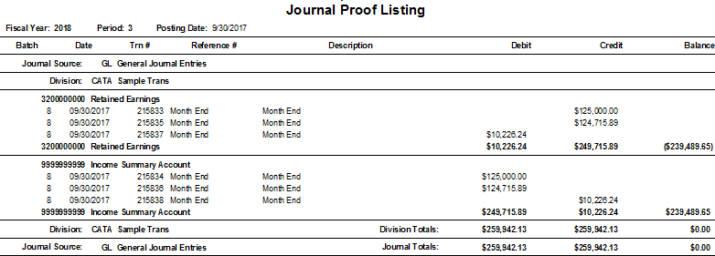

These reports should always be reviewed/printed/saved before update is initiated. The entries cannot be updated until the proofs have been printed.

Once the reports have been printed and reviewed close the document; the following prompt displays.

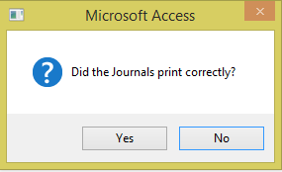

Click ***Yes*** to confirm reports have been reviewed/saved/printed or ***No*** to return to Journal Update form. If ***Yes*** is selected the Printed? field will now be checked as shown below.

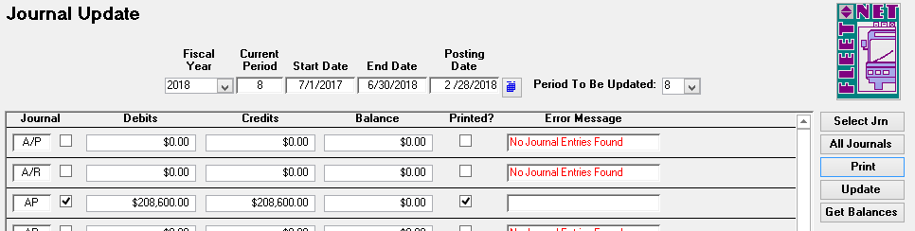

#### Update

Click ***Update*** to update the selected subsidiary journals to the General Ledger. The following message displays.

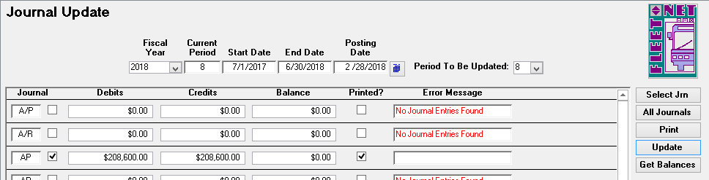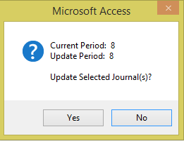

Click ***Yes*** to execute the update or ***No*** to return to the Journal Update form. If ***Yes*** is selected, the system will post the entries to the GL. The following message displays.

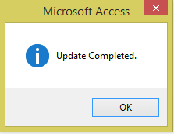

Click ***OK***.

**Journal Update** [Alternate Periods]

Entries can be posted to a period other than the current period.

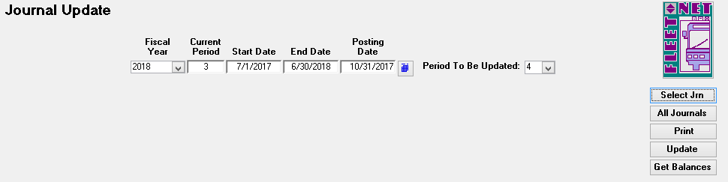

|  |  |  |
| --- | --- | --- |
| **Field Name** | **Field Type** | **Description** |
| Fiscal Year | Number | Enter or select fiscal year from drop down options. |
| Current Period | Number | Automatically populates based on fiscal year selected. |
| Start Date | Date/Time | Automatically populates based on fiscal year selected. |
| End Date | Date/Time | Automatically populates based on fiscal year selected. |
| Posting Date | Date/Time | Enter the GL posting date or select from the calendar. It is very important that the correct posting date is entered.  Entries in the subsidiary journals with the date entered or earlier will be updated to the period shown in the Period To Be Updated field. |
| Period To Be Updated | Alpha/Numeric | The system defaults to the current period however **any period in the current fiscal year can be selected.** |

If entries are being posted to a future period, ***prior to updating the future period entries verify that all entries in the current period have been updated***. This will prevent postings of current items to a ‘non- current’ period.

Example provided shows current period is period 3 (September 2017) and the user wants to update period 4 (October 2017) postings for the ALL journals.

Once Period 3 entries have been updated, change the posting date to 10/31/xxxx and change the Period to Be Updated to 4. All entries present will populate by Journal code.

If posting to period 13 verify that all period 12 entries have been updated for all journals. Select Period 13 from the dropdown list in the ‘Period to be Updated’ field. (Can be used for yearend journal entries to not impact the current year totals).

### Checkbook Adjustment Form

Navigate to ***Checkbook Adjustments*** *t*o create Journal entries affecting the checking accounts.

Checking Account entries made through Journal Entry will cause Checking Accounts General Ledger Accounts to be out of balance. Creating an error when reconciling checking accounts.

The form allows for entries that affect bank accounts. Entries made on this form will write to the checkbook and will create batched journal entries.

|  |  |
| --- | --- |
| **Field Name** | **Description** |
| Fiscal Year | Enter or select fiscal year from the drop down option. |
| Period | Auto populates the current period. |
| Start Date | Auto populates starting date for selected fiscal year. |
| End Date | Auto populates ending date for selected fiscal year. |
| Checking Account | Enter or select checking account. If transaction is a transfer, the account selected will be the account that funds are being taken from (credited). |
| GL Division & Account | Auto populates based on the Checking Account selected above. |
| Journal | Enter or select subsidiary journal that transaction will be written to. |
| Posting Date | Enter or select from the calendar, the General Ledger date for the transaction record. |

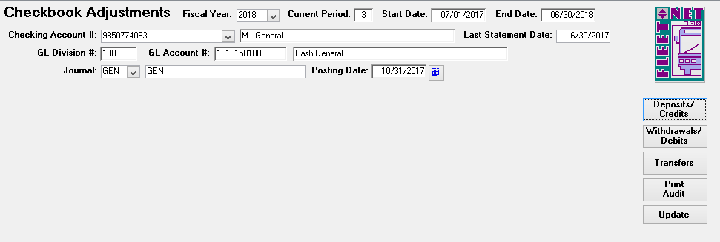

#### Deposit/Credits

Click ***Deposits/Credits*** make adjustments that will be records as funds received to the selected checking account. The following form displays. Once transaction has been entered Click ***Refresh*** to save the line item.

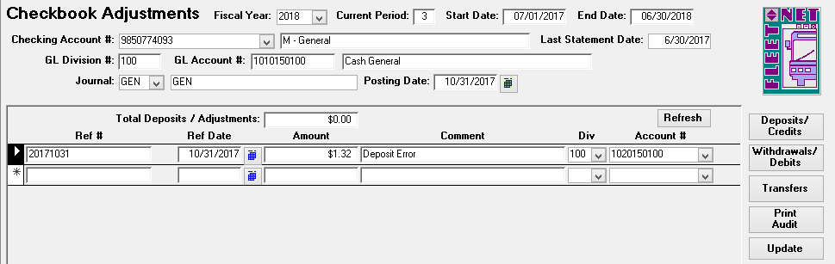

|  |  |
| --- | --- |
| **Field Name** | **Description** |
| Ref # | Enter user defined Reference #. The Reference entered will be recorded in the Checkbook and General Ledger. |
| Rec | Check box if entering items from bank statement that have cleared (service fee, interest, etc.). |
| Amount | Enter amount being deposited to the selected Checking Account. |
| Comment | Enter a comment/description, if desired. |
| Div/Account | Enter or select General Ledger Division and Account that will be credited for the transaction. Multiple accounts can be credited on this form. |

#### Withdrawals/Debits

Click ***Withdrawals/Debit*** make adjustments that will be records as funds withdrawn from the selected checking account. The following form displays. Once transaction has been entered Click ***Refresh*** to save the line item.

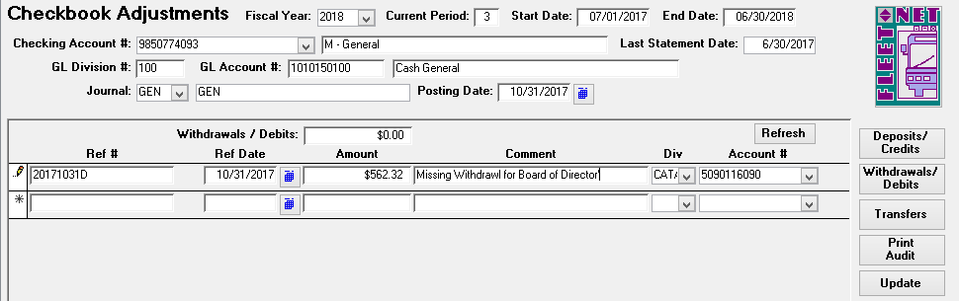

|  |  |
| --- | --- |
| **Field Name** | **Description** |
| Ref # | Enter user defined Reference #. The Reference entered will be recorded in the Checkbook and General Ledger. |
| Rec | Check box if entering items from bank statement that have cleared (service fee, interest, etc.) |
| Amount | Enter amount being withdrawn from selected Checking Account. |
| Comment | Enter a comment/description, if desired |
| Div/Account | Enter or select General Ledger Division and Account that will be debited for the transaction. Multiple accounts can be debited on this form. |

#### Transfer

Click ***Transfer*** when funds need to be transferred between Checking Accounts. The following form displays. Once transaction has been entered Click ***Refresh*** to save the line item.

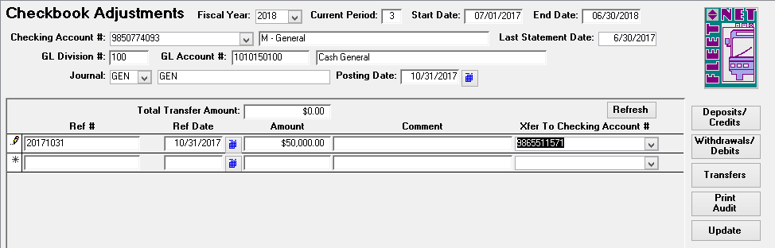

|  |  |
| --- | --- |
| **Field Name** | **Description** |
| Ref # | Enter user defined Reference #. The Reference entered will be recorded in the Checkbook and General Ledger. |
| Rec | The Reconciled checkbox will automatically be checked. The box can be  unchecked. Leaving it checked on this form will flag it as cleared when processing bank statement reconciliation. |
| Amount | Enter amount being transferred from the selected Checking Account. |
| Comment | Enter a comment/description, if desired. |
| Xfer To Checking Account # | Enter or select the Checking Account the money will be transferred to. |

#### Print Audit

Click ***Print Audit*** to generate reports for reviewing/saving/printing. The following report displays.

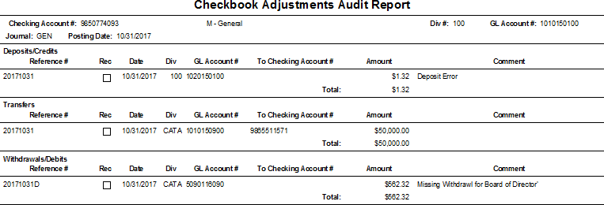

#### Update

Click ***Update*** to update all entries to Checking Account9s) and General Ledger Accounts.

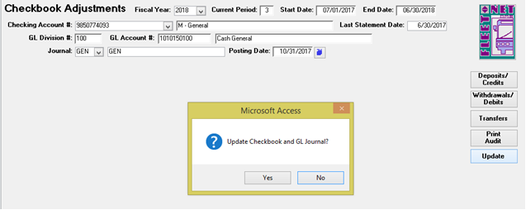

Click ***Yes*** to update Checking Account entries and General Ledger subsidiary Journal or ***No*** to return to Checkbook Adjustment form. Once completed the following message displays.

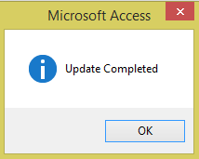

Click ***OK.***

### Un-post Journal Entries

***NOTE: Please contact Avail prior to using this feature.***



If entries were posted to an incorrect period they can be ‘un-posted.’ Using this process returns the entries to the subsidiary journal(s) where they can be re-updated to the correct period. In the example below October 18th entries posted to Period 3 (September).

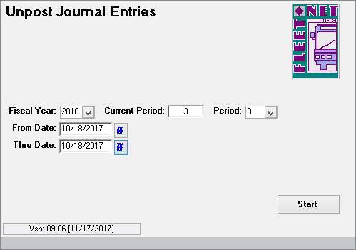

|  |  |  |
| --- | --- | --- |
| **Field Name** | **Field Type** | **Description** |
| Fiscal Year | Number | Enter or select fiscal year from the drop down options. |
| Current Period | Number | Auto populates based on fiscal year selected. |
| Period | Number | Defaults to current period but can be changed if the un-post is being processed for a period other than current. |
| From Date | Date/Time | Determine earliest date is for the entries being un-posted. |
| Thru Date | Date/Time | Determine latest date is for the entries being un-posted. |

#### Start

Click ***Start***; the following confirmation message displays.

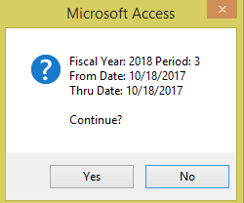

Click ***Yes*** to un-post entries for the selected date range or ***No*** to return to Un-post Journal Entries. Click ***OK*** on completion message.

# Financial Statements/Inquiries

Navigate to ***Financial Statements***

### Financial Statements

Click ***Financial Statements***, the following form displays:

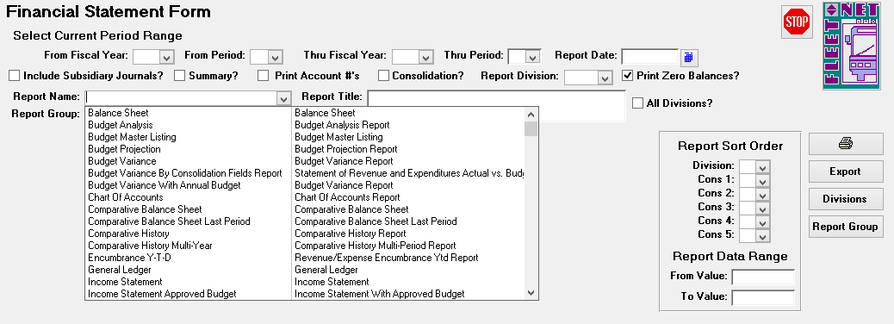

|  |  |  |
| --- | --- | --- |
| **Field Name** | **Field Type** | **Description** |
| From Fiscal Year | Number | Enter or select fiscal year from drop down options. |
| From Period | Number | Enter or select applicable period from drop down options. |
| Thru Fiscal Year | Number | Enter or select fiscal year from drop down options. Allows for different fiscal year to be selected for through year. |
| Thru Period | Number | Enter or select applicable period from drop down options. |
| Report Date | Date/Time | Enter or select date from calendar. Date displays in Header area of selected financial report. The date selected will not impact the data included in the reports. |
| Include Subsidiary Journals? | Yes/No | Check box to include entries in the subsidiary journals, not yet updated to the General Ledger. Only available when generating  the Income Statement or Balance Sheet. |
| Summary? | Yes/No | Check box to generate a report without posting account detail. Report would show only accounts classified as subtotals or totals (TRAN CODE 3 or 6 defined via Chart of Accounts Setup). |
| Print Account #’s | Yes/No | Check box to include General Ledger Chart of Account numbers on reports. |
| Consolidation? | Yes/No | Check box to generate a consolidated report. (See below). |
| Report Division | Alpha/Numeric | Select report division from the drop down options. These options have been setup to generate a summarized report. A Target Report Division will have general account descriptions, (not specific to any division). The Target Report Division must also be selected in the Source Division list. |
| Print Zero Balances? | Yes/No | Uncheck box to omit accounts with zero balances from the reports. |
| All Divisions? | Yes/No | Check box to include data from all divisions on selected report. Leave box unchecked to select specific divisions. Utilizing  ***Division*** button on right side task bar. |

|  |  |  |
| --- | --- | --- |
| **Field Name** | **Field Type** | **Description** |
| Report Name | Alpha/Numeric | Enter or select report name from the drop-down list. (See below) |
| Report Title | Alpha/Numeric | Auto populates based on Report Name selected. See Financial Statement Builder section of this manual for information on customizing the Report Titles. |
| Report Group | Alpha/Numeric | If Report Groups have been previously setup. Enter or select the group from the drop-down options. |
| Source Divisions | Yes/No | Check the applicable boxes to indicate which Divisions are to be included on the report. |
| Report Sort Order | Number | If consolidation fields were created select the order that data will appear on the selected reports. |
| Report Data Range | Number | Enter a starting and ending consolidation field number. |

***NOTE: Items posted but not updated do not appear on the Financial Reports unless the ‘Include Subsidiary Journals’ box was checked***

#### Report Options

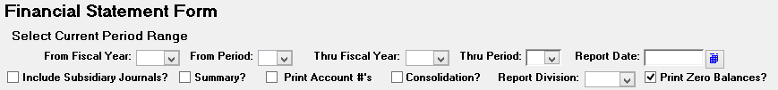

Period Reports:

Reports can be generated for range of periods within a fiscal year or from one fiscal year to another by utilizing the From & Thru Fiscal Year and From & Thru Period.

Include Subsidiary Journals:

Include Subsidiary Journal option is only available on the following reports: Income Statement & Balance Sheet. When selected the report will include entries not yet updated to the General Ledger.

Summary Reports:

When selected and General Ledger Chart of Accounts numbers have been identified as suppressed, the report generated will only show the dollar values in Subtotal and Total format.

Print Account #’s:

Reports default to generate NO Account #’s on reports. If Account #’s are required, select this option.

Consolidated Report:

The Consolidated Report lists the total for each account number regardless of the Division. For example, if in every Division the expense account for FICA is 5020100000, the Consolidation Report will list that account number once; the amount listed would be the sum of every instance of that account number.

Report Division:

The Report Division option is used in conjunction with the consolidation fields. The division must be set up and defined in Chart of Accounts setup prior to being available for selection.

**Print Zero Balances:** Reports default to show all account numbers and balances even if the balance is $0.00. To eliminate the accounts with zero balances, select this option.

### Reports

Click ***Balance Sheet*** to review and/or print a balance sheet for the selected division(s). Balance Sheet is a result of prior period (beginning balance) totals plus postings updated via Journal Update.

Closing entries must be made to income summary account(s) and retained earnings (via Auto Post Closing), each month or the Balance Sheet will not be in balance and Month End Closing will not be permitted.

Check the summary box, to print balance sheet totals without posting account detail. Balance sheet would show only accounts classified as subtotals or totals (TRAN CODE 6 defined via Chart of Accounts Setup).

Click ***Budget Analysis Report*** to review, print or export to Excel, a budget analysis report. Data included on the report: actual and budgeted dollars for current period and actual amount for the same period in the previous fiscal year as well as year to date comparisons for the same categories.

Click ***Budget Master Listing*** to review, print or export to Excel, a budget master listing for each account by periods, quarters and annual budget total.

Click ***Budget Projection*** to review, print or export to Excel, a budget projection report which will list the current period’s actual, budget, balance of budget remaining, and percentage spent figures. Year-to-date actual, annual budget, balance of budget remaining, and percentage spent figures also print.

Click ***Budget Variance*** to review, print or export to Excel, a budget variance report comparing actual and budget and variance figures for the current period as well as year-to-date comparisons.

Click ***Budget Variance by Consolidation Fields Report*** to review, print or export to Excel, a budget variance report comparing actual and budget and variance figures for the current period as well as year-to- date comparisons. This report also includes the annual budget amount for each account. This report is based on Consolidation Fields and Report Divisions being set up prior to running.

Click ***Budget Variance with Annual Budget*** to review, print or export to Excel, a budget variance report comparing actual and budget and variance figures for the current period as well as year-to-date comparisons. This report also includes the annual budget amount for each account.

Click ***Chart of Accounts*** to review, print or export to Excel, a chart of accounts for the selected division(s).

Click ***Comparative Balance Sheet*** to review, print or export to Excel, a balance sheet (detail or summary) showing figures for current year-to-date, last year-to-date, and the variance between the two.

Check the summary box, to print a comparative balance sheet report without posting account detail. Report would show only accounts classified as subtotals or totals (TRAN CODE 6 defined via Chart of Accounts Setup).

Click ***Comparative Balance Sheet Last Period*** to review, print or export to Excel, a balance sheet (detail or summary) showing figures for current period, last period, and the variance between the two.

Check the summary box, to print a comparative balance sheet report without posting account detail. Report would show only accounts classified as subtotals or totals (TRAN CODE 6 defined via Chart of Accounts Setup).

Click ***Comparative History Report*** to review, print or export to Excel, a report that includes an analysis between current period for current year and current period for previous year as well as comparisons year- to-date for current and previous years.

Click ***Comparative History Multiple-Year Report*** to review, print or export to Excel, a report that includes an analysis between current period for current year and other multiple year periods.

Click ***Encumbrance Ytd*** to review, print or export to Excel, a year-to-date Expense/Encumbrance vs Budget Report. The report lists the following data for each account: Annual Budget Amount, Current Month Actual Amount, Year-to-Date Actual Amount, Year-to-Date Encumbrance Amount, Year-to-Date total of Actual plus Encumbrance, Year-to-Date Amount Over/Under Budget and Year-to-Date Percentage of Budget expended. Encumbrance amounts will only be available if the budget division and general ledger account fields are completed in Purchase Order entry.

Click ***General Ledger*** to review, print or export to Excel, a general ledger report that includes all entries (except those made via Prior Period Adjustments) posted to the current G/L accounting period for the selected division(s). Click ***Division*** select either all division or individual divisions. Click ***Printer Icon***. Enter or select the range of General Ledger Account # to be included on the report. *This is the only report that allows for the entry: From and Thru Account #’s.*

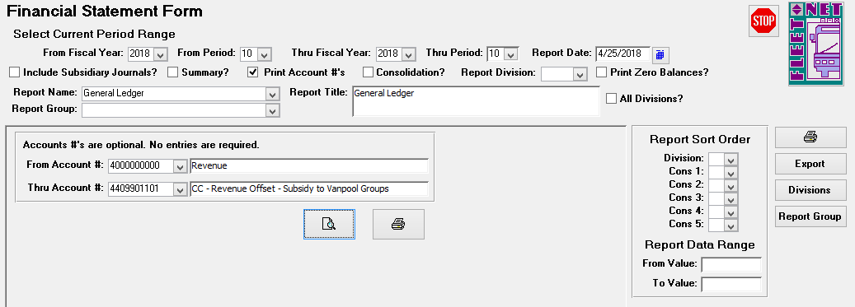

Click ***Income Statement*** to review, print or export to Excel, an income statement for the selected division(s). The Income Statement is a result of prior period (beginning balance) total plus postings updated via Journal Update.

Click ***Income Statement Approved Budget*** to review, print or export to Excel, an income statement that includes amounts for current period and year-to-date as well as the approved annual budget amounts.

Click ***Income Statement Budget Remaining*** to review, print or export to Excel, an income statement that includes amounts for current period/current fiscal year, current period budget, variance in dollars, variance by percentage, current period/last fiscal year and variance in dollars between current period/current fiscal year, current period/last fiscal year and year-to-date/current fiscal year, year-to-date budget, variance in dollars, variance by percentage, year-to-date/last fiscal year and variance in dollars between year-to-date

/current fiscal year and year-to-date/last fiscal year.

Click ***Income Statement by Period*** to review, print or export to Excel, an income statement that includes amounts for each account for each period in the selected fiscal year.

Click ***Statement of Expenses*** to review, print or export to Excel, a statement of expenses report (detail or summary) listing current period, year-to-date totals and the percentage of each.

Click ***Statement of Revenue*** to review, print or export to Excel, a statement of revenue report (detail or summary) showing current period, year-to-date totals and the percentage of each.

Click ***Trial Balance*** to review, print or export to Excel, a trial balance for the selected division(s). The report lists account numbers, titles, beginning balances, current period and ending balances. At the end of each division, the trial balance totals each column and displays a division total.

Click ***Trial Balance with Fiscal Year Starting Balance*** to review, print or export to Excel, a trial balance for the selected division(s) with opening balances. The report lists account numbers, titles, beginning balances, current period and ending balances. At the end of each division, the trial balance totals each column and displays a division total.

Click ***Working Trial Balance*** to review, print or export to Excel, a working trial balance for the selected division(s). The report includes data for the selected period that can be used to reconcile accounts, providing columns for noting adjusting entries.

#### Printer

Click ***Printer*** Icon (Right Task Bar) to generate the selected report, for viewing/saving/printing. The following form displays.

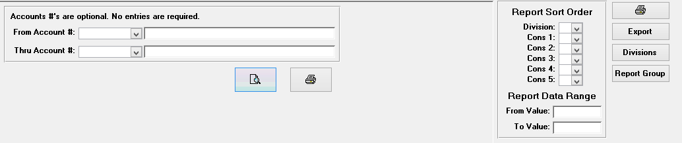

Click ***View Icon*** to review reports prior to printing.

Click ***Printer Icon*** to print selected reports, the preview view will not be generated, report will go directly to the printer.

#### Division

Click ***Divisions*** to populate a list of the divisions. Select a Division if the report being generated should only include one or a selected group of divisions.

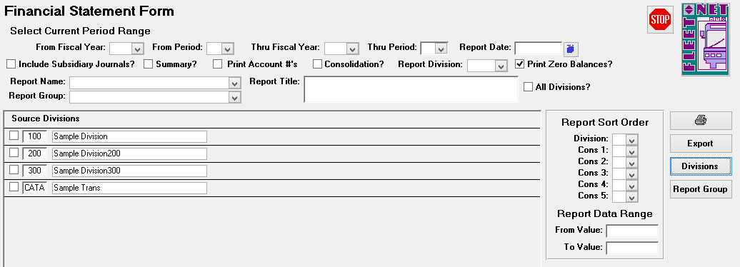

#### Export

**Click *Export*** to create a Word, Excel or PDF file of the selected report. Program requires Path To Export Data field has a location prior to exporting the documentation. The following form displays.

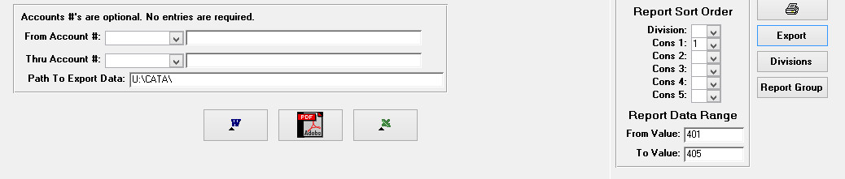

Click ***Word Icon*** to create a Word document. Click ***PDF Icon*** to create a PDF document.

Click ***Excel Icon*** to create an Excel Spreadsheet.

#### Report Group

Click ***Report Group*** to set up and define the reports to be generated together for that Group.

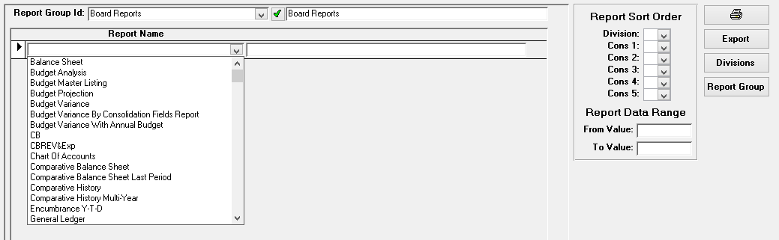

|  |  |  |
| --- | --- | --- |
| **Field Name** | **Field Type** | **Description** |
| Report Group Id | Alpha/Number | Enter or select the Report Group Id. Click ***Green Checkmark***  to create a new group. |
| Report Name |  | Highlight / Click Reports to be included in Group Id for preparing multiple documents for the selected group. |

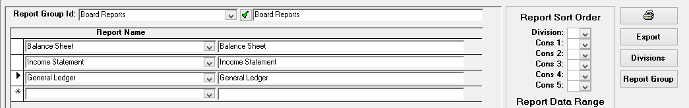

### Encumbrance Inquiry

Navigate to ***Encumbrance Inquiry*** to display the monthly activity against current fiscal budget amounts.

Inquiry is populated based on selected account number. **Encumbrance amounts are updated when line items are entered on Purchase Orders**.

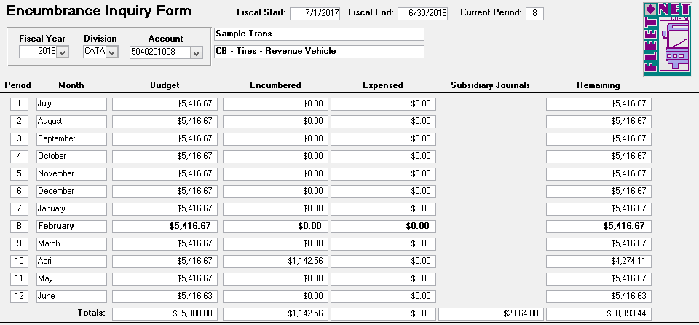

|  |  |
| --- | --- |
| **Field** | **Description** |
| Fiscal Year | Enter or select fiscal year from drop down options. |
| Division | Enter or select division from drop down options. |
| Account | Enter or select GL Account # from drop down options. |
| Fiscal Start | Auto populates based on fiscal year selected. |
| Fiscal End | Auto populates based on fiscal year selected |
| Current Period | Auto populates current period. |
| Division Description | Auto populates based on division selected. |
| Account Description | Auto populates GL Account # description from Chart of Accounts. |
| Month | Auto populates months in period order based on fiscal year setup. |
| Budget | Auto populates budgeted amounts for Division and GL Account # selected by month. |
| Encumbrance | Auto populates dollar amounts from open Purchase Orders posted to selected Division and GL Account #. |
| Subsidiary Journals | Auto populates funds updated to subsidiary journals for the Division and GL Account # selected. |
| Remaining | Auto populates remaining total budget balance. |

### Financial Graphs

Navigate to ***Financial Graphs*** to generate pie or bar charts based on criteria selected, utilizing consolidation fields and values defined via Chart of Accounts Setup.

#### Pie Chart

Click ***Pie Chart*** to generate a pie graph based on selected criteria. This graph requires the following items to be selected prior to generating: Fiscal Year, Period, Revenue or Expenses, Divisions (either All or Specific Divisions), selection of a consolidation field previously defined in the Chart of Accounts Setup, selection of number of items to chart and sort order, either ascending or descending.

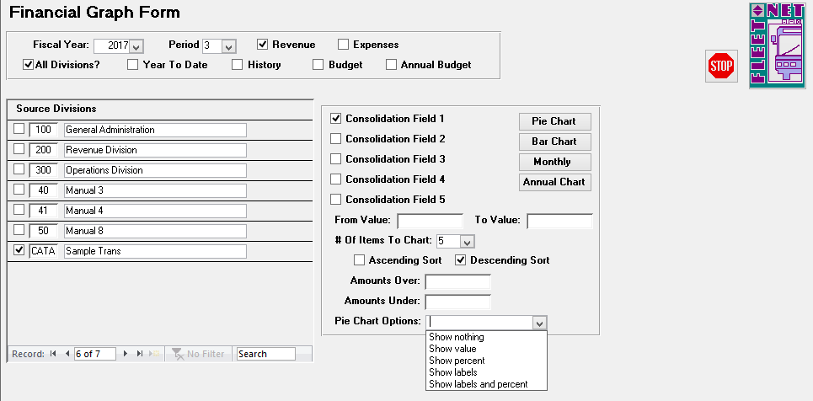

|  |  |
| --- | --- |
| **Field** | **Description** |
| Fiscal Year | Enter or select fiscal year from drop down options. |
| Period | Enter or select period from the drop down options. |
| Revenue or Expenses | Check either box for the desired graph. |
| All Divisions | Check box to generate chart to include all divisions or select specific divisions by checking box (es) to the left of the division number. |
| Year To Date | Check box to generate a year-to-date chart. |
| History | Check box to generate a consolidated chart for the previous year. If Year-to-Date box is also checked, Historical chart will contain Year-to-Date figures for previous year. If only history box is check, historical chart will contain revenue/expenses for same period for previous year. |
| Budget | Check box to generate a consolidated graph for amounts budgeted for selected period. |
| Annual Budget | Check box and leave Budget box checked to generate a consolidated graph for annual amounts budgeted. |
| Consolidation Fields | Select one of the five consolidation fields defined in Chart of Accounts Setup |
| From Value | Enter a beginning consolidation value for range or leave blank to include all values |
| To Value | Enter an ending consolidation value for range or leave blank to include all values |
| Number of Items to Chart | Select number of items to be include in graph from the drop down list. i.e. If 5 is selected, the chart will display top 5 account balances. |
| Ascending or Descending Sort | Check box to select sort order |
| Amounts Over/Under | Enter minimum and maximum amounts to be included in the graph or leave blank to include all amounts. |
| Pie Chart Options | Select chart options from the drop down list. (See examples below) |

The following confirmation message will display.

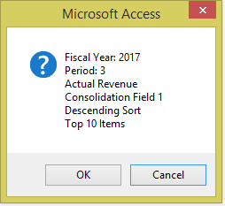

Click ***OK*** to create selected options graph or ***Cancel*** to return to Financial Graph Form. If ***OK*** is selected, the graph will preview on the screen. Click ***Print*** to print the graph.

**Show Nothing:**

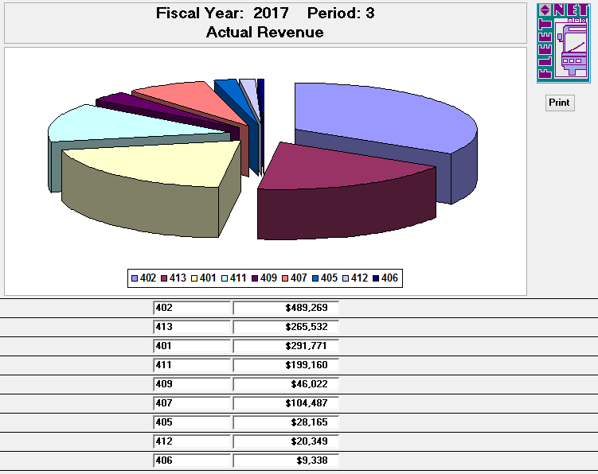

**Show Value:**

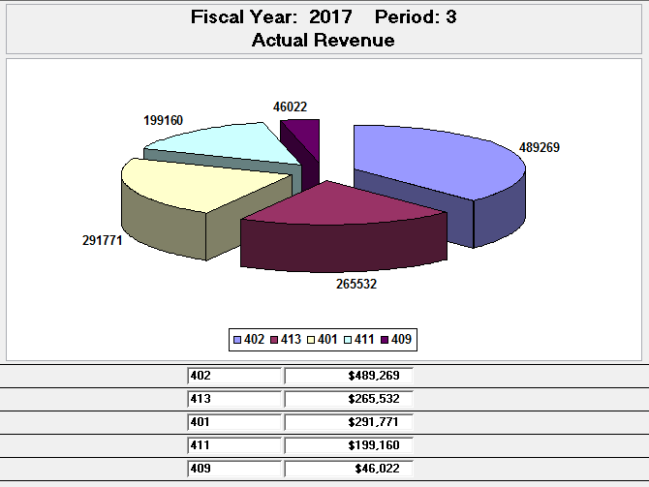

**Show Percent:**

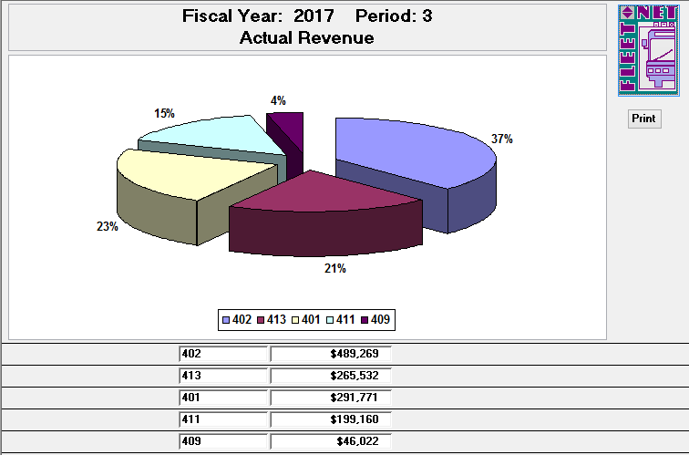

**Show Labels:**

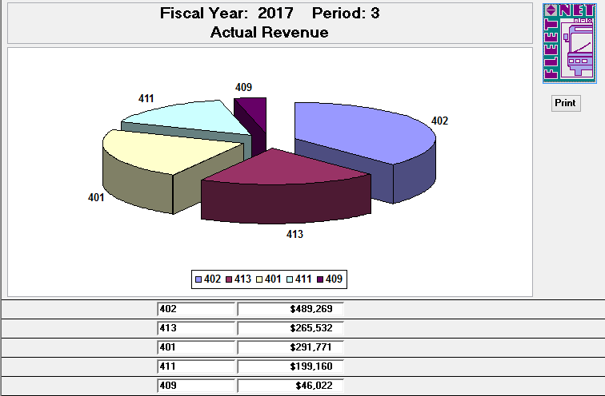

**Show Labels and Percent:**

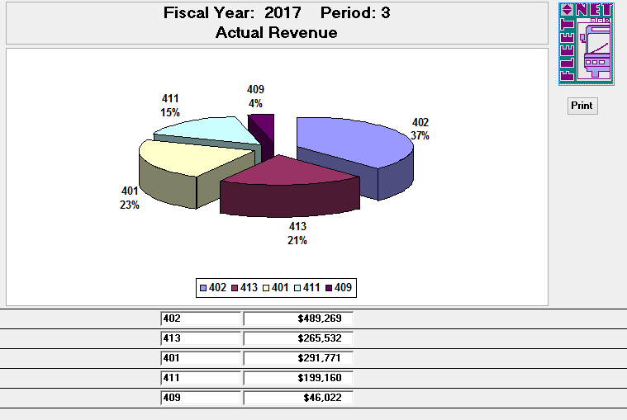

#### Bar Chart

Click ***Bar Chart*** to generate a bar graph based on the selected criteria. This graph requires the following items to be selected prior to generating: Fiscal Year, Period, Revenue or Expenses, Divisions (either All or Specific Divisions), selection of a consolidation field previously defined in the Chart of Accounts Setup, selection of number of items to chart and sort order, either ascending or descending.

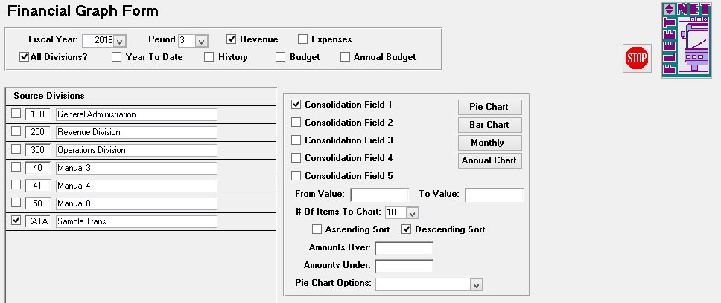

|  |  |
| --- | --- |
| **Field** | **Description** |
| Fiscal Year | Enter or select fiscal year from drop down options. |
| Period | Enter or select period from the drop down options. |
| Revenue or Expenses | Check either box for the desired graph. |
| All Divisions | Check box to generate chart to include all divisions or select specific divisions by checking box(es) to the left of the division number. |
| Year To Date | Check box to generate a year-to-date chart. |
| History | Check box to generate a consolidated chart for the previous year. If Year-to-Date box is also checked, Historical chart will contain Year-to-Date figures for previous year. If only  history box is check, historical chart will contain revenue/expenses for same period for previous year. |
| Budget | Check box to generate a consolidated graph for amounts budgeted for selected period. |
| Annual Budget | Check box and leave Budget box checked to generate a consolidated graph for annual amounts budgeted. |
| Consolidation Fields | Select one of the five consolidation fields defined in Chart of Accounts Setup |
| From Value | Enter a beginning consolidation value for range or leave blank to include all values |
| To Value | Enter an ending consolidation value for range or leave blank to include all values |
| Number of Items to Chart | Select number of items to be include in graph from the drop down list. i.e. If 5 is selected, the chart will display top 5 account balances. |
| Ascending or Descending Sort | Check box to select sort order |
| Amounts Over/Under | Enter minimum and maximum amounts to be included in the graph or leave blank to include all amounts. |
| Pie Chart Options | No selection is required for Bar Charts. |

The confirmation message displays.

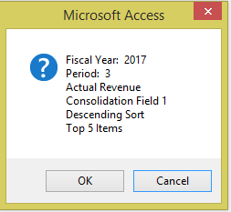

Click ***OK*** to create selected options graph or ***Cancel*** to return to Financial Graph Form. If ***OK*** is selected, the graph will preview on the screen. Click ***Print*** to print the graph.

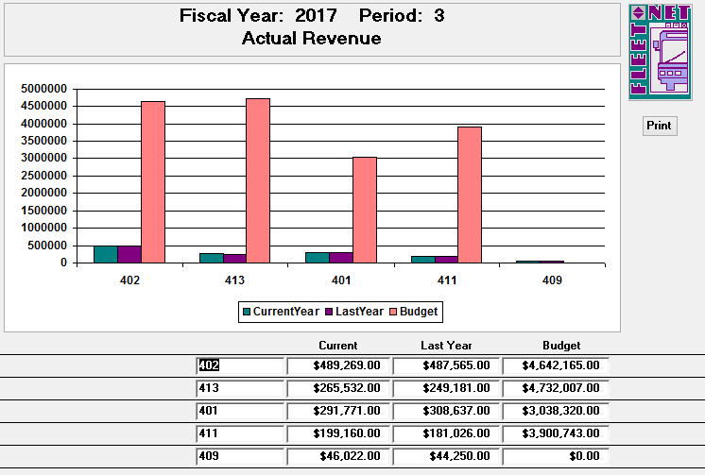

#### Monthly

Click ***Monthly*** to generate a bar graph for selected criteria. This graph requires the following items to be selected prior to generating: Fiscal Year, Period, Revenue or Expenses, Divisions (either All or Specific Divisions), selection of a consolidation field previously defined in the Chart of Accounts Setup, selection of number of items to chart and sort order, either ascending or descending.

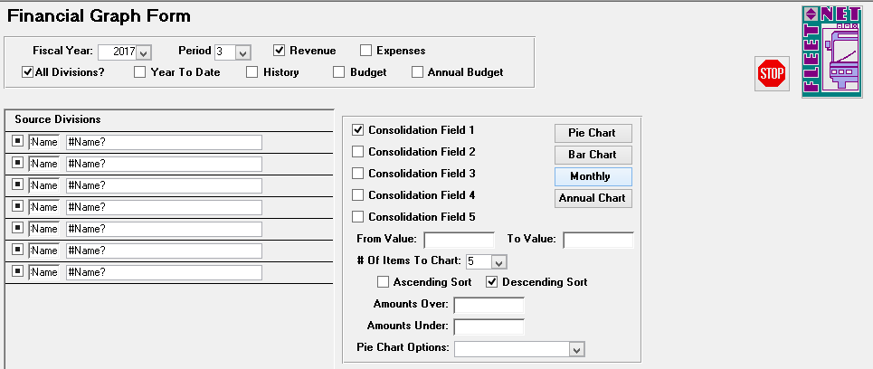

|  |  |
| --- | --- |
| **Field** | **Description** |
| Fiscal Year | Enter or select fiscal year from drop down options. |
| Period | Enter or select period from the drop down options. |
| Revenue or Expenses | Check either box for the desired graph. |
| All Divisions | Check box to generate chart to include all divisions or select specific divisions by checking box (es) to the left of the division number. |
| Year To Date | Check box to generate a year-to-date chart. |
| History | Check box to generate a consolidated chart for the previous year. If Year-to-Date box is also checked, Historical chart will contain Year-to-Date figures for previous year. If only  history box is check, historical chart will contain revenue/expenses for same period for previous year. |
| Budget | Check box to generate a consolidated graph for amounts budgeted for selected period. |
| Annual Budget | Check box and leave Budget box checked to generate a consolidated graph for annual amounts budgeted. |
| Consolidation Fields | Select one of the five consolidation fields defined in Chart of Accounts Setup |
| From Value | Enter a beginning consolidation value for range or leave blank to include all values |
| To Value | Enter an ending consolidation value for range or leave blank to include all values |
| Number of Items to Chart | Select number of items to be include in graph from the drop down list. i.e. If 5 is selected, the chart will display top 5 account balances. |
| Ascending or Descending Sort | Check box to select sort order |
| Amounts Over/Under | Enter minimum and maximum amounts to be included in the graph or leave blank to include all amounts. |
| Pie Chart Options | No selection is required for Monthly. |

The following confirmation message displays.

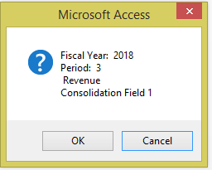

Click ***OK*** to create selected options graph or ***Cancel*** to return to Financial Graph Form. If ***OK*** is selected, the graph will preview on the screen. Click ***Print*** to print the graph.

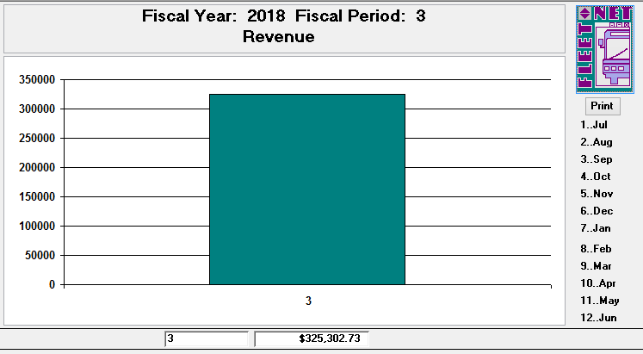

#### Annual Chart

Click ***Annual Chart*** to generate a bar graph illustrating previous years as selected by user. This graph requires the following items to be selected prior to generating: Fiscal Year, Period, Revenue or Expenses, Divisions (either All or Specific Divisions), selection of a consolidation field previously defined in the Chart of Accounts Setup, selection of number of items to chart and sort order, either ascending or descending.

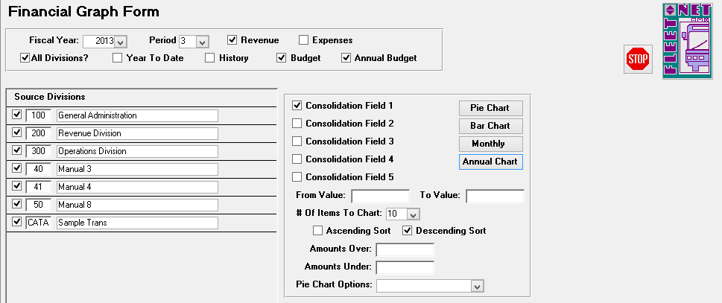

|  |  |
| --- | --- |
| **Field** | **Description** |
| Fiscal Year | Enter or select fiscal year from drop down options. |
| Period | Enter or select period from the drop down options. |
| Revenue or Expenses | Check either box for the desired graph. |
| All Divisions | Check box to generate chart to include all divisions or select specific divisions by checking box(es) to the left of the division number. |
| Year To Date | Check box to generate a year-to-date chart. |
| History | Check box to generate a consolidated chart for the previous year. If Year-to-Date box is also checked, Historical chart will contain Year-to-Date figures for previous year. If only history box is check, historical chart will contain revenue/expenses for same period for previous year. |
| Budget | Check box to generate a consolidated graph for amounts budgeted for selected period. |
| Annual Budget | Check box and leave Budget box checked to generate a consolidated graph for annual amounts budgeted. |
| Consolidation Fields | Select one of the five consolidation fields defined in Chart of Accounts Setup |
| From Value | Enter a beginning consolidation value for range or leave blank to include all values |
| To Value | Enter an ending consolidation value for range or leave blank to include all values |
| Number of Items to Chart | Select number of items to be include in graph from the drop down list. i.e. If 5 is selected, the chart will display top 5 account balances. |
| Ascending or Descending Sort | Check box to select sort order |
| Amounts Over/Under | Enter minimum and maximum amounts to be included in the graph or leave blank to include all amounts. |
| Pie Chart Options | No selection is required for Annual Chart. |

The following confirmation message displays.

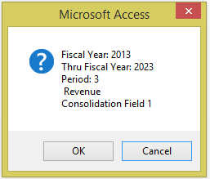

Click ***OK*** to create selected options graph or ***Cancel*** to return to Financial Graph Form. If ***OK*** is selected, the graph will preview on the screen. Click ***Print*** to print the graph.

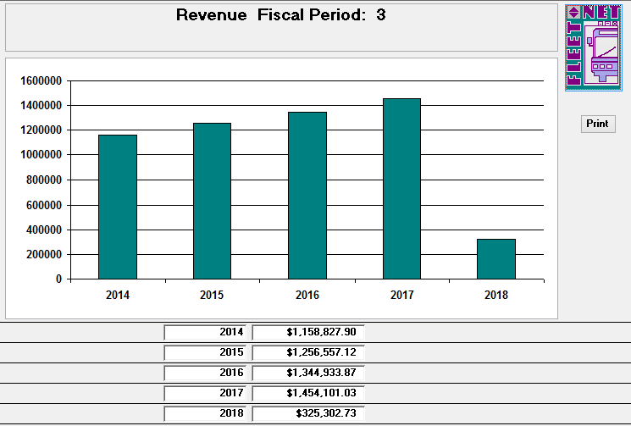

### Financial Statement Builder

Navigate to ***Financial Statement Builder*** to allow users to create customized reports.

#### Report Names

Enter or select fiscal year from the drop down options.

Click ***Report Names*** to populate a list of reports that can be generated. The following form displays. Go to the last record on the form to add a new report.

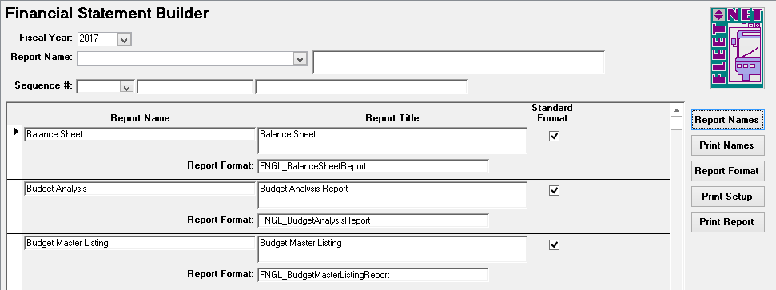

|  |  |
| --- | --- |
| **Field** | **Description** |
| Report Name | Enter a report name. This is the name that will display in the drop down selection list. |
| Report Title | Enter a report title. The title will appear at the top of the printed report. |
| Report Format | Enter one of the four available report formats (See Below). |
| Standard Format | Leave the box unchecked. |

The following Report Formats are available for use in creating customized reports:

#### Print Names

FNGL_FinancialAssetLiabilityReport FNGL_FinancialRevExpByPeriodReport FNGL_FinancialRevenueExpenseReport FNGL_FinStmtBldrBudgetVarianceReport

Click Print to generate a report for view/print. All standard reports are listed on this form.

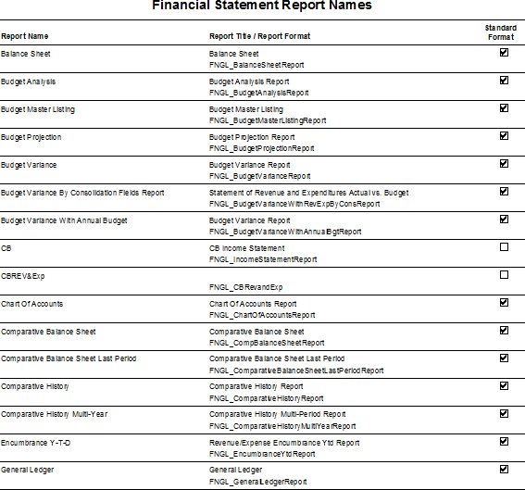

#### Report Format

Click ***Report Format*** define the setup for view/printing selected customized report. The following form displays.

Enter or select a Report from the Report Name drop down options.

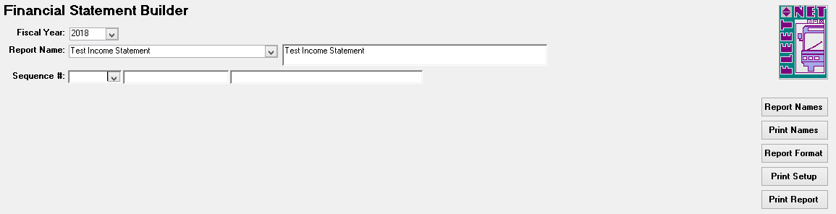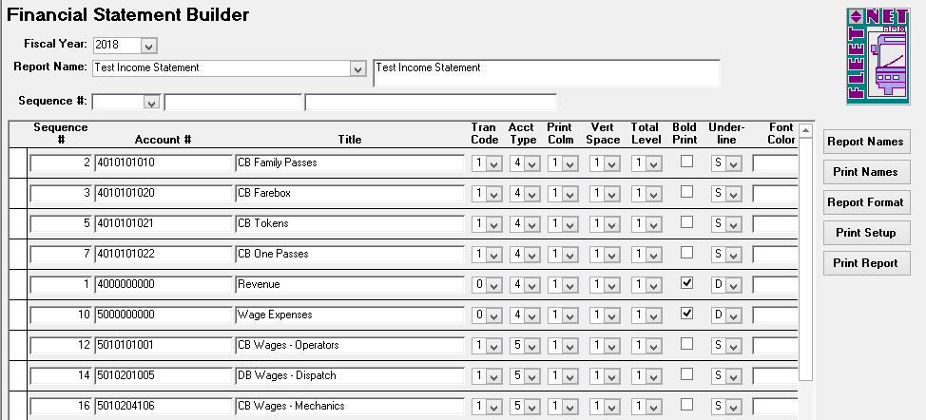

***NOTE:*** *All numbers on financial statements (except contra accounts and/or a loss on income statement) appear as positive numbers. If this is not the case when you print financials, account type specified is incorrect.*

***Print Column Note:*** *Although a number must be entered in this field for all accounts, it only affects printing of Balance Sheet accounts*

***Space Note:*** *Spacing of financial reports may be changed at any time; this only makes a cosmetic change in printing of financials. If any number except 1 is selected, the added lines will appear above the account.*

***Total Level Note****: If subtotals or totals on financial reports are not correct but posting account figures are, this is only a cosmetic problem. Total level codes must be corrected to remedy this situation.*

*A Total Level 2 account will display the total of all of the accounts listed above it with a Total Level 1.*

*A Total Level 3 account will display the total of all of the accounts listed above it with a Total Level 2, if there are none, it will display the total of all accounts with a Total Level 1.*

*A Total Level 4 account will display the total of all of the accounts listed above it with a Total Level 3, if there are none, it will display the total of all accounts with a Total Level 2 or 1 if there are no Total Level 2 accounts.*

To assign general ledger accounts to the Financial Statement Builder accounts (only accounts with Tran Code 1 are eligible for general ledger account assignment), double click in the Sequence # field, the following form displays.

|  |  |  |  |
| --- | --- | --- | --- |
| **Field** | **Max**  **Field Size** | **Field Type** | **Description** |
| Sequence # | 10 | Number | Enter a sequence number. This number will determine order the ‘accounts’ are listed on this form. Duplicate numbers are not allowed. |
| Account # | 20 | Alpha/Numeric | Assign an account number. This number determines order the accounts are listed on the report. If accounts include letters the data is sorted first by number, then by letter. |
| Title | 50 | Alpha/Numeric | Enter account title as it will appear on financial reports. |
| Tran Code | 1 | Number | Select type of transaction applicable for the GL account from the drop-down options. |
| 0 |  | | Heading account (non-posting). |
| 1 | Acquire total from account balances. |
| 3 | Combined Revenue/Expense from total level. |
| 6 | Subtotal/Total from total level. |
| Acct Type | 1 | Alpha/Numeric | Identifies type of account for posting and financial reporting. |
| 1 |  | | Asset |
| 2 | Liability |
| 3 | Capital/Equity |
| 4 | Revenue |
| 5 | Expense |
| 6 | Revenue percentage calculation. |
| Print Column | 1 | Alpha/Numeric | Specify column (1 thru 3) for balance sheet printing (**See Note below**). |
| Space | 1 | Alpha/Numeric | Specify one of the following to determine vertical print line space between accounts on Balance Sheets and Income  Statements (**See Note below**). |
| 1 |  | | Skip 1 Line (print on next line) |
| 2 | Skip 2 Lines (double space) |
| 3 | Skip 3 Lines (triple space) |
| 4 | Skip 4 Lines (skips 3 lines – prints on 4th) |
| 5 | Skip 5 Lines (skips 4 lines – prints on 5th) |
| 6 | Skip 6 Lines (skips 5 lines – prints on 6th) |
| 7 | Skip 7 Lines (skips 6 lines – prints on 7th) |
| 8 | Skip 8 Lines (skips 7 lines – prints on 8th) |
| 9 | Force new page |
| Total Level | 1 | Alpha/Numeric | A total level code number (1-9) determines where subtotals and totals print on financial reports. The total level code used for heading accounts with Tran Code 0 will not impact the reports (**See Note below**). |
| Bold Print |  | Yes/No | Select the checkbox to print the account number, title and amount in bold print on financial reports. |
| Underline | 1 | Alpha/Numeric | Select single or double to underline the amount on financial  reports. |
| Font Color |  | Number | Select the palette icon to choose a font color to print the account number, title and amount on financial reports. |
| Sup Print |  | Yes/No | Select the checkbox to suppress the printing of the account on financial reports when the Summary Option is selected. |
| Sub Amt |  | Yes/No | Select the checkbox to subtract the amount from the total. |
| Rev Sign |  | Yes/No | Select the checkbox to show credits as positive numbers and/or debits as negative numbers. |

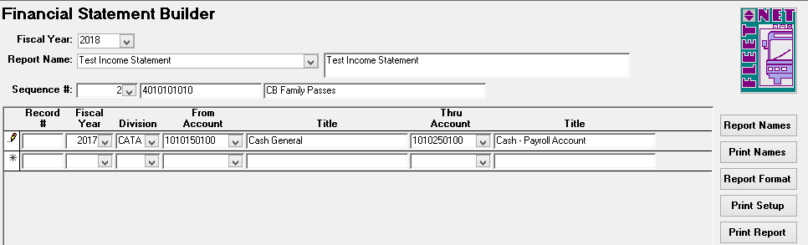

|  |  |  |  |
| --- | --- | --- | --- |
| **Field** | **Max Field Size** | **Field Type** | **Description** |
| Record # | 10 | Number | Enter a record number. This number will determine order the accounts are listed on this form. Duplicate numbers are not allowed. |
| Fiscal Year |  | Number | Enter or select fiscal year from drop down options. Fiscal year is used to validate general ledger account numbers only. |
| Division |  | Number | Enter or select division from drop down options. |
| From Account |  | Number | Select first account number that will be grouped under Financial Statement Builder account number from the drop down options (See below) |
| Title |  | Alpha/Numeric | Auto populates based on general ledger account # selected in previous step |
| Thru Account |  | Number | Select last account number that will be grouped under Financial Statement Builder account number from drop down options. (See below) |

#### Print Setup

Click ***Print Setup*** to generate a report listing report specifications.

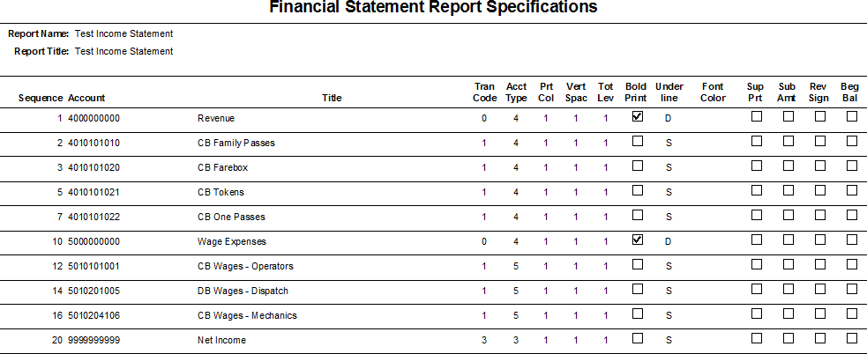

#### Print Report

Click ***Print Report*** to generate final report, the following form displays.

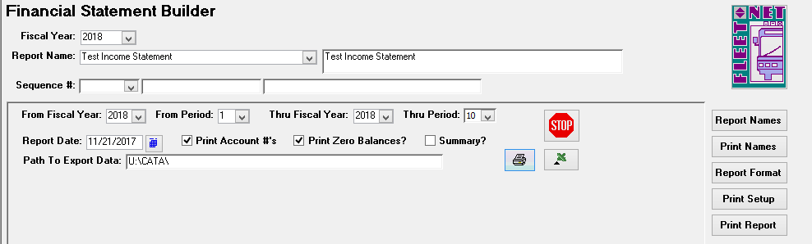

|  |  |  |
| --- | --- | --- |
| **Field** | **Field Type** | **Description** |
| From Fiscal Year | Number | Enter or select starting fiscal year from drop down options. (See Below) |
| From Period | Number | Enter or select first accounting period that will be included on the report from drop down options. |
| Thru Fiscal Year | Number | Enter or select ending fiscal year from drop down options. (See Below) |
| Thru Period | Number | Enter or select last accounting period that will be included on the report from drop down options. |
| Report Date | Date | Enter or select date from calendar that will be displayed at top of the report. |
| Print Account #’s | Yes/No | Check box to include GL account numbers on the report. Account Numbers that will display are those that were created on Report Format form. |
| Print Zero Balances? | Yes/No | Check box to include GL account numbers with zero balances on the report. Unchecking the box will exclude accounts with zero balances. |
| Summary? | Yes/No | Check box to generate a report that excludes GL account numbers set up as suppressed print, which were checked ***Sup Print.*** |

# Account Balance Inquiry

Navigate to ***Balances*** to display and/or print an account balance and transaction listing for a specific account number.

#### Totals

Click ***Totals*** to view transaction totals by month, current period, YTD, LTD and Debit & Credits for selected Period.

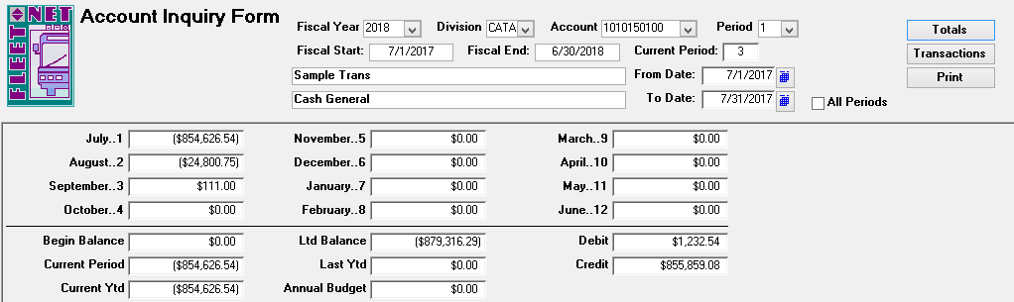

|  |  |
| --- | --- |
| **Field** | **Description** |
| Fiscal Year | Enter or select fiscal year from drop down options. |
| Division | Enter or select division from drop down options. |
| Account | Enter or select GL account number from drop down options. |
| Period | Enter or select period from drop down options. |
| Fiscal Start | Auto populates based on fiscal year selected. |
| Fiscal End | Auto populates based on fiscal year selected. |
| Current Period | Auto populates based on current period in General Ledger. |
| Period | Enter or select period from drop down options. |

#### Transactions

Click ***Transaction*** to display/and or print the account balances by month. The following form displays.

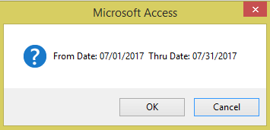

Click ***OK*** to continue or ***Cancel*** to cancel. If ***OK*** is selected the following form displays.

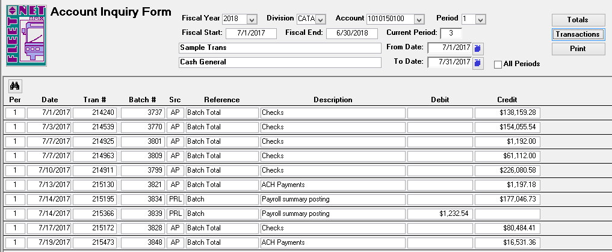

#### Print

Click ***Print*** to display/and or print the account balance inquiry report for the selected account. The following reports display.

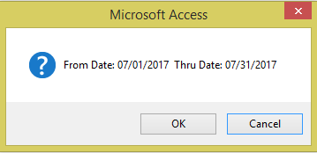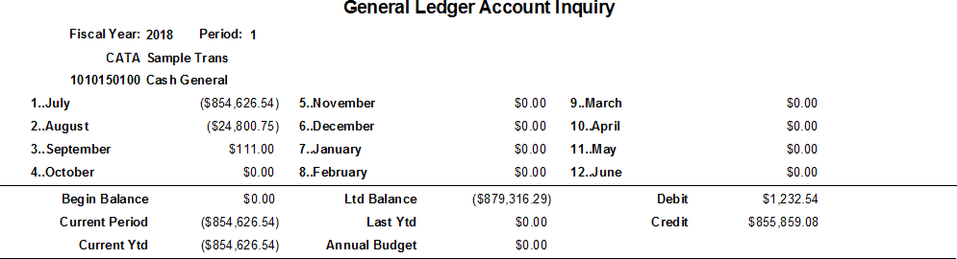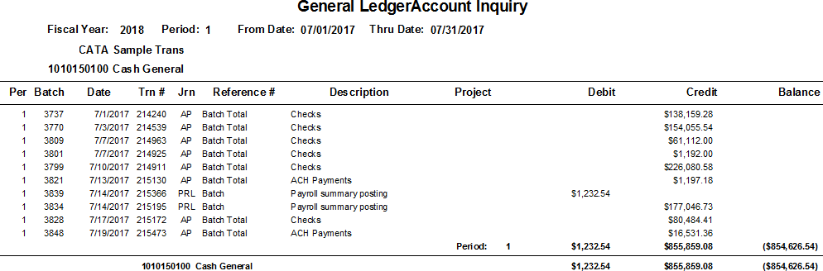

# GL Transaction Inquiry

Navigate to ***Transaction Inquiry*** to view GL Transactions.

The inquiry can be general or refined to include one or more selection criteria. The only required field is the fiscal year.

#### Refresh

Click ***Refresh*** to refresh the screen to view selected options.

 Highlight a selected field. Click **Binocular Icon** will open Find form.

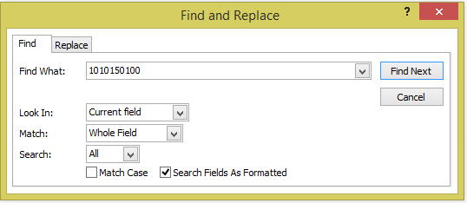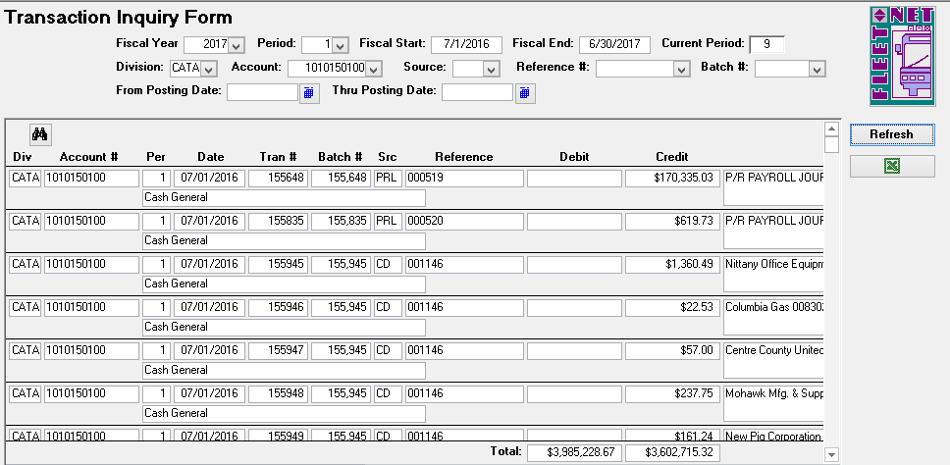

|  |  |
| --- | --- |
| **Field** | **Description** |
| Fiscal Year | Enter or select fiscal year from the drop down options – **Mandatory field.** |
| Period | Enter or select period from the drop down options – *Optional field.* |
| Posting Date | Enter or select posting date from the drop down options – *Optional field.* |
| Batch # | Enter or select batch number from the drop down options – *Optional field.* |
| From Posting Date | Enter a starting date or select it from the calendar – *Optional field.* |
| Thru Posting Date | Enter an ending date or select it from the calendar – *Optional field.* |

#### Excel Icon



Click ***Excel Icon*** to export inquiry screen data into an Excel spreadsheet.

**Excel Spreadsheet:**



# Quick Balance Inquiry

Navigate to ***Quick Balance Inquiry*** to display current fiscal period balance information by division number.

To To ensure that you are in balance, run periodically and prior to month end or year end.

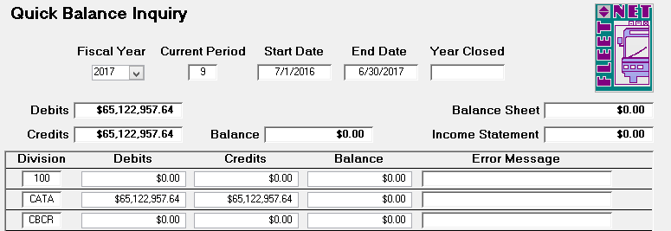

|  |  |
| --- | --- |
| **Field** | **Description** |
| Fiscal Year | Enter or select fiscal year from drop down option. Totals will accumulate automatically. |
| Current Period | Auto populates based on fiscal year selected. |
| Start Date | Auto populates based on fiscal year selected. |
| End Date | Auto populates based on fiscal year selected. |
| Debits | Auto populates after balances are accumulated. |
| Credits | Auto populates after balances are accumulated. |
| Balance | Auto populates after balances are accumulated. |
| Balance Sheet | Auto populates after balances are accumulated. |
| Income Statement | Auto populates after balances are accumulated. |

# Month End Closing

Navigate to ***Month End*** to close accounting period and post income and expenses to retained earnings.

The previous period does NOT need to be closed prior to posting to the current period.

Month End Closing clears current period income statement figures and posts totals to retained earnings for the selected period. Current accounting month flag is incremented during this process.

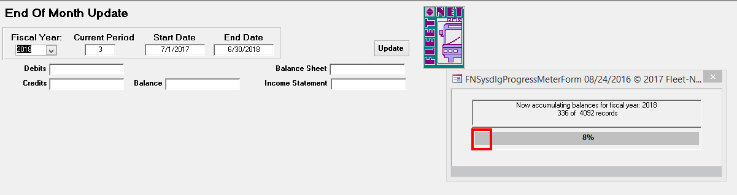

After accumulating account balances, the following form displays. If debits and credits are out of balance or closing entries have not been generated and updated the following error message displays.

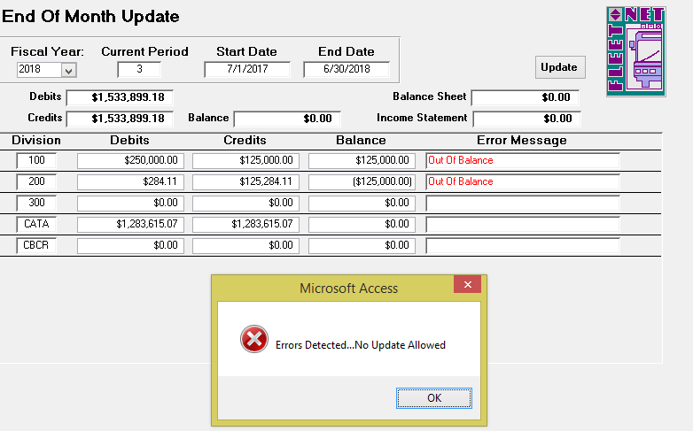

|  |  |
| --- | --- |
| **Field** | **Description** |
| Fiscal Year | Enter or select fiscal year from the drop down options. Totals will accumulate automatically. |
| Current Period | Auto populates based on fiscal year selected. |
| Start Date | Auto populates based on fiscal year selected. |
| End Date | Auto populates based on fiscal year selected. |
| Debits | Auto populates after balances are accumulated. |
| Credits | Auto populates after balances are accumulated. |
| Balance | Auto populates after balances are accumulated. |
| Balance Sheet | Auto populates after balances are accumulated. |
| Income Statement | Auto populates after balances are accumulated. |

This is due to the fact that Auto Post Closing entries have not been generated and updated wherein the profit or loss is posted from the income summary accounts to the retained earnings account. Once that process has been run, the accounts will be in balance and the End of Month Update form will display as shown below.

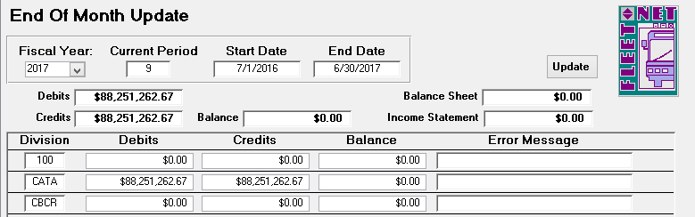

#### Update

Click ***Update*** to update month end closing entries to General Ledger and close current period. The following prompt displays.

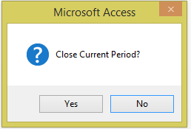

Click ***Yes*** to continue or ***No*** to return to End of Month Update form. Once completed the following confirmation message displays.

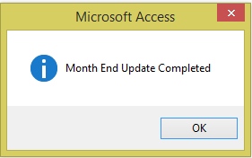

Click ***Ok***.

# Fiscal Year End Closing

Navigate to ***Year End*** to perform fiscal year end update on all general ledger files. Before this can be done, all current period journal entries must be updated.

***Note: Month End Closing must be executed prior to running Fiscal Year End Closing.***

This process moves the current year-to-date balances to the last year-to-date field and beginning balance is set to zero on income statement accounts.

Enter or select Fiscal Year from the drop-down options. All other fields automatically populate after the process completes. See next page for explanation of the *Create Revenue/Expense Accounts for New Fiscal Year*

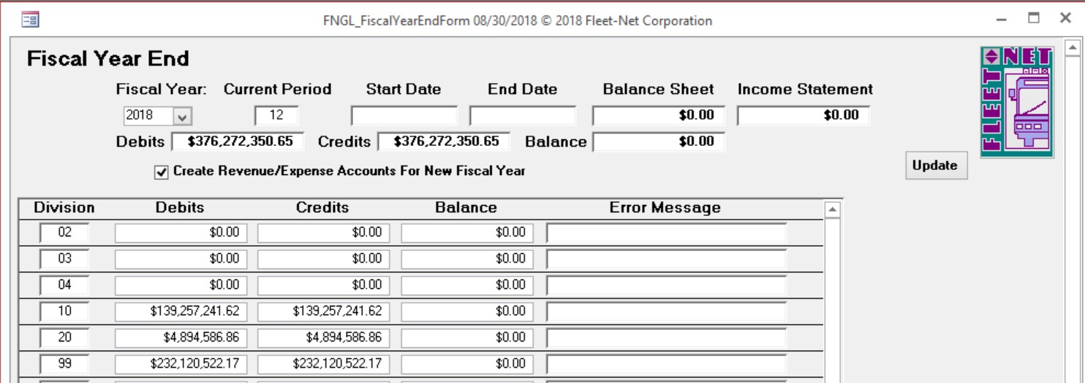

#### Create Revenue/Expense Accounts for New Fiscal Year

If this box is checked, all accounts in the Chart of Accounts for the Fiscal Year being closed will be written to the next year’s Chart of Accounts.

Uncheck this box if accounts were deleted when the Chart of Accounts was created for the upcoming fiscal year. The Year End Close process will not write accounts from the year being closed that are not in the Chart of Accounts for the next year.

If the Chart of Accounts was not previously created using the Create New Budget Year function, the Create Revenue/Expense Accounts for New Fiscal Year check box **MUST** be checked due to the following provisions:

If **UNCHECKED** only Assets (1), Liabilities (2) and Capital (3) accounts are created for the next fiscal year. **NO** Revenue (4), Expense (5) or Revenue % Calculation (6) accounts are created for the next fiscal year.

Debits and credits are displayed. Balance Sheet and Income Statement fields should be $0.00. Error Message field should be blank.

#### Update

Click ***Update*** to update year end closing entries to General Ledger and close current fiscal year.

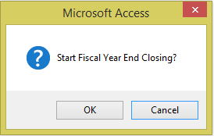

Click ***OK*** to continue or ***Cancel*** to return to Fiscal Year End form.

Once closing is completed the following confirmation message displays.

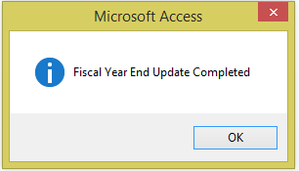

Click ***OK***.

# Uniform System of Accounts

(USOA) for National Transportation Database (NTD) Reporting

USOA Appendix of Asset Categories – for definitions see USOA Publication

***As these categories, functions, and object classes are defined by FTA, please check the latest USOA Publication for the most current data.***

#### List of Asset Categories

1. CASH AND CASH ITEMS
2. Cash
3. Working (Interest) Funds
4. Special Deposits, Interest
5. Special Deposits, Dividends
6. Special Deposits, Other
7. Temporary Cash Investments
8. RECEIVABLES
   1. Accounts Receivable
   2. Notes Receivable
   3. Interest and Dividends Receivable
   4. Receivables from Associated Companies
   5. Receivable Subscriptions to Capital Stock
   6. Receivables for Capital Grants
   7. Receivables for Operating Assistance
   8. Other Receivables
   9. Reserve for Uncollectible Accounts
9. MATERIALS AND SUPPLIES INVENTORY

##### 02. Accumulated Depreciation

1. OTHER CURRENT ASSETS
2. WORK IN PROCESS
   1. Unbilled Work for Others
   2. Capital Projects
3. TANGIBLE TRANSIT OPERATING PROPERTY
   1. Property Cost
   2. Leased-Out Property Cost
   3. Accumulated Depreciation
4. TANGIBLE PROPERTY OTHER THAN FOR TRANSIT OPERATIONS
   1. Property Cost

121. INTANGIBLE ASSETS

1. Organization Costs
2. Franchises
3. Patents
4. Goodwill
5. Other Intangible Assets
6. Accumulated Amortization

131. INVESTMENTS

1. Investments and Advances, Associated Companies
2. Other Investments and Advances
3. Reserve for Revaluation of Investments

141. SPECIAL FUNDS

1. Sinking Funds
2. Capital Asset Funds
3. Insurance Reserve Funds
4. Pension Funds
5. Other Special Funds

151. OTHER ASSETS

1. Prepayments
2. Miscellaneous Other Assets

###### List of Liabilities

1. TRADE PAYABLES
   1. Payables to Associated Companies
2. ACCRUED PAYROLL LIABILITIES
3. ACCRUED TAX LIABILITIES
4. SHORT-TERM DEBT
   1. Notes Payable
   2. Matured Equipment and Long-Term Obligations
   3. Unmatured Equipment and Long-Term Obligations, Current Portion
   4. Matured Interest Payable
   5. Accrued Interest Payable
   6. Current Pension Liabilities
5. OTHER CURRENT LIABILITIES
   1. Unredeemed Fares
   2. CODs Unremitted
   3. Dividends Declared and Payable
   4. Short-Term Construction Liabilities
   5. Miscellaneous Other Current Liabilities

211. ADVANCES PAYABLE

1. Advances Payable to Associated Companies
2. Other Advances Payable

221. LONG-TERM DEBT

1. Equipment Obligations
2. Bonds
3. Receivers' and Trustees' Securities
4. Long-Term Construction Liabilities
5. Other Long-Term Obligations
6. Unamortized Debt Discount and Expense
7. Unamortized Premium on Debt
8. Reacquired and Nominally Issued Long-Term Obligations

231. ESTIMATED LIABILITIES

1. Long-Term Pension Liabilities
2. Uninsured Public Liability and Property Damage Losses
3. Other Estimated Liabilities

241. DEFERRED CREDITS

###### Revenue Categories – for definitions see USOA Publication

1. PASSENGER FARES FOR DIRECTLY-OPERATED TRANSIT SERVICE
   1. Full Adult Fares
   2. Senior Citizen Fares
   3. Student Fares
   4. Child Fares
   5. Disabled Rider Fares
   6. Park and Ride - Parking Revenue Only

90. Special Ride Fares

99. Other Primary Fares

1. SPECIAL TRANSIT FARES
   1. Contract Fares for Postal Workers
   2. Contract Fares for Police Officers
   3. Special Route Guarantees
   4. State and Local Government
   5. Other Special Contract Transportation Fares - Other Sources
   6. Non-Contract Service Fees
2. SCHOOL BUS SERVICE REVENUES
3. FREIGHT TARIFFS
4. CHARTER SERVICE REVENUES
5. AUXILIARY TRANSPORTATION REVENUES
   1. Station Concessions
   2. Vehicle Concessions
   3. Advertising Services
   4. Automotive Vehicle Ferriage

99. Other Auxiliary Transportation Revenues

1. NON-TRANSPORTATION REVENUES
   1. Sales of Maintenance Services
   2. Rental of Revenue Vehicles
   3. Rental of Buildings and Other Property
   4. Investment Income
   5. Parking Facilities Revenue

99. Other Non-Transportation Revenues

1. TAXES LEVIED DIRECTLY BY THE TRANSIT SYSTEM - TAXES DEDICATED TO TRANSIT AT THEIR SOURCE
   1. Property Taxes
   2. Sales Taxes
   3. Income Taxes
   4. Payroll Tax Revenue
   5. Utility Tax Revenue
   6. Gasoline Taxes

99. Other Taxes

1. LOCAL CASH GRANTS AND REIMBURSEMENTS
   1. General Operating Assistance
   2. Special Demonstration Project Assistance - Local Projects
   3. Special Demonstration Project Assistance - Local Share for State Projects
   4. Special Demonstration Project Assistance - Local Share for FTA Projects
   5. Reimbursement of Taxes Paid
   6. Reimbursement of Interest Paid
   7. Reimbursement of Transit System Maintenance Costs
   8. Reimbursement of Snow Removal Costs
   9. Reimbursement of Security Costs

99. Other Financial Assistance

1. LOCAL SPECIAL FARE ASSISTANCE
   1. Disabled Citizen Fare Assistance
   2. Senior Citizen Fare Assistance
   3. Student Fare Assistance

99. Other Special Fare Assistance

1. STATE CASH GRANTS AND REIMBURSEMENTS
   1. Operating Assistance
2. Special Demonstration Project Assistance - State Projects
3. Special Demonstration Project Assistance - State Share for FTA Projects
4. Reimbursement of Taxes Paid
5. Reimbursement of Interest Paid
6. Reimbursement of Transit System Maintenance Costs
7. Reimbursement of Security Costs

99. Other Financial Assistance

1. STATE SPECIAL FARE ASSISTANCE
   1. Disabled Citizen Fare Assistance
   2. Senior Citizen Fare Assistance
   3. Student Fare Assistance

99. Other Special Fare Assistance

1. FEDERAL CASH GRANTS AND REIMBURSEMENTS
2. Special Demonstration Project Assistance

99. Other Financial Assistance

1. REVENUE ACCRUED THROUGH A PURCHASED TRANSPORTATION AGREEMENT
2. FARE REVENUE RETURNED BY SELLER (CONTRACTOR)
3. FARE REVENUE RETAINED BY SELLER (CONTRACTOR)

430. CONTRIBUTED SERVICES

1. State and Local Government
2. Contra Account for Expense

440. SUBSIDY FROM OTHER SECTORS OF OPERATIONS

1. Subsidy from Utility Rates
2. Subsidy from Bridge and Tunnel Tolls

99. Other Subsidies

#### Summary of Expense Functions

1. VEHICLE OPERATIONS
2. TRANSPORTATION ADMINISTRATION AND SUPPORT

151. TICKETING AND FARE COLLECTION

161. SYSTEM SECURITY

030. REVENUE VEHICLE OPERATIONS

1. REVENUE VEHICLE MOVEMENT AND CONTROL

021. SCHEDULING OF TRANSPORTATION OPERATIONS

041. MAINTENANCE ADMINISTRATION - VEHICLES

051. SERVICING REVENUE VEHICLES

061. INSPECTION AND MAINTENANCE OF REVENUE VEHICLES

062. ACCIDENT REPAIRS OF REVENUE VEHICLES

071. VANDALISM REPAIRS OF REVENUE VEHICLES

081. SERVICING AND FUEL OF SERVICE VEHICLES

091. INSPECTION AND MAINTENANCE OF SERVICE VEHICLES

042. MAINTENANCE ADMINISTRATION - FACILITIES

101. MAINTENANCE OF VEHICLE MOVEMENT CONTROL SYSTEMS

111. MAINTENANCE OF FARE COLLECTION AND COUNTING SYSTEMS

1. MAINTENANCE OF ROADWAY AND TRACK
2. MAINTENANCE OF STRUCTURES, TUNNELS, BRIDGES, AND SUBWAYS
3. MAINTENANCE OF PASSENGER STATIONS
4. MAINTENANCE OF OPERATING STATION BUILDINGS, GROUNDS, AND EQUIPMENT
5. MAINTENANCE OF GARAGES AND SHOP BUILDINGS, GROUNDS, AND EQUIPMENT
6. MAINTENANCE OF COMMUNICATIONS SYSTEM
7. MAINTENANCE OF GENERAL ADMINISTRATION BUILDINGS, GROUNDS, AND EQUIPMENT
8. ACCIDENT REPAIRS OF BUILDINGS, GROUNDS, AND EQUIPMENT

131. VANDALISM REPAIRS OF BUILDINGS, GROUNDS, AND EQUIPMENT

141. OPERATION AND MAINTENANCE OF ELECTRIC POWER FACILITIES

|  |  |
| --- | --- |
| 160. | GENERAL ADMINISTRATION |
| 165. | INJURIES AND DAMAGES |
| 166. | SAFETY |
| 167. | PERSONNEL ADMINISTRATION |
| 168. | GENERAL LEGAL SERVICES |
| 169. | GENERAL INSURANCE |
| 170. | DATA PROCESSING |
| 171. | FINANCE AND ACCOUNTING |
| 172. | PURCHASING AND STORES |
| 173. | GENERAL ENGINEERING |
| 174. | REAL ESTATE MANAGEMENT |
| 175. | OFFICE MANAGEMENT AND SERVICES |
| 176. | GENERAL MANAGEMENT |
| 145. | PRELIMINARY TRANSIT SYSTEM DEVELOPMENT |
| 181. | GENERAL FUNCTION |
| 162. | CUSTOMER SERVICES |
| 163. | PROMOTION |
| 164. | MARKET RESEARCH |
| 177. | PLANNING |

###### Summary of Object Class Expenses

1. LABOR
   1. Operators' Salaries and Wages
   2. Other Salaries and Wages
2. FRINGE BENEFITS
   1. FICA or Railroad Retirement
   2. Pension Plans
   3. Hospital, Medical, and Surgical Plans
   4. Dental Plans
   5. Life Insurance Plans
   6. Short-Term Disability Insurance Plans
   7. Unemployment Insurance
   8. Worker's Compensation Insurance or Federal Employees' Liability Act Contribution
   9. Sick Leave
3. Holiday
4. Vacation
5. Other Paid Absence
6. Uniform and Work Clothing Allowance
7. Other
8. SERVICES
   1. Management Service Fees
   2. Advertising Fees
   3. Professional and Technical Services
   4. Temporary Help
   5. Contract Maintenance Services
   6. Custodial Services
   7. Security Services

99. Other Services

1. MATERIALS AND SUPPLIES CONSUMED
   1. Fuel and Lubricants
   2. Tires and Tubes

99. Other Materials and Supplies

1. UTILITIES
   1. Propulsion Power
   2. Utilities Other than Propulsion Power
2. CASUALTY AND LIABILITY COSTS
   1. Premiums for Physical Damage Insurance
   2. Recoveries of Physical Damage Losses
   3. Premiums for Public Liability and Physical Damage Insurance
   4. Payouts for Uninsured Public Liability and Physical Damage Settlements
   5. Provision for Uninsured Public Liability and Physical Damage Settlements
   6. Payouts for Insured Public Liability and Physical Damage Settlements
   7. Recoveries for Public Liability and Physical Damage Settlements
   8. Premiums for Other Corporate Losses
   9. Other Corporate Losses

10. Recoveries of Other Corporate Losses

1. TAXES
   1. Federal Income Tax
   2. State Income Tax
   3. Property Tax
   4. Vehicle Licensing and Registration Fees
   5. Fuel and Lubricant Taxes
   6. Electric Power Taxes

99. Other Taxes

1. PURCHASED TRANSPORTATION SERVICE
   1. In Report
   2. Filing Separate Report
2. MISCELLANEOUS EXPENSES
   1. Dues and Subscriptions
   2. Travel and Meetings
   3. Bridge, Tunnel and Highway Tolls
   4. Entertainment Expenses
   5. Charitable Donations
   6. Fines and Penalties
   7. Bad Debt Expense
   8. Advertising/Promotion Media

99. Other Miscellaneous Expenses

1. EXPENSE TRANSFERS
   1. Function Reclassifications
   2. Expense Reclassifications
   3. Capitalization of Non-Operating Costs
2. INTEREST EXPENSE
   1. Interest on Long-Term Debt Obligations
   2. Interest on Short-Term Debt Obligations
3. LEASES AND RENTALS
   1. Transit Way and Transit Way Structures and Equipment
   2. Passenger Stations
   3. Passenger Parking Facilities
   4. Passenger Revenue Vehicles
   5. Service Vehicles
   6. Operating Yards or Stations
   7. Engine Houses, Car Shops, and Garages
   8. Power Generation and Distribution Facilities
   9. Revenue Vehicle Movement Control Facilities
4. Data Processing Facilities
5. Revenue Collection and Processing Facilities
6. Other General Administration Facilities
7. DEPRECIATION
   1. Transit Way and Transit Way Structures and Equipment
   2. Passenger Stations
   3. Passenger Parking Facilities
   4. Passenger Revenue Vehicles
   5. Service Vehicles
   6. Operating Yards or Stations
   7. Engine Houses, Car Shops, and Garages
   8. Power Generation and Distribution Facilities
   9. Revenue Vehicle Movement Control Facilities
8. Data Processing Facilities
9. Revenue Collection and Processing Facilities
10. Other General Administration Facilities
11. Depreciation and Amortization - Amortization of Intangibles
12. PURCHASE LEASE PAYMENTS
13. RELATED PARTIES LEASE AGREEMENT
14. OTHER RECONCILING ITEMS